South Krios Data Collection Protocol v1.2
Low Mag Maps (LMM)
- See cheat sheet for LMM parameters (updated regularly). Adjust mag depending on desired resolution (LM100-175×). Beam should cover the entire detector (~1.16mm). Test with a record pic (bin 1, 0.5-1.0s)
- Navigator Ribbon>Open a Navigator
- Navigator Ribbon>Full Montaging and Grids>Set Up Full Montage>Default Setup and Default Montage Pieces highlighted in yellow (use whatever number pops up)>File Properties settings on image below (check all the boxes)>Save as “LMM.st” in KEEP folder
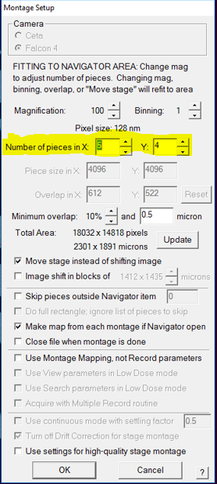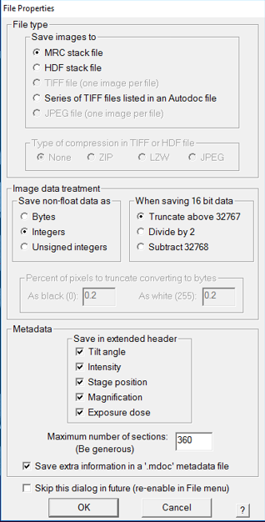
- Go to Montage Controls lower left side of serialEM tiles>hit Start
- Save NAV after LMM completes by Nav ribbon>Save>Save as “nav.nav” in KEEP folder
Medium Mag Maps (MMM)
- See cheat sheet for MMM parameters. Adjust mag so that a single square fits comfortably within the detector (EFTEM LM600x to LM940 depending on mesh size and ice thickness)
- Take a record pic (Bin 1, 0.5-1 secs) of a centered square at selected Medium Mag, then Tasks Ribbon>Eucentricity>Rough Eucentricity>Wait for finished message on log window>On Nav window click “Update Z”
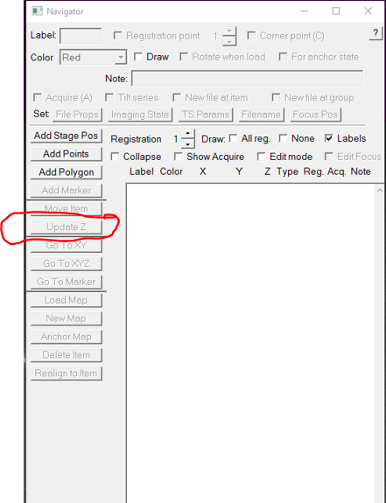
- Shift To Marker LMM to Medium Mag - Open LMM (double click) from Nav>Search for distinct feature inside a square>On Nav select Add Points>Click on feature and remember where on feature point is made>On Nav click Stop Adding>on Nav click Go to XYZ>Take Record pic> Feature should be on pic but not exactly where point was placed>click on where point should be (green +)>navigator ribbon>halfway down the ribbon click Shift to Marker>ok>point will move to desired location
- On Nav click Add Points>add point to center of squares to be mapped>Select enough squares for a 24hr or 48hr data collection (25-50 squares)>collapse into group by checking Collapse>check Acquire>uncheck Collapse, all square point will show an “A” beside
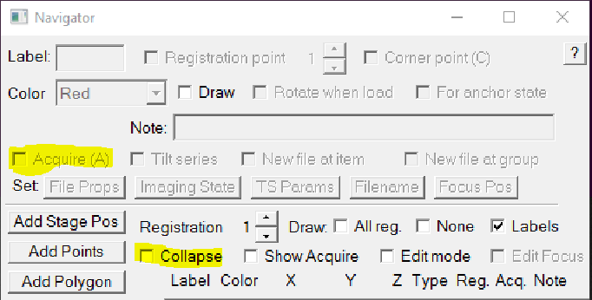
- On Nav select first square point with an A>on Nav check New File at Item>single frame>save in KEEP as “MMM.st”>selected point will change from A to AF
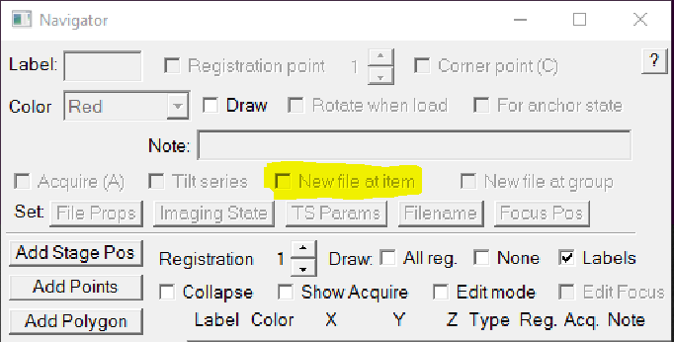
- Nav ribbon>click on Acquire at Items>on new window select settings below>Go
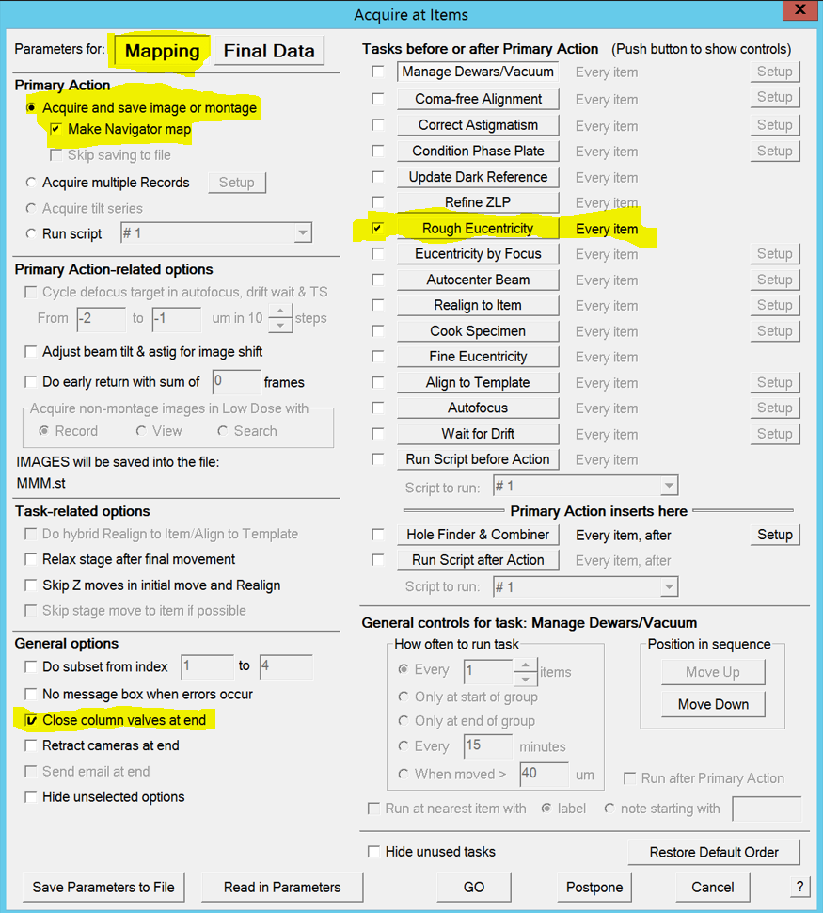
- When MMMs finish>Nav ribbon>save
Low Dose Beam Setup
- On Nav check MMM’s and open one with distinct feature/s (no big cracks!), we will use this sacrificial square for the next few steps (“bad” MMM)
- We will now set up Record, Trial, and Focus Beams
- Activate low dose panel by checking Low Dose Mode>check Continuous Update>click on Rec beam first
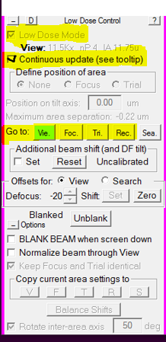
- Check cheat sheet for parameters
- Record beam – EFTEM, NanoProbe, collection mag and illumination area, Energy Slit in @10ev
- Trial and Focus – Copy settings from Record to Trial and Focus, Energy Slit in @10ev
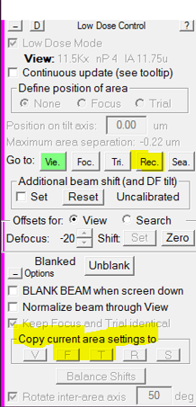
- View – EFTEM, NanoProbe, adjust mag to fit one hole into the view frame (SA11000× to SA19500×), Energy Slit in @20ev
Shift to Marker MMM to View Mag
- On NAV open “bad” MMM with features>look for distinct feature>on Nav click Add Points>click on feature to add point, remember where on feature>on Nav click Stop Adding>click GO TO XYZ>Take VIEW pic>if feature found on pic, click (green +) on where the point should be>Nav ribbon>Shift to Marker>point will move to desired location. If feature not found on VIEW pic>move over to microscope flu screen and explore around until feature is found>when feature found, center inside detector area>take VIEW pic>click (green +) on where the point should be>Nav ribbon>Shift to Marker>point will move to desired location.
Align Record Mag to View Mag, View Shift Offset
- On NAV open “bad” MMM with features>click Go To XYZ>take VIEW pic>find a small feature that will fit inside a RECORD pic, drag in VIEW mag to get close to feature>take RECORD/PREVIEW pic>drag to align feature and refresh with new RECORD pic till feature is centered>take VIEW pic>locate feature, if not aligned>Uncheck MOVE STAGE FOR BIG MOUSE SHIFTS on SerialEM tile>Drag to align feature>in LOW DOSE CONTROL tile, click SET on offsets for view>recheck MOVE STAGE FOR BIG MOUSE SHIFTS
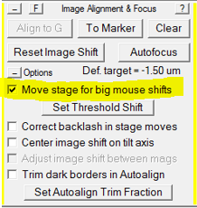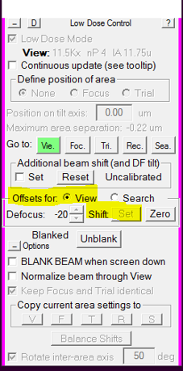
CTF Corrections
- On NAV go to “bad” MMM>Take VIEW pic>drag to carbon area>take RECORD pic to confirm strong thon rings on FFT>if strong rings present move on to do 3 CTF cals under SerialEM Focus and Tuning ribbon
  - Focus and Tuning ribbon>Correct Astigmatism by CTF
  - Focus and Tuning ribbon>Correct Coma Free Alignment by CTF
  - Take a view pic>zoom out with scroll wheel>Focus and Tuning ribbon>Coma vs Image Shift – settings depend on hole size(use 3.6 for 1.2/1.3 grid)>rotate boxes to ensure tilts fall on carbon>start>enter in the current C2 aperture size when prompted
Multi-shot Parameters Setup
- On NAV open “bad” MMM>create 9 hole pattern highlighted below>make center point (yellow) by Add Points>Stop Adding>add 4 corner points (red) by Add Points>make 4 corners points>Stop Adding
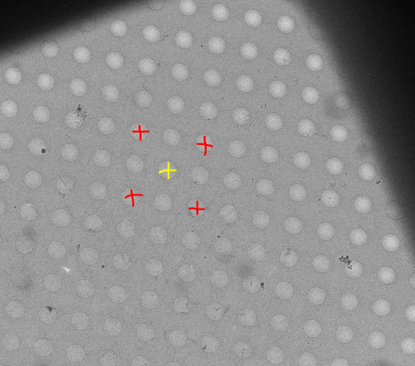
- on Low Dose Control Tile>Define Position of Area>click Focus or Trial>on Position on tilt axis box change to zero
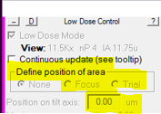
- On NAV select center point>Go To XYZ>take VIEW pic>drag to align hole, retake VIEW pic>repeat until centered
- Navigator Ribbon>Montaging and Grids>Set Multi-Shot Parameters, window will open>set up Do Multiple Records within each hole>select desired number of shots within hole
- on NAV select first corner point>on SerialEM left tiles Uncheck - MOVE STAGE FOR BIG MOUSE SHIFTS>Multiple record window click For Corners of Regular Pattern>click IS to Nav Pt>take VIEW PIC>drag to align hole, retake VIEW, repeat till centered>click Save Image Shift>first corner of pattern done>click IS to Nav Pt to go to next corner>take VIEW PIC>drag to align hole, retake VIEW, repeat till centered>click Save Image Shift>second corner of pattern done>repeat for two remaining corners
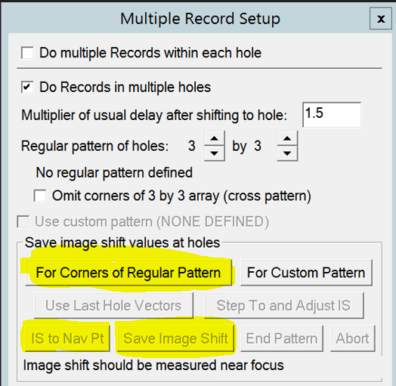
Set up Acquire Points (2 options)
Option 1: Hole Finder - see Hole Finder Protocol in Binder
Option 2: Polygons - Use when hole finder does not work because of thick ice or low-contrast MMMs
- On NAV open desired MMM>draw polygon around desired area by clicking ADD POLYGON (green)>click Stop Adding>create 5 point pattern below by clicking Add Points>make the 5 points>click Stop Adding
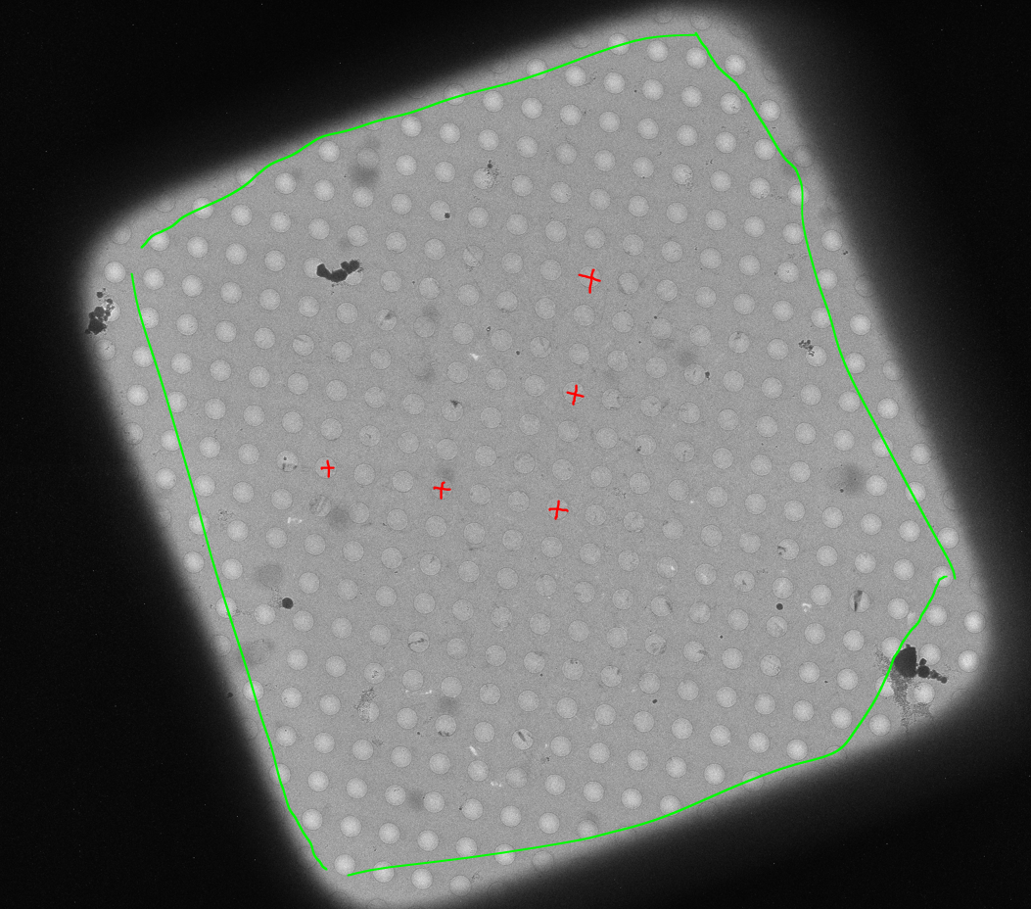
- On Navigator ribbon>Montaging and Grids>Add Grid of Points>input Polygon number (green number on MMM>on keyboard hit Enter, then Enter again>acquire points will populate inside polygon in magenta color>repeat steps for about 20-30 MMMs>save NAV
Align to Template Setup and Define Area of Focus/Trial
- We need a clean VIEW pic of an aligned hole>on NAV open desired MMM>take VIEW pic>drag to align hole>once a clean example of VIEW pic with aligned hole is found>on SerialEM windows ribbon>File>Save A>save as mrc on file properties window>name it “BufferP.mrc” in your KEEP folder>click save>on NAV click New Map>a map will be created>remember label associated with new BufferP map/Image for final data setup section
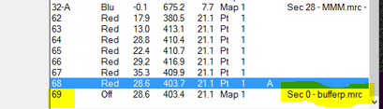
- on Nav reopen BufferP/View Aligned Hole>on Low Dose Panel find Define Position of Area
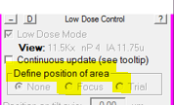
- Click Focus or Trial>F/T area will appear on image>click on biggest area of carbon visible on image>area of F/T will move to where you click>select none on low dose panel when desired area is selected
Final Data Setup
- On Navigator ribbon>Acquire at Items>below window will appear>Go over highlighted parts
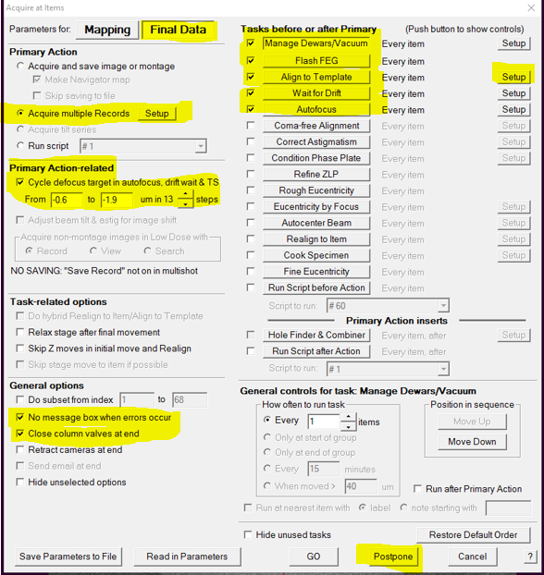
- Align To Template>Setup>new window will open>add label number of BufferP>click ok
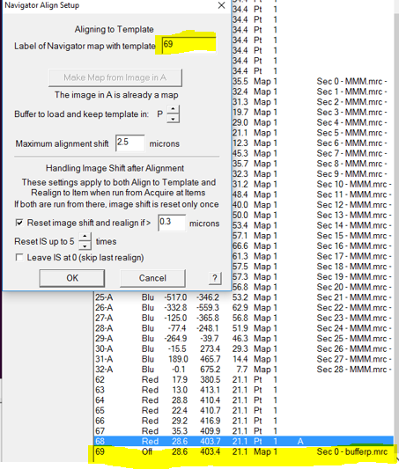
- Once all items have been checked/Reviewed>click Postpone
Final Data Camera Setup
- Go to the Camera Tile>click Setup
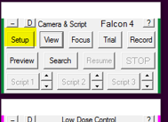
- Go over highlighted areas below

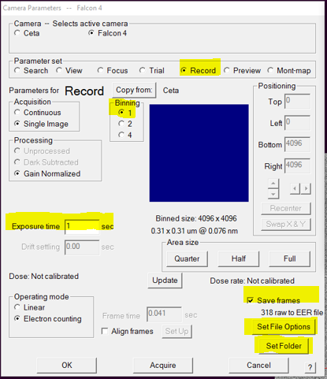
- Record settings bin 1, exposure time to achieve desired total dose, check save frames
- Set file options
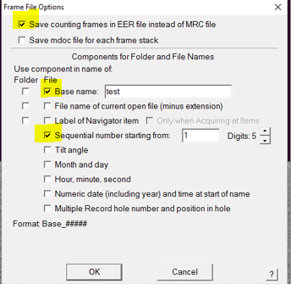
- Set Folder to set folder for saved images
- Go to low dose setup MMM to check beams are centered
- Go NAV ribbon>Acquire at Items>GO>data collection starts

