Module L: Clinical Trial Accounting & Analysis
Outline

- Clinical Research Overview
- Clinical Research Administration is a broad enterprise that requires the collaboration of multiple departments across Campus and multiple teams within the central administrative office. Clinical Research embraces a continuum of studies involving interactions with patients, diagnostic clinical materials and/or data.
- Principal Investigators (PIs) are individuals designated to direct the project being supported by a grant or industry agreement and must ensure funds are spent appropriately for each project
- Sponsored Programs Administration (SPA) assists researchers with applying for funding and managing their agreements, including budgeting and execution of clinical trial agreements
- Clinical Trial Accounting & Analysis (CTAA) is responsible for start-up billing and invoicing of clinical trials, ClinCard administration, and clinical trial budget reviews and maintenance
- Acronyms commonly used by CTAA:
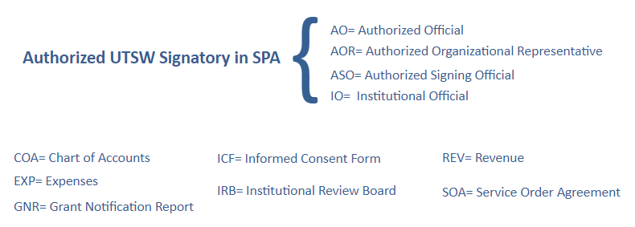

- Clinical Trial Finance Overview
- Budgets should provide financial security and non-reliance on additional departmental income sources. Components of a budget:
- Revenue - based on number of patients accrued and enrolled into a study and any associated fees not captured in budget
- Expenses - UTSW builds its Research Fee Schedule from the Centers for Medicare and Medicaid Services (CMS) published fee schedules
- Fees - such as IRB/HRPP, Coverage Analysis, Start up and Ancillary fees
- Personnel Time - assessed by actual personnel and labor expenses, including pre-screening efforts, chart reviews and administrative time for the Study
- Facilities and Administration (F&A) or “indirect costs” – vary depending on sponsor. See SPA website for current rates.
- Note: different Sponsors will be budgeted different ways, depending on whether they are Federal, Non-federal, or Industry sponsors
- Start-Up Invoicing
- Fully executed contracts are the “source of truth” for start-up costs. Invoices are sent from Velos and populate via an interface with Peoplesoft into the General Ledger.
- eAgreements Smartform Section 9.1.1 is an essential tool for confirming that all start-up costs will be invoiced
- Comprehensive financial management
- Clincards can be obtained after submitting a signed Informed Consent Form (ICF) and Study Initiation Protocol (SIP) to ClinresClinCard@utsouthwestern.edu
- If a patient has provided his or her social security number, an IRS 1099 will be issued; if no social security number has been provided, payments will be assessed a 24% reduction to cover taxes

- Accessing systems used for Clinical Trial Finance
- Research system resources can be found on the SPA website
- Systems used for Clinical Trial Finance:
- Velos - requires completion of eResearch Access Request
- Peoplesoft - will auto-populate the GNR and contains the Chart of Accounts (COA)
- Orbit - user interface for UTSW Enterprise Data Warehouse EDW

- Getting Help
- SPA staff responds to tickets in ServiceNow: SPAOutreach@utsouthwestern.edu

