Module K: Clinical Research Services
Outline

- Clinical Research Administration
- Key stakeholders include: Study Team/PI, Sponsor, Contract Research Organization, Ethics Committees, Regulatory Authorities and Study Participants
- SPA helps Study Teams submit research proposals, execute grants, contracts, cooperative agreements and fiscally manage sponsored awards and agreements
- Lifecycle:


- Coverage Analysis
- Central Coverage Analysis Group performs systematic review of protocol related documents to determine if all patient care costs in study are covered
- Per Medicare Clinical Trial Policy, coverage analysis performed on all clinical research studies that involve billable procedures
- Cost to perform review: Nonprofit or PI initiated study - $0; Industry Study - $2,500; Institutional coverage analysis determination fee for Industry Studies - $500
- Responsibilities:
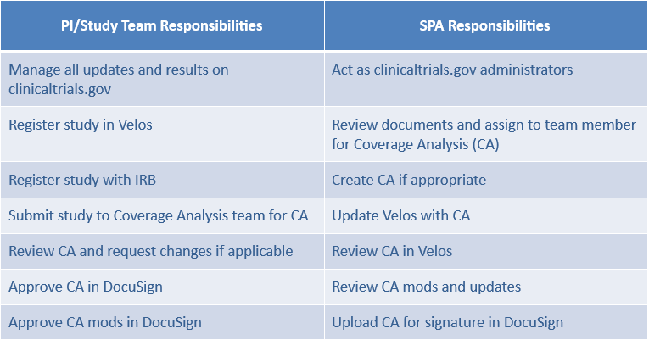

- Industry Agreements
- Industry Clinical Trials Agreement Group reviews and negotiates terms of industry contracts between UTSW and for-profit companies
- Clinical Trial Agreements, Master Clinical Trial Agreements, Amendments, Confidentiality Agreements, Treatment Use Agreements, Clinical Trial Subcontracts, EpicCare Link Agreements and Study Payment Agreements
- Study Team initiates study in Velos, then submits agreement into eAgreements, then SPA reviews and executes agreement
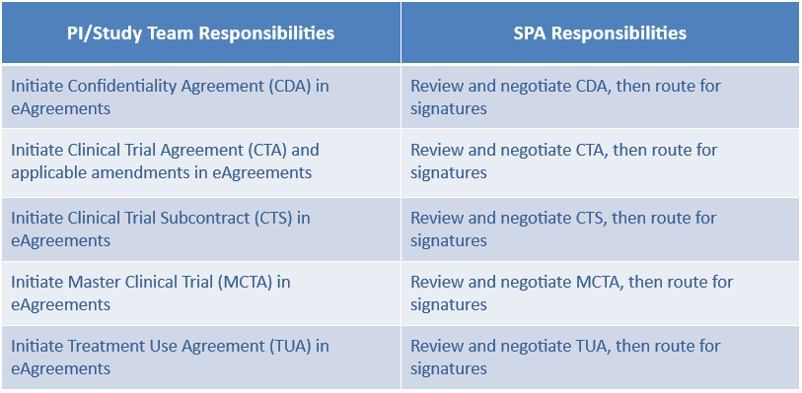

- Accessing systems used for Clinical Research Services
- Complete eResearch Access Request to gain access to: eAgreements, Velos, eIRB/eCOI/eOAE, PeopleSoft
- Submit request to ServiceDesk@UTSouthwestern.edu for access to ClinicalTrials.gov

- Getting Help
- SPA staff responds to tickets in ServiceNow: SPAOutreach@utsouthwestern.edu

