Module J: Financial Reporting and Award Closeout
Outline

- Post Award
- “Post Award” refers to acceptance, management and closeout of an award, as illustrated below:
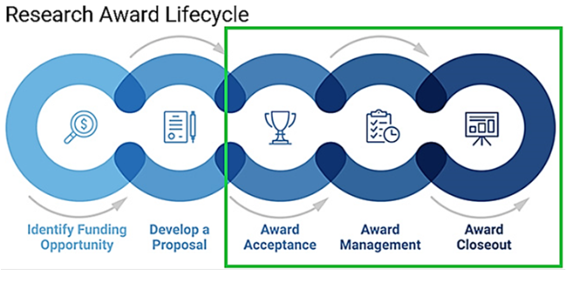
- SPA Financial Reporting Team is responsible for creation and submission of financial reports, providing backup support details and completing Personnel Level of Effort forms
- SPA Award Closeout Team performs the necessary steps to close out projects and associated charts of accounts
- Principal Investigators (PIs) manage the research and are responsible for ensuring granted research funds are spent appropriately for each project

- Financial Report creation and submission to Sponsor
- Successful submission of financial reports requires commitment of both SPA and research department staff. Report frequency is as follows:
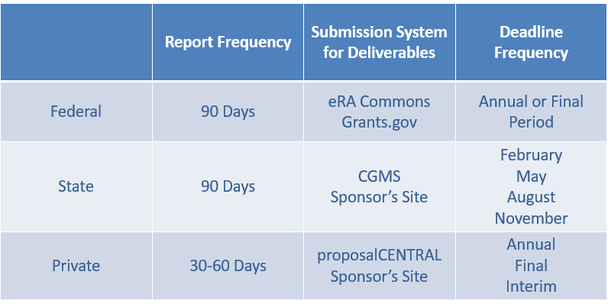

- Managing Financial Reports
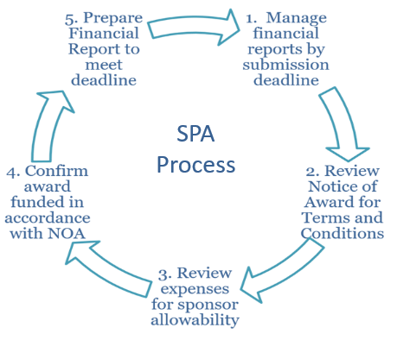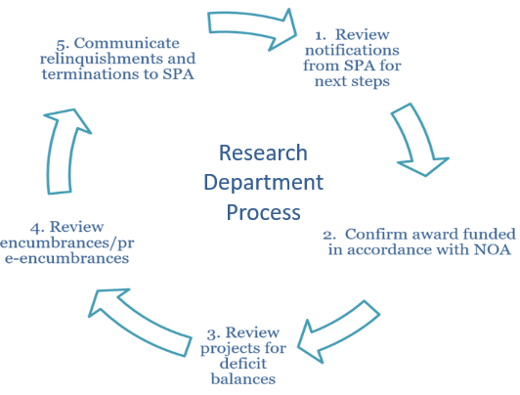
- Deliverable Notifications
- 60 days prior to award end date, a notification will generate from PeopleSoft to the PI and designated departmental staff which will outline important action steps
- 15 days after the award end date, a second notification will generate which will outline the next set of action steps to be achieved in 30 days in preparation for closeout
- Transactions reviewed by SPA to ensure compliance
- Non-Salary Cost transfer – an expense that is transferred from one account to another after expense was initially recorded in UTSW financial accounting system
- Salary Cost transfer/Direct Retro – prior period specific re-sourcing of selected salary related expenses
- Budget Retro – prior period Manager Self-Service Change Funding that changes sourcing for a group of salary-related expenses in one transaction
- Award Closeout
- Award Closeout requires multiple financial management steps, including clearing encumbrances, detailed in the Accounting and Fiscal Services Guidelines

- Accessing systems used for Proposal and Report Submission
- SPA website includes research system resources for eGrants and Peoplesoft
- Complete eResearch Access Request to gain access to eGrants
- Report submission may require multiple account logins on different systems, depending on the Sponsor’s preference
- Complete eRA Commons User Account Request Form to generate a user ID for NIH eRA Commons

- Getting Help
- SPA staff responds to tickets in ServiceNow: SPAOutreach@utsouthwestern.edu

