Module I: Revenue Cycle and Cash Management
Outline

- Post Award
- “Post Award” refers to acceptance, management and closeout of an award
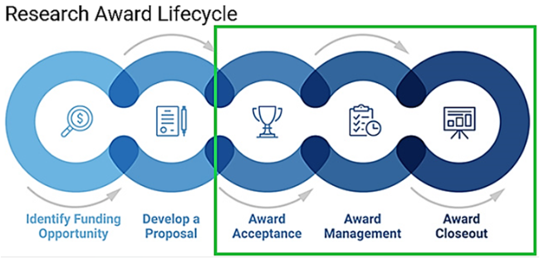
- Principal Investigators (PIs) and Research administrative staff are jointly responsible for providing appropriate and compliant stewardship of sponsored funds.
- SPA Award Maintenance Team manages award maintenance and modification functions which include: billing, invoicing and recognizing revenue for the award
- SPA Cash Management Team manages federal draw activities and performs treasury tasks
- PI/Departmental Staff are responsible for entering payroll and nonpayroll transactions timely, reviewing expenditures, ensuring OPA number appears on submitted invoices and carbon copying SPA-Remit@utsouthwestern.edu when submitting invoices to sponsors for clinical trials

- Cost Principles
- Anyone authorizing expenditure of federal funds must understand cost principles. Any cost charged to a sponsor must satisfy the following criteria:
- Allowable
- Allocable
- Reasonable
- Consistently treated

- Receiving Funding and Department Spending
- SPA is responsible for billing contracts or awards related to Sponsored Research, Service, and Clinical Trial Agreements. Each type of award has a unique setup in the way expenses are billed and the revenue is recognized:
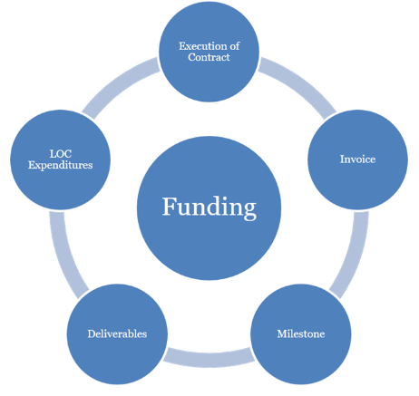
- Execution of contract –full budget granted during award setup
- Sponsor requires invoice – full budget granted at award setup and invoices submitted for reimbursement
- Sponsor requires notification of completed milestones – budget setup according to receipt of startup payment
- Sponsor requires deliverables – budget is setup according to receipt of startup payment
- Letter of credit awards – allow expenditures to be incurred in order to draw down funds

- Accessing systems and guidance for Proposal Submission
- SPA website includes research system resources for eGrants and Peoplesoft
- Complete eResearch Access Request to gain access to eGrants
- Uniform Guidance as established by The Office of Management and Budget

- Getting Help
- SPA staff responds to tickets in ServiceNow: SPAOutreach@utsouthwestern.edu

