Module H: Award Maintenance
Outline

- Post Award Maintenance and Modifications
- “Post Award” refers to acceptance, management and close out of an award granted by a funding agency
- The SPA Award Maintenance team is responsible for managing award maintenance functions during award lifecycle that comply with federal cost principles
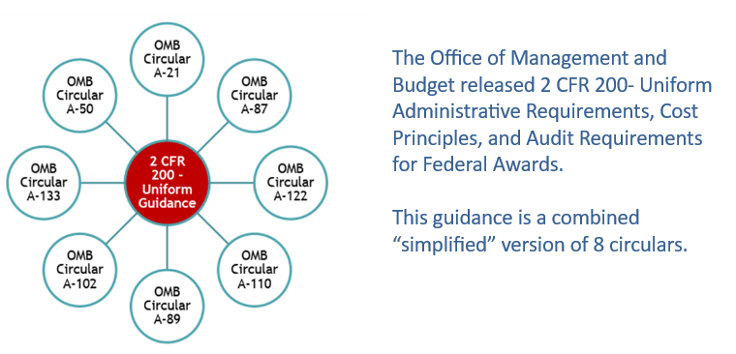
- Cost Principles: allowable, allocable, reasonable and consistently treated per institutional guidelines
- Direct Costs are specifically attributed to sponsored project
- Indirect Costs are incurred for common objectives and charged to project based on expenditures (F&A)
- Non-federal Sponsors define allowable and un-allowable costs differently than federal Sponsors
- Departmental Monthly Monitoring may reveal the need to request one or more of the following:
- Non-Salary Cost Transfers
- Direct Retro/Salary Cost Transfer requests which should be made immediately
- Budget Retros (MSS) which require Change Funding Form
- Award Modification
- Award Modifications must be recorded in eGrants under the “Awarded” tab before reflecting in PeopleSoft
- Modification can be triggered by: any change to the Terms and Conditions listed in the Notice of Award (NOA), Re-budget, No Cost Extension, Carry Forward, Key Personnel Change, Sponsor Change, Adding/Changing Subrecipients, or Decrease in Project Activity

- Distribution of Responsibilities
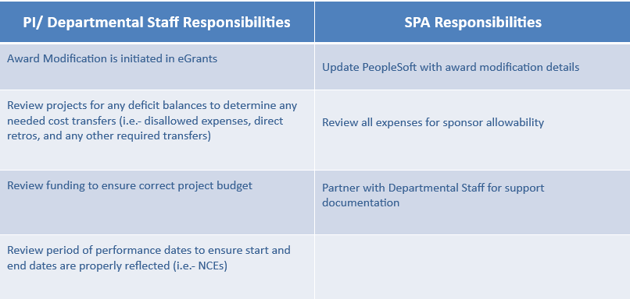

- Systems and Access
- Internal systems utilized include eGrants and PeopleSoft
- To gain access, complete eResearch Access Request Form
- External resources: NIH eRA Commons User Account Request Form and OMB Uniform Guidance

- Getting Help
- SPA staff responds to tickets in ServiceNow: SPAOutreach@utsouthwestern.edu

