Module G: Award Acceptance
Outline

- Post Award Overview
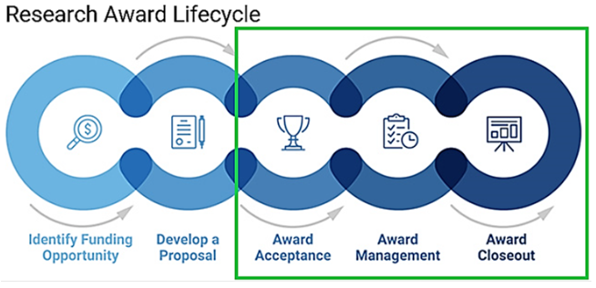
- SPA is authorized to accept awards and agreements for sponsored projects on behalf of UTSW. Any document requiring authorized representative signature undergoes SPA review.
- The Principal Investigator is responsible for managing the research, confirming project personnel, and ensuring funds are spent appropriately.

- Intake and Acceptance of Grant Agreement
- Award intake may begin after SPA receives the NOA (Notice of Award)
- The NOA is the official grant award document and will contain information regarding the amount of funds, period of performance and scope of work
- Each Sponsor will have their own NOA template, typically including unique identifiers and application type codes
- If the PI receives the NOA directly, please promptly forward to SPA
- SPA’s Award Setup Team manages the award intake process by:
- classifying and assigning the award for setup according to activity type, sponsor type, award type, and complexity
- Award mechanisms include grants, contracts and agreements
- Award types include Direct 1:1 and Flow Through Awards
- setting up the award
- communicating with the PI/Department through the GNR (Grant Notification Report)
- performing quality assurance by reviewing select awards
- Grant Agreement Award Workflow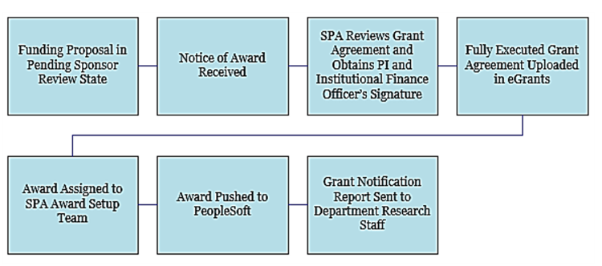

- Advance Accounts
- Advance Accounts allow PIs to begin spending on research awards prior to receiving an official NOA or fully executed agreement
- PI/Department can initiate Request Advance Account activity in eGrants (Note: this can only be requested when award is in Pending Sponsor Review status)
- Charges must be within the project period, in accordance with applicable regulations, provide direct benefit to the project, compliant with institutional polices, and included in the budget

- Accessing systems used for Proposal Submission
- Research system resources can be found on the SPA website
- Systems used for award setup, management and closeout include:
- eGrants (which requires completion of eResearch Access Request)
- Peoplesoft
- Auto-populates the GNR and contains the Chart of Accounts (COA)
- NIH eRA Commons (click here to fill out the user account request)
- Enterprise Data Warehouse EDW

- Getting Help
- SPA staff responds to tickets in ServiceNow: SPAOutreach@utsouthwestern.edu

