Module B: Non-Industry Agreements
Outline

- Non-Industry Agreements Team
- SPA Pre-Award is comprised of the Proposal Team and the Non-Industry Agreements Team; these teams audit budgets to ensure costs are reasonable, allocable and allowable. Additionally, the teams review and process award modifications and progress reports.
- Distribution of Responsibilities
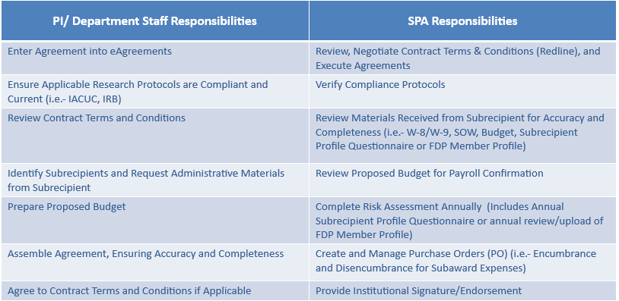

- Routing of Non-Industry Agreements
- The Non-Industry Agreements Team process Subawards, Flow Through Agreements, Research Service Agreements, Grant Award Agreements, Non-Industry Clinical Trial Agreements
- Distinctions to Keep in Mind
- Sub-Recipient vs. Vendor/Contractor
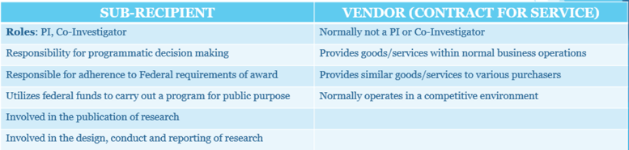
- UTSW is responsible for monitoring the programmatic and financial activities of its Subrecipients to ensure proper stewardship of Sponsor funds and adherence to Uniform Guidance. PI/Department request Subrecipient Organization Information so SPA can assign a Risk Rating. PI/Department then monitor each Subaward throughout period of performance.
- Flow Through Agreements must be entered into eGrants before entering in eAgreements and require a Notice of Award, Budget/Justification, and Statement of Work
- Subaward proposal must be entered in eGrants and in “Awarded” state before entering in eAgreements, and require a Notice of Award, Budget/Justification, Subrecipient Questionnaire, Subrecipient W-9 (W-8 if foreign), and a Statement of Work
- F&A Rates as of 9/1/19: 63% Federal; 26% Federal Off Campus; 40% Other Sponsored Activities; 8% Federal Foreign; 10% Federal De Minimis Rate; (Refer to Sponsor Guidelines for State, Private and Foundation Sponsors)
- Process Workflow
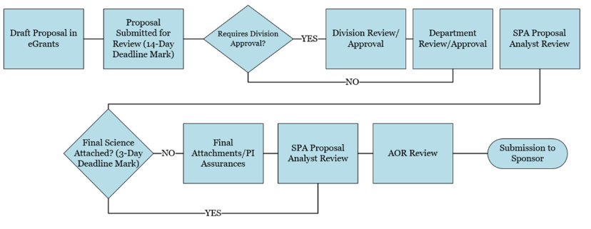

- Accessing systems used for Non-Industry Agreements
- Complete eResearch Access Request to gain access to: eAgreements and eGrants
- Contracts and Agreements Pathfinder (CAP) assists users with properly routing agreements to correct department

- Getting Help
- UTSW is a member of The Federal Demonstration Partnership (FDP)
- SPA staff responds to tickets in ServiceNow: SPAOutreach@utsouthwestern.edu

