Module A: Proposal Submission & Pre-Award Essentials
Outline

- Research Administration
- Successful Research Administration requires collaboration among multiple teams and departments across campus. Key players include:
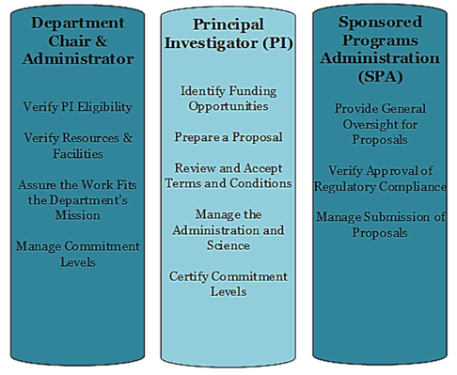
- UTSW policy requires the PI on a grant must have a faculty designation, and a measurable level of commitment between .1cm and 12cm. The exception is for fellowships, development grants or any funding mechanism that requires a faculty mentor.
- The SPA Pre Award team is comprised of proposal analysts and non-industry contract specialists. The team reviews all proposals to ensure compliance with guidelines, and reviews budgets to ensure proposed costs are reasonable, allocable and allowable.

- Pre Award and Proposal Submission
- “Pre Award” refers to identification of a funding opportunity, development of a proposal, and submission to Sponsor
- Proposal Submission Guidance
- Successful submission of a proposal requires adherence to a concise schedule:
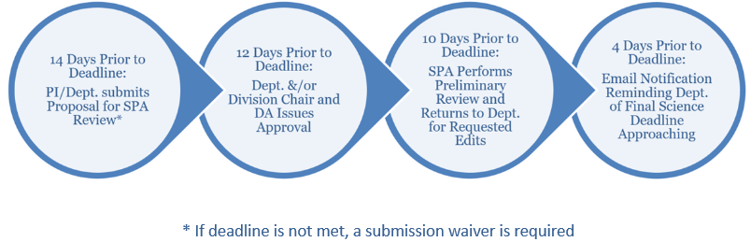
- Administrative components due to SPA 14 days in advance of deadline include: budgetary information, Sponsor information, and compliance approval confirmations.
- Defined Science Components of the proposal are due to SPA 3 days in advance of the deadline.
- Awards must be categorized correctly in eGrants prior to submission. Award types are Direct 1:1, Flow Through, and Sub Award.
- For assistance determining whether the on-campus or off-campus F&A rate should be applied, access to the indirect cost matrix and additional tips, visit the SPA website and select the Institutional Fact Sheet tab.

- NIH Just-In-Time (JIT)
- JIT is a request to the PI for additional information before making a final funding decision; this is not a notice of award, nor should applicants submit JIT information until a formal request is received from NIH
- Departments should notify SPA of JIT Response by uploading all information in eGrants, then the SPA proposal analyst will review for submission by SPA AOR

- Pre Award Systems Used and Gaining Access
- Internal systems used during the Pre Award phase include: eGrants, eAgreements and eIRB/eCOI/eOAE
- To obtain access to the eResearch Suite, complete the eResearch Access Request by clicking here or visiting the SPA website
- Depending on the grant type, some proposals will be initiated, routed and submitted via eGrants; others will make use of eAgreements or utilize an existing funding proposal:
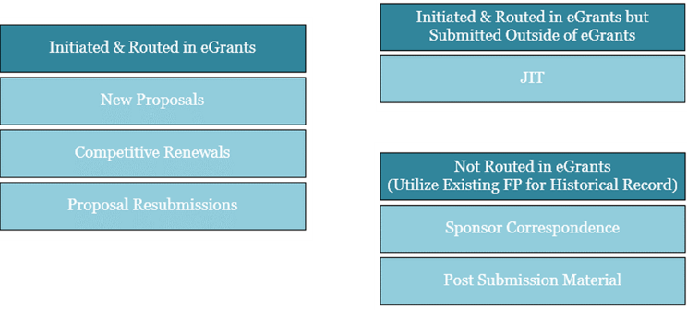
- External systems may include NIH eRA Commons or any other system listed on the Sponsor’s login request page
- The Access Request form for NIH can be found here or on the SPA website

- Getting Help
- SPA staff responds to tickets in ServiceNow: SPAOutreach@utsouthwestern.edu

