Scheduler Use

AIRC Scheduling Policies Link:

AIRC Scheduling System Account Link: https://swlxaircapp.swmed.org/new/newAccount.pl

AIRC Scheduling System Link: (Inside UTSW) https://swlxaircapp.swmed.org/scanPlan.html

(Outside UTSW) https://swlxaircweb.swmed.edu/scanPlan.html

The first time you enter the scheduler from your browser, you must provide your assigned username and password. Subsequent entry from the same invocation of the browser will not require authentication - the browser will remember your username. As present, no browser provides a method for "logging out". If you need to enter the system under a different login name, exit and restart your browser.

Weekly Schedule

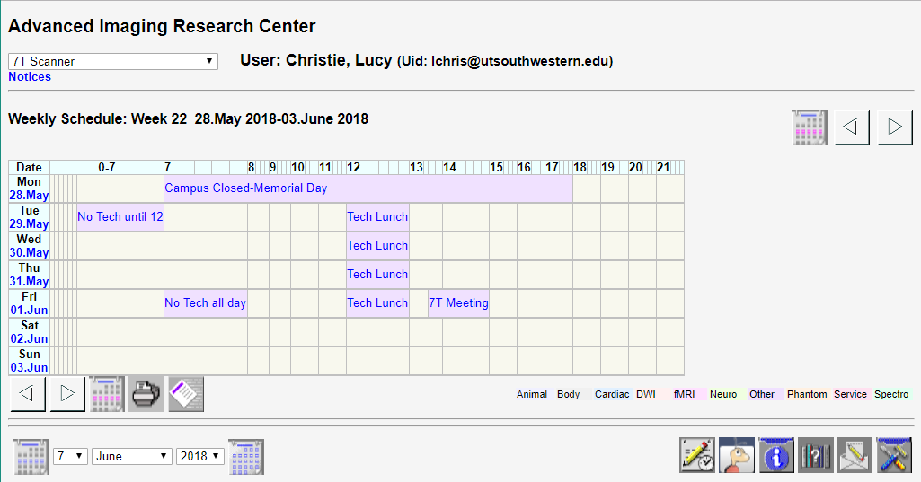

The initial display is the Weekly Schedule. The top of this screen is a header with a pull down menu that permits selection of the scanner to be displayed and scheduled, and your full name and user ID (Uid). The scanner currently selected appears in the pull down menu box. Click on the box and scroll to another scanner to select it for display and scheduling. The system remembers the last scanner you worked on between scheduling sessions using a browser cookie. Make sure you have cookies enabled in your browser. At the bottom of the header, current notices are displayed set by site administrators from time to time. Click on the word "Notices" to display a pop-up with more info on the notices as well as older notices.

Below the header, the schedule for the current week is displayed. The top line shows the week number and range of dates shown. Week numbers start at 1 for the first full week of the year. On the right, 2 or 3 navigation buttons are displayed.

The arrows move one week back or forward in time.

If the calendar icon is shown, clicking it will move you to the current week. It's not displayed if you are in the current week.

A time scale is displayed across the top of the schedule; early morning hours at the start of the day and late hours at the end of the day may be eliminated if there are no scans for the week during those times.

Next, starting with Monday, several rows are displayed for each day of the week. The day and date are shown on the left - click on the date to schedule a scan for that date. To the right, the first row displays any scheduled scans in the proper relation to the time scale at the top. Each scan shows the owner's username (blurred on the example) and the text entered in the scan description field. Click on the username or description text to get information on that scan.

This row is repeated for each day of the week.

Below that schedule display the navigation buttons are repeated for convenience. They have the same functions as the ones at the top.

Next is a printer icon that generates a printable version of the schedule and runs the browser print function. The printable version of the schedule appears in a pop-up window followed by a printer selection dialog generated by the browser to select the destination printer. Close the printable schedule after printing.

This last icon generates a list of all scans you have scheduled. If you are a principal investigator, it will list all scans scheduled for any of your protocols, regardless of who scheduled them.

To the right of this is a key to the colors used for identifying the scan types. For example:
Body | Cardiac | GE Dev | Neuro | Other | Sedation | Service | Spectro

Footer

A footer is located at the bottom of all scheduling system pages.
On the left there are day, month and year pull down menus with 2 icons.

Select any day, month and year and press the left calendar icon to jump directly to the Weekly Schedule containing that date.

Select any month and year and then press the right calendar icon to jump directly to the Monthly Schedule for that date.

On the right side of the footer there are more icons.

Jump into Week's Schedule for the most recent date used.

Jump into Scanner Login for the current date. Shown only if the Login feature is in use.

Open window with Scanner Log for reporting Scheduling System or Scanner Problems.

Modify User Profile including your password, personal information (phone number, fax number and mailing address). Your name, email address and sites can be changed or corrected only by one of the administrators.

Display the help page you are now reading.

Send email to the technologists for arranging alternate tech coverage or for issues related to scanning. Or send email to or get phone number of other users of the scheduling system in order to request scan time changes or other issues.

Below these buttons, an information line the gives the current date and time, the program name and a link to the system administrator for use in reporting problems with the scheduling system.

New Scan Entry

From the Weekly Schedule click on the desired date in the left column of the schedule to go to the Scan Input Form. From the Daily Schedule use the schedule icon below the day's schedule. The Scan Entry Form will appear.

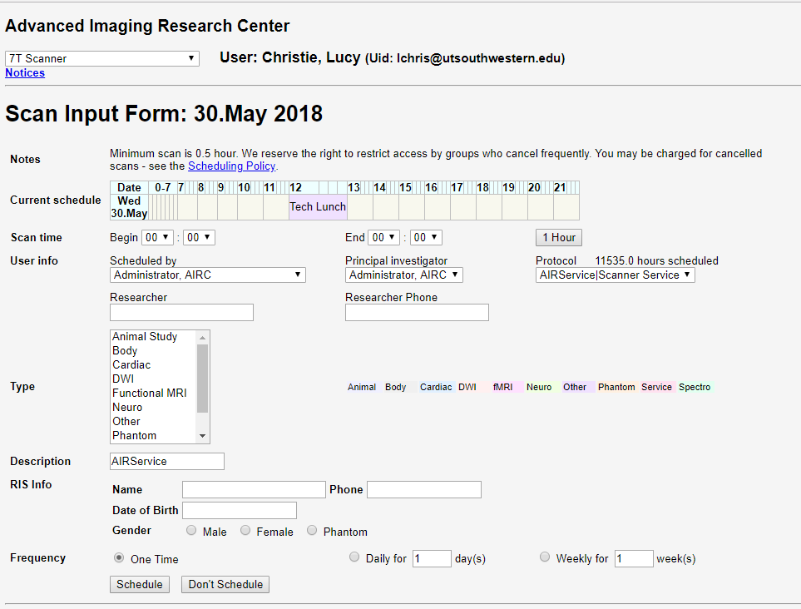

The first row of the form, "Notes" reminds you of some scheduling policies. Only scans that do not overlap dates already scheduled are accepted. The "Current Dates" row shows scans scheduled for the date selected. Next the "Restrictions" row shows scheduling restrictions for the selected date as described elsewhere.

The "Scan Time" row of the form is used to set the beginning and ending time of the scan. All times are typically entered on even 15 minutes periods (:00 :15 :30 :45); scan length must be at least 1 hour (see your site's policy for actual intervals). You cannot schedule a scan which crosses dates - schedule one scan up to 24:00 and a second the next day starting at 00:00.

The next row shows your username that will be set as the owner of the scan. (A person with superuser privilege will see the list of all usernames and can select anyone as owner of the scan.) Next to the username is a pull down list for selecting the Principal Investigator followed by one for selecting the Protocol. Only PIs you are authorized to schedule for will be shown. The protocols listed are only those belonging to the PI shown.

A line of Budget information follows the User info. A pull down list contains budgets previously entered. The Contact person, phone number and address can be changed if corrections are needed. In most cases, none of the fields can be left blank. Protocols can be set up by the administrator to allow budget information to be left blank in cases where this information never changes. Select the "New" choice in the Budget pull down to enter information on a new budget. The information provided here will be used for billing your scan time. Make sure it is correct.

A pull down menu for the type of scan follows. The default setting is "Other". A proper setting for this entry assists us in determining scanner usage patterns. If the time period is restricted by scan type, you must set this to match the restricted type AND you must be privileged to use this type of restriction.

A field follows for free text to describe the scan. Remember!! all authorized users can view this field so use patient names and other identifying information only when appropriate. A second free text field is provided next labeled Subject/ID. Use of this field is optional and is not displayed to anyone except the owner of the scan.

Finally the "Frequency" field allows the scan described by the other parameters to be repeated daily or weekly for a selected number of times. Both are limited to 50 repetitions. The default is to schedule the scan for one time on the selected date.

When all parameters are set, press the "Schedule Scan(s)" button to actually schedule the scan or repeated scans.

If you attempt to
- schedule a scan that overlaps another scan
- schedule into a restricted time period you do not have privilege to use
- schedule outside tech coverage time and you are not permitted to do so

you will receive a "Permission Denied" message with an explanation. If the scan is accepted, you will receive a "Request Entered" message. If you were scheduling multiple scans using the daily or weekly repeat capability, messages will be generated for each scan. A summary will indicate how many scans were actually scheduled and how many failed.

Scan Information

Click the owner name or description of a scan in the Weekly Schedule or Daily Schedule to enter the Scan Information page. The top of this page shows all information entered for the scan, except the Subject/ID field if you are not the owner or PI.

Reschedule and Cancel

If you are the owner or principal investigator of the scan, and the scan date and time is not past, the Reschedule Scan and Cancel Scan sections follow.

The Reschedule Scan section contain a single button that can be pressed to change the scan date and time or modify any information entered for the scan. After pressing the button, the scan is canceled from the schedule and all scan info is stored in a browser cookie. Move to the date of reschedule and enter the Scan Entry Form by clicking the date (Weekly Schedule) or clicking the schedule icon (Daily Schedule). Move to the bottom of the window and press the Reschedule button. This button only appears if you have just previously used the Reschedule button on a Scan Information page. All info from that scan will fill in the blanks on the Scan Entry form. You can make changes to the time or correct any info fields and then press the Schedule button. Note that since a cookie is used to save the information, you must have cookies enabled in your browser for this to work.

The Cancel Scan section contains a text field labeled Reason and a button labeled Cancel. Enter the reason for canceling and press the button to cancel the scan. The cancellation will be logged and a page is displayedverifying the cancellation. If the time remaining until the scan date/time is less than the that permitted by cancellation policy, you will be warned that you may be charged for this scan even though you cancel and do not use the time. Different policies exist for each site.

Monthly Schedule

The Monthly Schedule is accessed using the month and year pull down menus and calendar button at the bottom of every scheduling system page. The month and year being displayed appears at the top followed by a calendar for that month.

The leftmost column (labeled "Wk") on the calendar shows the week numbers for each week in the month. Click on these to jump to the Weekly Schedule » for that week.

The remaining columns of the calendar show the days of the month ordered Monday through Sunday. Click on any day for the Daily Schedule » for that day.

Left and right navigation arrows below the calendar allow you to move backward or forward one month.

The standard footer » is displayed at the bottom allowing you to navigate by month and year, and includes the icons for jumping to the current week, editing your info, getting help and sending email.

Daily Schedule

The Daily Schedule is reached from the Monthly Schedule by clicking on a date on the month's calendar. The page displays the date and the list of scans currently scheduled for that date. Clicking on the owner name of a scan displays information for that scan ».

Below the scan list there are 3 or 4 icons. Click leftmost icon to schedule » a new exam on this date.

Left and right navigation arrows below the calendar allow you to move backward or forward one day. If you are not displaying today's schedule, a calendar icon is displayed that will jump you directly to today's schedule.

The standard footer » is displayed at the bottom allowing you to navigate by month and year, and includes the icons for jumping to the current week, editing your info, getting help and sending email.

