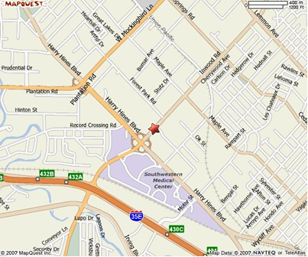

Physical Address:
2201 Inwood Road
Dallas, TX 75390

We are located on the UTSW North campus
in the Clements Imaging Building.
Redfield Street
(WE ARE NOT IN CLEMENTS UNIVERSITY HOSPITAL!)
Valet parking is provided (present ticket to AIRC staff).
Take the Clements Building elevators to the 2nd floor Roger’s MRI. Please check in at the reception desk.

Driving Directions
The Clements Imaging Building is located on Inwood Road at Redfield Street (between Harry Hines Boulevard and Forest Park Road). For more detailed directions, see below or call 214-648-6264. If you need further instructions, please do not hesitate to call 214-645-2726 or 214-645-2738. Español: 214-645-2777
From I-35E, traveling south (from Lewisville/Irving)  - Take exit 432A for Inwood Road/Southwestern Medical Center  - Stay on service road to Inwood Road  - Turn left at Inwood  - Turn left at Redfield Street into the parking area | From I-35E, traveling north (from Duncanville/Lancaster)  - Take exit 432A for Inwood Road/Southwestern Medical Center  - Stay on service road to Inwood Road  - Turn right at Inwood  - Turn left at Redfield Street into the parking area
From US 75/Central Expressway  - Take exit 1A to merge onto TX 366 W/Woodall Rodgers Freeway following signs to I-35E North to Denton  - Take exit 432A for Inwood Road/Southwestern Medical Center  - Stay on service road to Inwood Road  - Turn right at Inwood  - Turn left at Redfield Street into the parking area | From Dallas North Tollway  - Take Mockingbird exit  - Bear right to Mockingbird intersection  - Turn right at Mockingbird  - Follow Mockingbird to Inwood Road  - Turn left at Inwood  - Stay on Inwood until Redfield Street  - Turn right on Redfield Street into the parking area

UTSW Campus Shuttle
Take the orange line or the connector shuttle (from St. Paul Hospital and south campus) to the north campus NC stop. Additional shuttle information: http://www.utsouthwestern.edu/patientcare/patientguide/directions/shuttlesinfo.html

Public Transportation
There is a DART bus stop in front of the north campus. Additional public transportation information: http://www.utsouthwestern.edu/patientcare/patientguide/directions/transitinfo.html

