UT Southwestern Pitch Competition

Request for Proposals | November, 2021

Key Dates

- April 26, 2021: Request for Proposals (RFP) released
- Invention Disclosures Due: June 30, 2021
- July 30, 2021 by 5:00 PM CST: Proposals due
- August 2 to September 24, 2021: Proposals reviewed by selection committee
- October 1, 2021: Finalists selected for Pitch Presentation in November 2021
- November, 2021: UT Southwestern Pitch Competition Day

Table of Contents

About the UT Southwestern Pitch Day Competition 3
Why Participate? 3
Project Eligibility 4

Intellectual Property Requirements 4
Confidential Information 5
Principal Investigator and Team Requirements 5
Application Submission & Evaluation Process 6
- Overview 6
- Proposal Submission 6
- Final Participant Selection 7
- Pitch Presentation 7
General Evaluation Criteria 7
Contact Information 8

About the UT Southwestern Pitch Competition
This second annual UT Southwestern Pitch Competition is an opportunity for UT Southwestern (UTSW) faculty, students and staff to present their startup ideas and interact with leading investors and executives in the Dallas-Fort Worth (DFW) healthcare innovation ecosystem. Anticipated attendees will include entrepreneurs, biotech investors (Angels / VCs), pharma scouts, academic investigators, etc. The competition provides an opportunity to network with mentors and investors to learn about new resources available for entrepreneurs. Through this process, teams receive valuable feedback that can help them strengthen their business model and value proposition and potentially lead them to receive funding.

The UT Southwestern Pitch Competition is intended to showcase early-stage technologies developed at UTSW with strong commercialization potential. UTSW innovators are encouraged to submit their proposals to the Office for Technology Development (OTD) following the submission process outlined in this RFP. Submissions will be reviewed by a committee comprised of OTD members, senior faculty, and industry partners. The review committee will evaluate each submission based on novelty, therapeutic potential, and path to proof-of-concept in a venture-backed startup. Selected presenters will work one-on-one with OTD mentors to further refine their proposal and prepare a 10-minute presentation for UT Southwestern Pitch Competition Day.

About the 2020 UT Southwestern Pitch Competition
UT Southwestern partnered with UT Dallas Capital Factory’s Texas Startups Roadshow for the Big Idea Competition (BIC) in November 2020. Dr. Vinood Mootha, Professor of Ophthalmology was UT Southwestern’s Biotech+s grand prize winner for his presentation, “Oligonucleotide Therapeutic for Fuchs’ Endothelial Corneal Dystrophy.” See more information about Dr. Mootha and last year’s finalists in Appendix A below.

Why Participate?
The UT Southwestern Pitch Competition aims to promote the commercialization of emerging scientific discoveries at UT Southwestern. Participants will gain from the following benefits:
- Win prizes
- Build exposure to investor community (Angels/VCs etc.)
- Strengthen strategic connections
- Earn valuable feedback
- Gain assistance in developing and refining Pitch Decks.
- Refine skills training to engage potential stakeholders (i.e. pitch coaching for investors, early adopters, etc.)
- Obtain professional guidance to refine your commercialization strategy
- Develop commercialization focused milestones

Project Eligibility
The technologies presented at the UTSW Pitch Competition event must have already advanced beyond basic research and have the equivalent of a laboratory-scale proof of concept prior to the application.*

Examples of projects too early for competition | - Basic Science Research  - Research customer demand  - Generate laboratory- scale proof of concept
Examples of projects appropriate competition | - Prototype Development  - Animal studies  - Human clinical data studies  - Complete software coding or user interface development  - Validate markets and customer demand  - Scale up and commercialization
Examples of projects too advanced for competition ** | - Business Development activities  - Beta prototype development  - Deployment of beta prototype to potential customers for testing and evaluation

*Please email businessdevelopment@utsouthwestern.edu for eligibility questions.
**Please email businessdevelopment@utsouthwestern.edu to learn about special events for existing UT Southwestern Startups.

- The UTSW Pitch Competition will showcase milestone-driven projects designed to obtain the proof needed to license the technology to a startup company. Project milestones can be informed by input from mentors at OTD to focus the project on achieving commercially-relevant objectives.

Intellectual Property Requirements
- The technology must be the subject of an invention disclosure filed with the UTSW Office for Technology Development 14 days prior to the proposal deadline.
- If the technology is jointly owned by an academic institution, an inter-institutional agreement (IIA) must be in place before the UTSW Pitch Competition event. The IIA must designate UTSW as having the lead role in commercializing the technology.
- A technology must have intellectual property (IP) protection, defined as patent pending or patent issued, prior to the UTSW Pitch Competition event.
- Copyrighted materials, including software, are eligible if UTSW has the right to commercialize the copyrighted materials via an exclusive license agreement.
- The technology must be available for licensing at the time of Pitch Competition presentation.
        - Intellectual property rights must not be encumbered by any prior obligation, such as an industry sponsored research agreement or collaboration agreement.
        - Technologies under an option agreement in the applicable field of use are NOT eligible to be presented.
        - Technologies under a license agreement in the applicable field of use are NOT eligible to be presented.

Confidential Information
Members of the review committee who will be reviewing the proposals and selecting finalists will be under confidentiality agreements.

Principal Investigator & Team Requirements
- A limit of one (1) proposal submission per Lead or Co-Lead inventor per application cycle.
- Each team will comprise of 2-3 members (including faculty, students or staff)
- Each team should identify an Entrepreneurial Lead (EL). The EL could be any faculty, student, or staff with a deep commitment to the commercialization objectives of the project and be open to receiving coaching and oversight for the preparation of slide decks.

Application Submission & Evaluation Process

- Overview
The UT Southwestern Pitch Competition application process consists of four required stages: an invention disclosure, proposal submission, finalist selection, and pitch presentation. Invention Disclosures for the technology associated with the application must be filed with the Office for Technology Development by June 30, 2021 to be eligible for the November 2021 Pitch Competition. Disclosures are submitted through the businessdevelopment@utsouthwestern.edu.

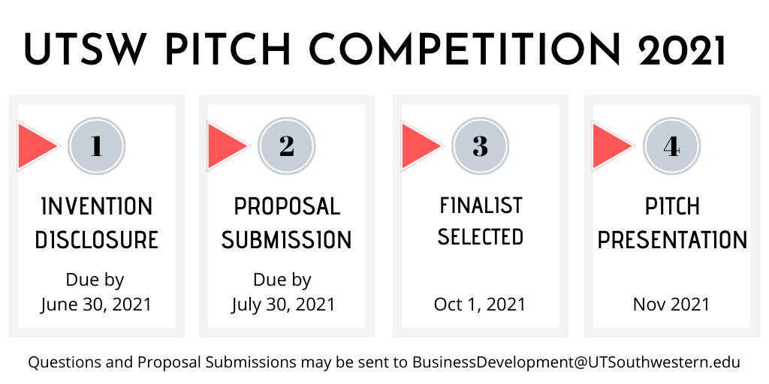

- Proposal Submission
Proposal Submissions are due by close of business on July 30, 2021. Please submit the proposal as a PDF file and email to businessdevelopment@utsouthwestern.edu. The proposal template may be downloaded from the OTD website and should be limited to four pages in length, including cover page and technology funding page. Proposals will first be reviewed for compliance with the competition’s requirements and alignment with the goals of the UTSW Pitch Competition event. Proposals that meet the screening requirements will advance to the review committee. The review committee consists of representatives from the Office for Technology Development, senior faculty, and industry partners.

- Finalist Selection
The proposal review is conducted from August 2, 2021 through September 24, 2021. Invitations to present at the UT Southwestern Pitch Competition event will be sent to the finalists via email during the week of August 10, 2021. Selected finalists will be required to work with designated mentors at OTD to prepare a pitch deck. Proposals that do not advance to the full application phase will receive notification via email and may request a debriefing for feedback on the proposal to guide a resubmission for a future application cycle.

- Pitch Presentation
Finalists will be invited to make a pitch presentation at the UT Southwestern Pitch Competition event in November, 2021. An individual timeslot will be assigned to each finalist. Finalists will prepare a 5-minute pitch of how the proposed project will accelerate the commercialization of the technology, with an additional 5-minutes for questions and answers. Entrepreneurial Leads are required to work with their designated mentors at the Office for Technology Development to prepare for the pitch presentation. Each team is required to present the pitch using a PowerPoint slide deck template that will be provided to the finalists. PowerPoint slide decks must be emailed to businessdevelopment@utsouthwestern.edu at least 48 hours in advance of the assigned timeslot.

General Evaluation Criteria
The proposals will be evaluated on overall potential for technology transfer, including scientific/technical merit, need, and commercial potential of the technology. The following evaluation criteria will be considered during the review process:
- Potential impact and significance for human health and public benefit
- Significant market need and opportunity
- Competitive advantage over technologies that are currently available or in development
- Likelihood of generating high-value intellectual property assets
- Significant de-risking or value inflection point without which the technology is not partnerable.
- Demonstrated interest from potential industry partners
- Innovation and technical/execution risk
- Appropriateness of the research objectives and proposed technical milestones

Contact Information
For additional queries please contact
businessdevelopment@utsouthwestern.edu

Appendix A

UT Southwestern Pitch Competition Finalist

Grand Prize Winner: Dr. Vinod Mootha
Description: We AIM to develop a novel therapy for the Prevention and treatment of Fuchs’ endothelial corneal dystrophy (FECD).
Bio:
Dr. Vinod Mootha earned his medical degree at the Johns Hopkins University School of Medicine and completed a residency in ophthalmology at the University of Wisconsin. He then received advanced training in treating corneal and external eye disease and performing keratorefractive surgery through a fellowship at UT Southwestern Medical Center.
Certified by the American Board of Ophthalmology, he joined the UT Southwestern faculty in 2004. Dr. Mootha is a member of the American Academy of Ophthalmology and the Association for Research in Vision and Ophthalmology, and he is an associate examiner for the American Board of Ophthalmology. He received the Ten-Year Service Award from the Department of Ophthalmology at UT Southwestern in 2015.
Dr. Mootha has delivered scores of national and international presentations, served as principal investigator for several National Institutes of Health-funded research projects, and published numerous academic articles on corneal transplantation and Fuchs’ endothelial corneal dystrophy. His current research aims at developing molecular therapies for FECD in collaboration with a group of expert collaborators.
Industry: Ophthalmology
Stage: Pre-seed
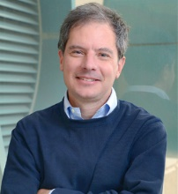
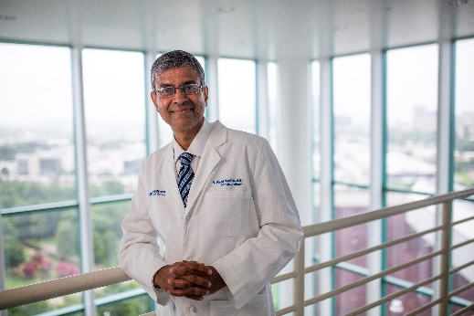

Dr. Vinod Mootha Dr. David Corey

FINALIST- Dr. Bo Li
Description:
We AIM to provide a novel non-invasive test to detect early stage cancers based on the early changes in the human immune system.
Bio:
Dr. Li received his bachelor’s degree in physics from Peking University, China (2009), and developed a fascination with complex, yet highly organized biological systems. He then pursued a PhD degree in Bioinformatics at the University of Michigan, Ann Arbor, under the supervision of Dr. Jun Li. He joined the Dr. Xiaole Shirley Liu lab at Dana-Farber Cancer Institute for a postdoctoral fellowship, where he was jointly supervised by Drs. Shirley Liu and Jun S. Liu at Harvard Department of Statistics. Li’s research interests are in developing novel bioinformatics methods for investigating high-throughput genomics data to understand disease etiology and biological processes, with a particular interest in cancer. In 2017, Li joined UT Southwestern Medical Center to continue his research in cancer genomics and computational cancer immunology.
Industry: Liquid Biopsy
Stage: Pre-Seed

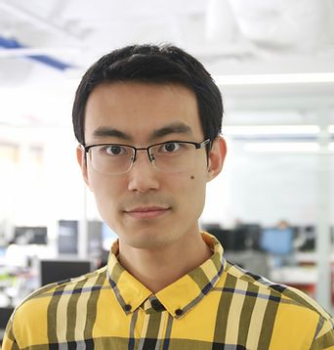
Bo Li, PhD Jayanthi Lea, MD

Finalist Dr. Yang Xie
Description: We AIM to develop a Histology-based Digital (HD) staining method for identification and classification of different types of cells tumor pathology images.
Bio:
Dr. Yang Xie is a Professor and the founding director of the Quantitative Biomedical Research Center at UT Southwestern Medical Center with a joint appointment in the Department of Population and Data Sciences and the Department of Bioinformatics. She holds the Raymond D. and Patsy R. Nasher Distinguished Chair in Cancer Research. Dr. Xie received her medical training from Peking University Health Science Center in 2000 and a PhD in Biostatistics from the University of Minnesota in 2006. Her research focuses on algorithm development, predictive modeling and data integration for precision medicine.
Industry: Histopathology
Stage: Pre-seed

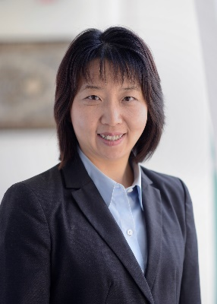
Dr. Yang Xie

Finalist: Dr. Kiyoshi Ariizumi
Description: We AIM to develop an improved immune checkpoint inhibitor therapy
Bio:
Dr. Kiyoshi Ariizumi is a Professor at the Department of Dermatology, UT Southwestern Medical Center, Dallas. He earned his Ph.D. degree and postdoctoral training at the University of Tokyo, Institute of Medicine. For the past 25 years, Dr. Ariizumi’s research focus has been studying the molecular and cellular immunology of antigen presenting cells (or dendritic cells) and T cells relevant to skin diseases and cancer.
Industry: Immunotherapy
Stage: Pre-seed

Dr. Kiyoshi Ariizumi Dr. Ponciano Cruz

