PI Actions in iLab:

See screen shots below
- Accepting users into your lab
- Assigning Chart of Accounts to lab members

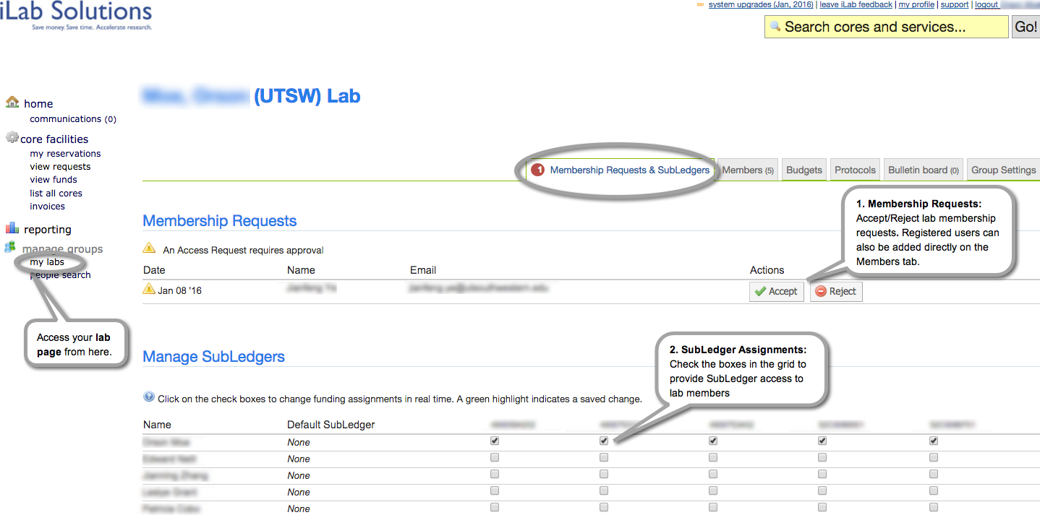

PI Actions in iLab cont:

3) Requesting access to additional Chart of Accounts
4) Hide/Show Chart of Accounts from view/access

​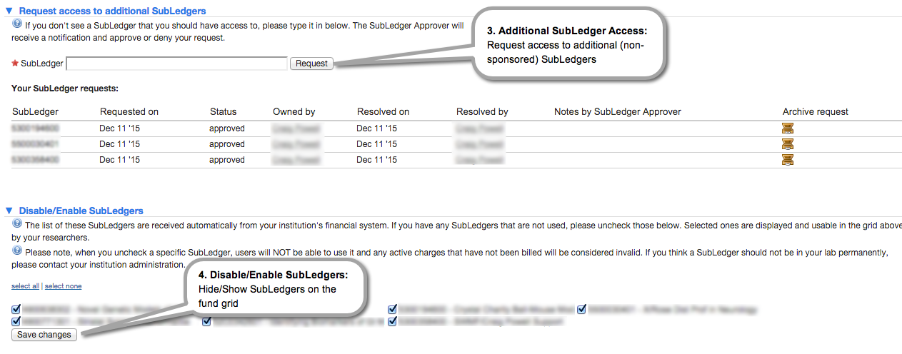

PI Actions in iLab cont:

5) Managing lab members and their rights
6) Managing lab members and their rights
7) Managing lab members and their rights

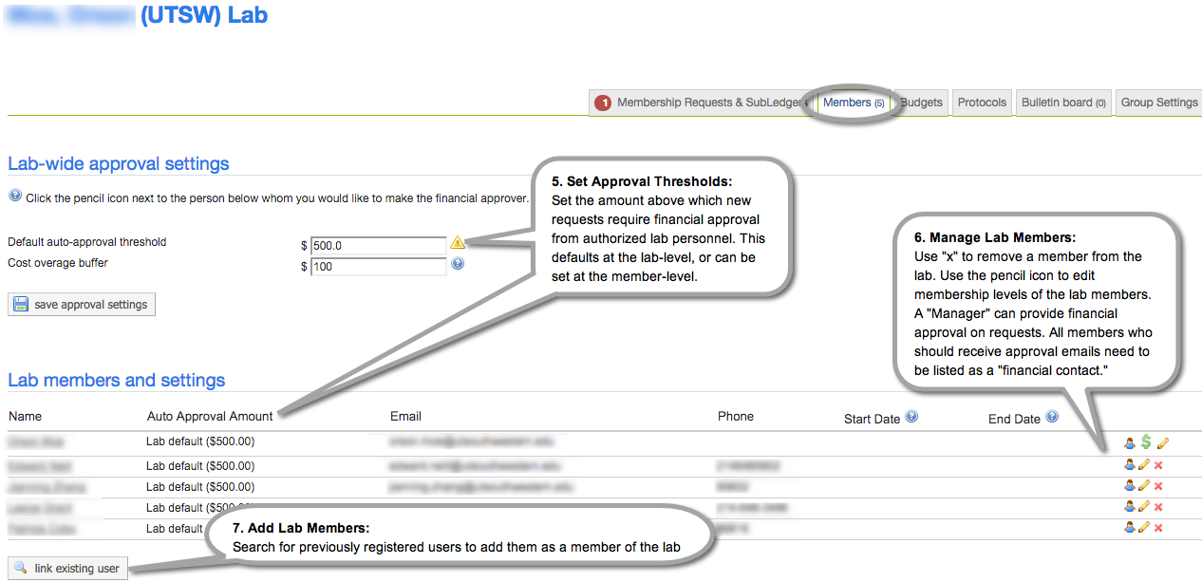

PI Actions in iLab cont:

8) Approving service requests and reviewing/providing payment information
9) Approving service requests and reviewing/providing payment information

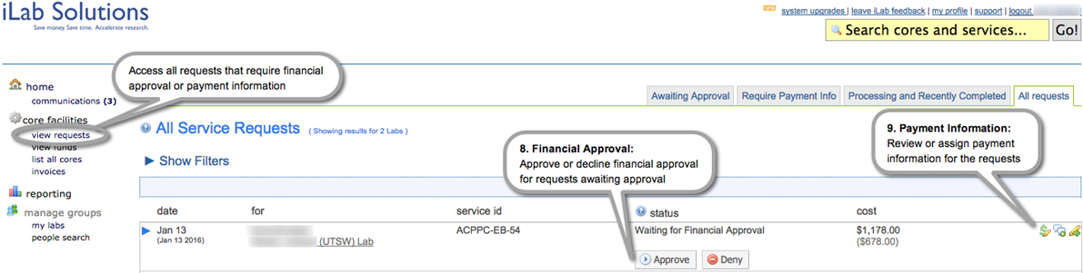

If you would prefer to delegate these notifications and approvals to specific member(s) of your lab, please email support@ilabsolutions.com with their name and email.

Additional help
More detailed instructions are available in the PI Manual. For any questions not addressed in the manual, click on the “leave iLab feedback” link in the upper right hand corner or contact support@ilabsolutions.com.

