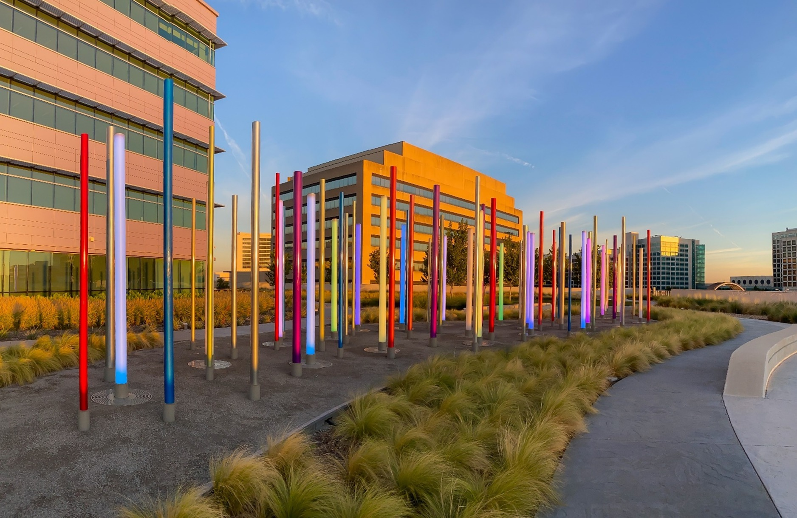

2025 ANNUAL SECURITY AND FIRE SAFETY REPORT
Containing Information for the 2025-2026 Academic Year

Printed copies of this report are available upon request.
To request a printed copy, please contact:

UT Southwestern Medical Center Police Department
Phone: 214-648-8311
University Police Building (BE)
6010 Forest Park Road
Suite 100
Dallas, TX 75235
Table of Contents
Message from the Chief of Police 4
The UT Southwestern Police Department 6
Overview 6
Contact Information 7
How to Report a Crime 7
Daily Crime Log 7
Law Enforcement and Jurisdiction 8
Authority 8
Jurisdiction 8
Working Relationship with Other Law Enforcement Agencies 9
About UT Southwestern Medical Center 9
Mission Statement 9
Our Values 10
Campus Location 12
What Is the Annual Security Report? 13
Compiling the Report 13
Campus Crime Reporting 13
Campus Security Authorities 13
“Blue-Light” Emergency Call Boxes 15
Definitions of Clery-Reportable Geography 15
On-Campus 16
On-Campus Student Housing 16
Public Property 16
Non-Campus 17
Guidance on University-Sponsored Trips 17
Definitions of Clery-Reportable Incidents 17
Primary Criminal Offenses 17
Hate Crimes 18
Violence Against Women Act (VAWA) Offenses 19
Arrests and Disciplinary Actions 20
Hazing Incidents 21
General Definitions 21
Annual Disclosure of Campus Crime Statistics 22
UT Southwestern Medical Center 22
2022-2024 Calendar Year Crime Statistics 22
Crime Prevention Education, Security Awareness, and Community Outreach 24
Crime Prevention Education & Security Awareness 24
Crime Prevention Presentations 24
Crime Prevention Site Surveys 24
Crime Prevention Tips & Guides 25
Other Programs & Resources 25
Sexual Assault Awareness Month 25
UTSW Safety Connection App 25
Personal Safety Escort Service 25
Bicycle & Property Registration 26
SAFE Community Safety Initiative 26
Community Outreach Initiatives 27
National Night Out 27
Trunk or Treat 27
Procedures 28
Timely Warnings 28
Emergency Notification 28
Types of Emergencies 29
Emergency Management and Evacuation Procedures 30
Emergency Response Guide 30
Emergency Tests and Evacuation Drills 30
Security and Access to UT Southwestern Facilities 31
Registered Sex Offender Information 31
UT Southwestern Procedures 31
Public Access to Sex Offender Data 31
New Student and Employee Training 32
Incumbent Student and Employee Training 32
Missing Students 32
Sexual Assault, Domestic Violence, Dating Violence, and Stalking 32
Reporting Domestic Violence, Dating Violence, Sexual Assault, and Stalking to Law Enforcement 32
Reporting Domestic Violence, Dating Violence, Sexual Assault, and Stalking to UT Southwestern (ETH-153 Title IX Sexual Harassment: Formal Grievance Policy) 33
Medical, Mental Health, and Counseling Services for Victims of Domestic Violence, Dating Violence, Sexual Assault, or Stalking 45
Disciplinary Proceedings: Notification of Final Results 46
Policies 47
UTSW PD-418.00 Campus Crime Reporting 47
UTSW PD-113.00 Unusual Occurrences, “All Hazards Plan” 47
EMP-152 Security-Sensitive Positions and Background Checks 47
ETH-151 Equal Opportunity 47
EDU-151 Student Conduct and Discipline 48
SEC-201 Drug-Free Campus 48
SEC-204 Serving Alcohol on Campus 49
SEC-205 Tobacco-Free Environment 49
SEC-156 Violence on Campus 49
SEC-155 Weapons on Campus 51
SEC-101 University Police 51
SEC-154 Reporting of Campus Security Policies and Crime Statistics 51
SEC-153 Badge and Identification Requirements 52
Annual Fire Safety Report 54
Overview 54
Description of Each On-Campus Student Housing Facility Fire Safety System 54
Residence Hall Fire Drills 54
Policy or Rules on Portable Electrical Appliances, Smoking, and Open Flame in Student Housing Facilities 54
Southwestern Medical Park Apartments Instructions on Evacuation in Case of a Fire Alarm or Fire 55
Fire Safety Education and Training 55
Reporting a Fire 55
Improvements in Fire Safety 56
Fire Safety Statistics 2022-2024 56
Higher Education Opportunity Act Annual Fire Safety Report 56
Additional Safety and Business Continuity Resources 57
Title IX 58
Reporting to UT Southwestern 58
Reporting to Law Enforcement 59
Commitment to Privacy and Confidentiality 59
Title IX Coordinator 59
Victim Services 60
SEC-201 DRUG-FREE CAMPUS 61
Appendix A: Information for Students and Employees Regarding Illicit Drugs and Alcohol Abuse 65
Health Risks of Alcohol and Drugs 65
UT Southwestern Penalties 66
Penalties Under State and Federal Law 67
Additional Resources 69
Office of Student Affairs 69
Office of Student Empowerment and Engagement (OSEE) 69
Student Health Services 69
Student Wellness and Counseling 70
UTSW Student Wellness and Counseling Crisis Line 70
Court-Issued Protective Orders 71
Dallas County District Attorney’s Office Resources 71
Campus Map 76
Hotlines 78

*Disclosure: Some links may only be viewable by persons with access to UTSW’s intranet.

Message from the Chief of Police

To the UT Southwestern Medical Center Community:
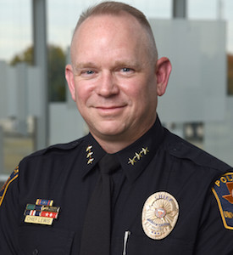
On behalf of all the members of the UT Southwestern Police Department, I want to say, welcome! Our Department’s mission is to proactively protect the people, resources, and infrastructure of UT Southwestern Medical Center so the institution may conduct and provide medical education, health care, and research.

The Annual Security Report contains information regarding law enforcement, public safety, security, and personal safety topics, including, but not limited to, crime prevention, our Department’s law enforcement authority, crime reporting policies, campus disciplinary procedures, and other matters of importance related to campus security.

This report contains information about crime statistics for the three previous calendar years concerning reported crimes that occurred on campus, at certain off-campus buildings, at property owned or controlled by UT Southwestern or The University of Texas System, or on public property immediately adjacent to and accessible from campus. This information is required by law and is provided by UT Southwestern.

The Annual Security Report is available on the UT Southwestern Police Department website at: Annual Security Report: UT Southwestern Police Department.
If you would like a copy of this report, you may stop by the UT Southwestern Police Department, or you can request that a copy be mailed to you by calling 214-648-8311.

Sincerely,

Marcus Lewis
Chief of Police

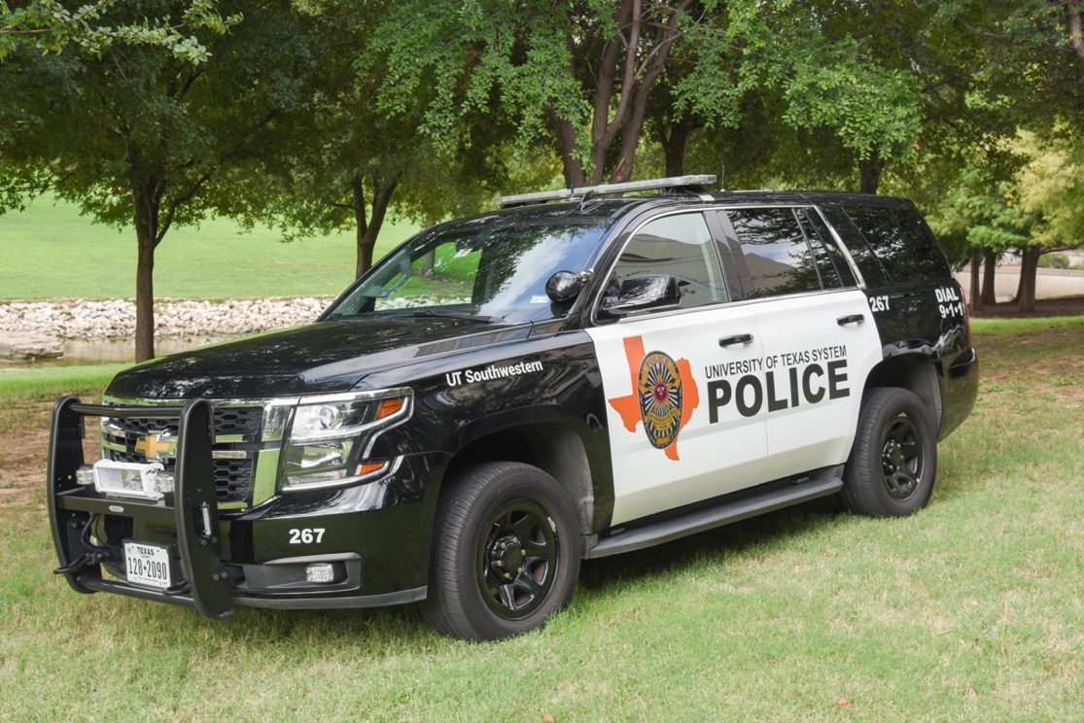
The UT Southwestern Police Department

Overview
The UT Southwestern Police Department is the law enforcement agency that provides security, enforces state and local laws, and takes reports of accidents, offenses, and incidents for the UT Southwestern campus and off-campus properties.
The UT Southwestern Police Department has an authorized strength of:
- 48 law enforcement officers.
- 79 public safety officers.
- 13 police communications operators.
- 16 administrative and civilian staff.

Public safety officers assist law enforcement officers in providing security.
The UT System Board of Regents commissions the Department’s officers per Article 51.203 of the Texas Education Code. The officers are defined as “peace officers” under Article 2.12 of the Texas Code of Criminal Procedure. Therefore, University Police officers have the same authority to detain and arrest as municipal officers and other state officers.
An amendment by the Legislature in 1987 to Section 51.203 of the Texas Education Code extended the jurisdiction of University Police officers to include all counties in which property is owned by, leased by, or otherwise under the control of the UT System.
UT Southwestern Police Department officers have the power and authority to:
- Lawfully stop and detain individuals.
- Lawfully arrest individuals.
- Obtain and/or execute search or arrest warrants.
- Enforce state criminal and traffic laws.
- Issue citations for Class C misdemeanors.

Contact Information
Call 214-648-8911 (88911 from a campus extension) to report emergencies.
Call 214-648-8311 (88311 from a campus extension) to report non-emergencies or request general information.

The UT Southwestern Police Department Dispatch Office operates 24 hours a day, 365 days a year, and can also be contacted by pressing the button on any of the vehicle gate intercoms or emergency call boxes located throughout the campus, which are answered by Parking Services during business hours. All campus elevators are equipped with either call buttons with speakers or small compartments containing telephones that directly connect the caller to the UT Southwestern Police Department Dispatch Office.

How to Report a Crime
UT Southwestern encourages accurate and prompt reporting of all crimes that occur on campus to the
UT Southwestern Police Department, regardless of whether the victim intends to pursue criminal charges. Individuals may report crimes to the UT Southwestern Police Department at one of the phone numbers above or via the Report a Crime form found on the UT Southwestern Police Department webpage. Incidents occurring in other jurisdictions should be reported to the appropriate local law enforcement authority.

Daily Crime Log
The UT Southwestern Police Department maintains a Daily Crime Log in compliance with the requirements of the Jeanne Clery Campus Safety Act (Clery Act). The Daily Crime Log records the date and time each crime was reported, the date and time the crime occurred, the nature of the crime, the general location of the crime, the case number assigned to the report, and the disposition of the case. The Daily Crime Log is ordered sequentially by date rather than by case number, with the most recently reported activity listed first.
The UT Southwestern Police Department assigns case numbers for both criminal and non-criminal incidents that are reported. Only case numbers generated for criminal incidents and alleged criminal incidents reported to the UT Southwestern Police Department that occur within the University’s Clery Act reporting area and the Department’s patrol jurisdiction are included in the Daily Crime Log.
The Daily Crime Log is available 24 hours a day at the UT Southwestern Police Department, 6010 Forest Park Road, Dallas, Texas 75390. The public entrance is just off the front parking lot on the southwestern side of the building. The front desk staff can provide access to the Daily Crime Log immediately upon request.
In accordance with federal law, access to the Daily Crime Log may be temporarily withheld for any of the required data fields if there is clear and convincing evidence that the release of the information would:
- Jeopardize an ongoing investigation.
- Jeopardize the safety of an individual.
- Cause a suspect to flee or evade detection.
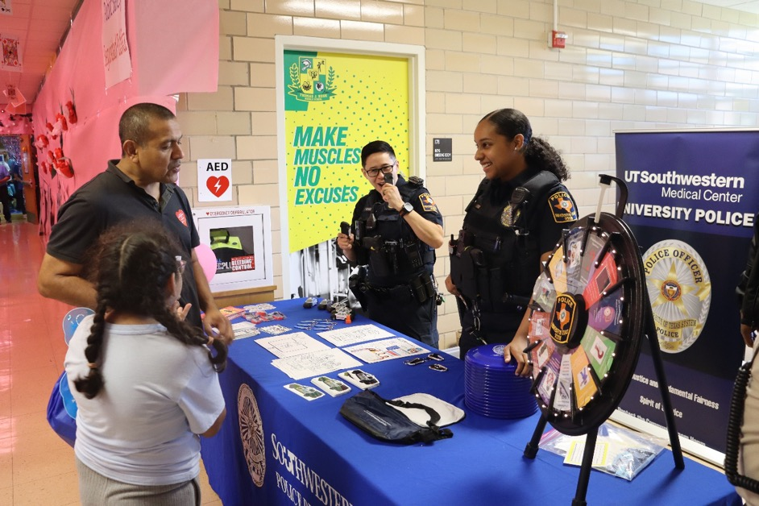
- Result in the destruction of evidence.

Law Enforcement and Jurisdiction

Authority
UT System commissioned police officers, including the police officers at UT Southwestern, are fully empowered by the state to stop vehicles, make arrests, and enforce all laws. The UT Southwestern Police Department has the authority and responsibility to investigate all crimes occurring on property owned or controlled by UT Southwestern.

Jurisdiction
The UT System controls 14 institutions across the state of Texas consisting of over 400,000 students, faculty, and staff.
Under state law, the UT System Police has the authority to operate at full capacity in any county within the state of Texas in which the UT System has property that is owned, leased, rented, or otherwise under its control.
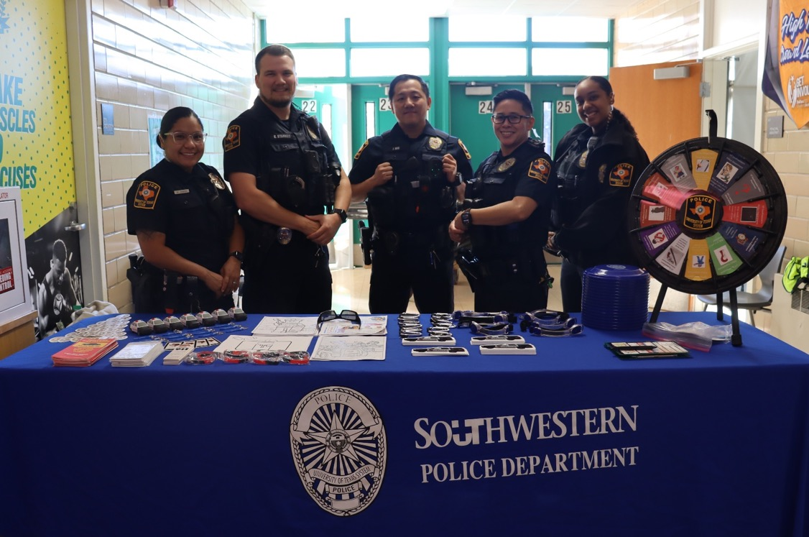

Working Relationship with Other Law Enforcement Agencies
When arrests are anticipated or warrants are to be served outside of their primary jurisdiction, commissioned peace officers shall, if time permits and circumstances warrant, notify and request assistance from the police agency having primary jurisdiction.
The UT Southwestern Police Department and the Dallas Police Department have entered into a Memorandum of Understanding regarding the investigation of alleged criminal offenses.

About UT Southwestern Medical Center

Mission Statement
Promoting health and a healthy society that enables individuals to achieve their full human potential
We:

EDUCATE
Physicians, scientists, and caregivers optimally prepared to serve the needs of patients and society

DISCOVER
Research that solves for unmet needs by finding better treatments, cures, and prevention with a commitment to ensuring real world application
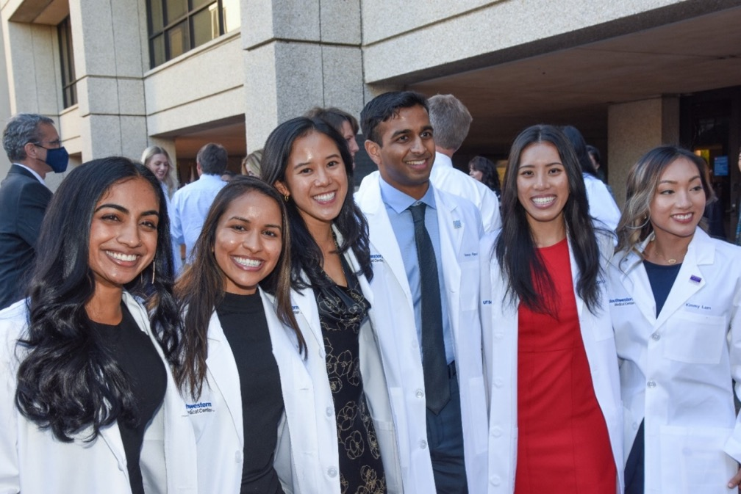
HEAL
Best care possible today, with continuous improvement and innovation for better care tomorrow

Our Values

Excellence
We strive for the highest standards of clinical excellence, educational distinction, research integrity, and administrative quality in all we do. We are rigorous in our commitment to ongoing improvement.

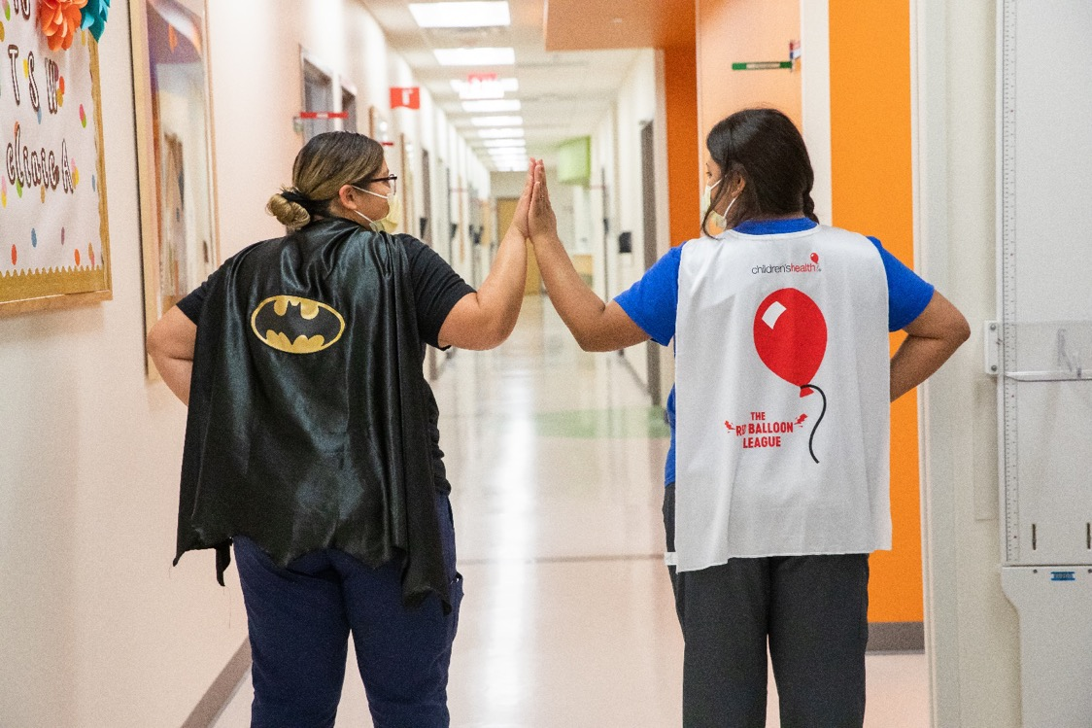

Innovation
We endeavor to develop new knowledge about diseases and treatment, enhance the lives of patients through better care and treatments, creatively approach challenges, and inspire the next generation of physicians, scientists, and health professionals.

Teamwork
We work collaboratively and with a shared purpose, drawing on our diverse backgrounds, talents and ideas, and bringing an unwavering integrity to everything we do.

Compassion
We foster an environment in which patients, visitors, and colleagues are treated with respect, dignity, and kindness in every encounter, every day.

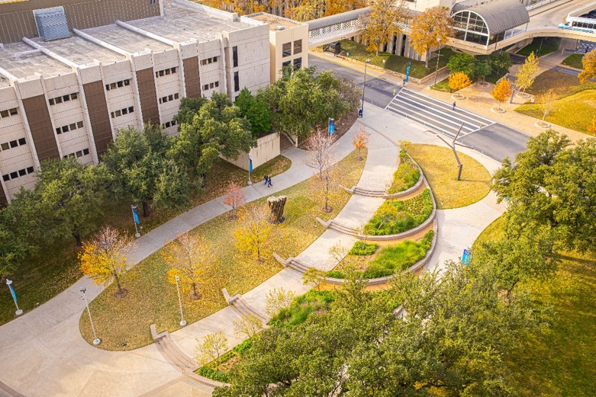
Campus Location
Main Entrance
5323 Harry Hines Blvd.
Dallas, Texas 75390
Phone: 214-648-3111
Campus Map
For Automated Directions:
214-648-6264

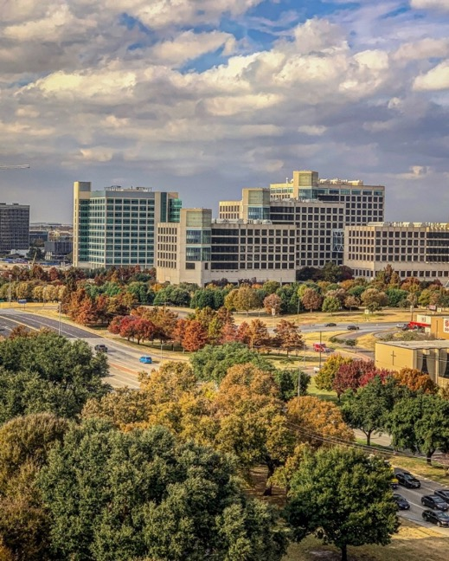
UT Southwestern Medical Center is located in the heart of the Southwestern Medical District – a nearly 400-acre medical complex 10 minutes north of downtown Dallas that incorporates UT Southwestern, Children’s Medical Center Dallas, and Parkland Memorial Hospital. The district is bordered by Mockingbird Lane, Medical District Drive, Interstate 35E (Stemmons Freeway), and Maple Avenue.
Located near the Main Entrance to UT Southwestern on Sen. Kay Bailey Hutchison Drive (opposite Harry Hines Boulevard from Butler Street; see Campus Map), the Visitor Information Booth is staffed on weekdays. It is a convenient resource for visitors arriving on campus.
Located on Dr. Donald Seldin Plaza on South Campus, the Visitor Center is near UT Southwestern’s Main Entrance and is open from 7:30 a.m. to 5 p.m. Monday through Friday.

What Is the Annual Security Report?

Compiling the Report
The Annual Security Report (ASR) contains three years of Clery crime statistics and information about the University, emergency preparedness, crime prevention, policies, and other important information as noted in the Table of Contents on pages 3 and 4. This report complies with the Clery Act using information maintained by the UT Southwestern Police Department, Title IX Coordinators, and Campus Security Authorities, and information provided by local law enforcement agencies surrounding UT Southwestern’s campus locations. This report is a great resource for future and current students, faculty, and the surrounding community.
Each crime reported in this document has occurred in a location directly related to the campus, whether it was on campus property, on a sidewalk on the perimeter of campus, or at an off-campus facility housing a class for UT Southwestern students.
The statistical information in this report allows members of the campus community to be informed about criminal activity occurring on UT Southwestern’s respective properties that have an educational purpose, non-campus properties that are owned or controlled by UT Southwestern, certain public property, and certain non-campus locations.
Unless otherwise noted, updates are issued annually, no later than October 1. All statistics contained in this report are also submitted to the U.S. Department of Education via web-based data collection.

Campus Crime Reporting
UT Southwestern Medical Center is deeply concerned about the safety and security of its students, faculty, staff, and visitors. To this end, the UT Southwestern Police Department will comply with the Clery Act, which requires that colleges and universities publicize campus crime statistics for certain crime incidents. These publicized statistics are meant to warn students, employees, and applicants of the occurrence of campus crime. Students and employees must be given statistics on murder, manslaughter, forcible sex offenses, non-forcible sex offenses, robbery, aggravated assault, burglary, vehicle theft, arson, certain hate crimes, dating violence, domestic violence, stalking, and certain arrests and referrals for disciplinary action. The Annual Security Report must describe how to report crimes and emergencies occurring on campus, as well as the method used to collect data. The purpose of the Clery Act is to educate the campus community about security.

Campus Security Authorities
Campus Security Authorities are designated mandated reporters. They are individuals who, by virtue of their campus responsibilities, are designated to receive potential Clery-reportable crime information and report criminal incidents to the UT Southwestern Police Department so that the incidents can be handled and reported appropriately in the annual disclosure of crime statistics. This also contributes to the distribution of resources to victims of serious crimes and the issuance of Timely Warning notifications to the campus community.

Who Is a Campus Security Authority?
- All UT Southwestern Police Department personnel.
- Any individual who has responsibility for campus security but is not part of the UT Southwestern Police Department. This includes individuals who provide security at campus parking facilities; monitor access into a campus facility; act as event security, such as at sporting events; or escort students around campus after dark.
- Any individual who is specified by the University as someone to whom students should report criminal incidents in addition to police or security-related personnel.
- An official of an institution who has significant responsibility for student and campus activities. An official is defined as any person who has the authority and the duty to take action or respond to particular issues on behalf of the University. Such officials include, but are not limited to:
  - School administrators
  - Student Affairs Deans and staff
  - Director and staff of Student Health Services
  - Human Resources officials
  - Faculty advisers to student groups
  - Title IX Coordinators and staff
  - Faculty and staff who supervise field trips and institution-sponsored events and activities
  - Academic and Peer Counselors
  - Student Support personnel

Exemptions to Campus Security Authority
The Clery Act specifically excludes the following from its reporting requirements:
- Pastoral Counselor – A person who is associated with a religious order or denomination and is recognized by that religious order or denomination as someone who provides confidential counseling within the scope of their position as a Pastoral Counselor.
- Professional Counselor – A person whose official responsibilities include providing mental health counseling to members of the institution’s community and who is functioning within the scope of his or her license or certification.
Pastoral and Professional Counselors who learn about Clery-reportable crimes in the performance of their official duties are not required to report these crimes for inclusion in the Annual Security Report. Per the Clery Act, this exemption is intended to ensure that Pastoral and Professional Counselors can provide appropriate counseling services without an obligation to report crimes they may learn about. This exemption is intended to protect the counselor-client relationship. However, even the legally recognized privileges acknowledge some exemptions, and there may be situations in which counselors are in fact under a legal obligation to report a crime. Furthermore, these employees are encouraged to provide confidential reporting resources to the person they are counseling when a criminal offense is disclosed.

Responsibilities of a Campus Security Authority
Any Campus Security Authority who becomes aware of a crime must report the incident to the UT Southwestern Police Department as soon as possible. This ensures that UT Southwestern issues a Timely Warning, if applicable, and can handle the matter appropriately.
The following information must be reported, if available:
- Details of the incident(s): Information to aid in the classification of the crime and the best course of action to handle the incident from a law enforcement or legal standpoint
- Location, date, and time of the incident
- When the incident was reported
The UT Southwestern Police Department collects and reviews all crime reports from Campus Security Authorities. Campus Security Authorities can report a crime online using the Clery Crime Reporting Form, which can be found on the UT Southwestern Police Department’s website or through normal reporting channels.

Confidential Crime Reporting
Confidential crime reporting is an option for victims of crimes who do not want to disclose their identity or prosecute. The Campus Security Authority who is taking the report shall disclose all information the reporting party is willing to give. The given information will be included in our crime statistics as required. Our crime statistics do not disclose any personal or identifying information.
Anonymous reports can be made through an online Report a Crime Form, which can be found on the UT Southwestern Police Department’s website.
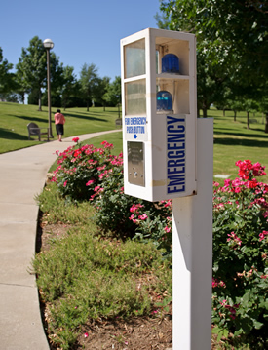

“Blue-Light” Emergency Call Boxes
Emergency phones are located throughout the campus to provide citizens with a means of immediate contact with campus dispatchers. Officers are dispatched and respond to calls from the emergency phones using the same procedures used in any 9-1-1 response.
Security personnel test each emergency phone monthly. Phones that do not function properly are reported to Access Control for repair. The reported phones are then checked to confirm that they have been repaired. The Senior Access Control Manager completes a written needs assessment every three years to evaluate the number and location of call boxes across campus.
Locations for placement of the emergency phones are determined during the development phase for new construction on campus and following the security survey. Contractors for the new construction meet with the Senior Access Control Manager, who provides input on the appropriate number and locations of emergency phones. When activated, each phone provides a unique description of the phone’s location. The University informs the campus community of the emergency phone system through brochures, maps, presentations, and the UT Southwestern Police Department’s website.
Please see page 76 for the “Blue-Light” location map.

Definitions of Clery-Reportable Geography
The Clery Act requires reporting for certain geographical areas, including areas that are considered on-campus, on-campus student housing, public property, and non-campus. The Clery Geography Map is annually updated and maintained by the UT Southwestern Police Department.

On-Campus
The Clery Act determines on-campus property to entail buildings and property that are reasonably contiguous to UT Southwestern’s geographic area in direct support to the institution’s educational purposes, including student housing.
Example:
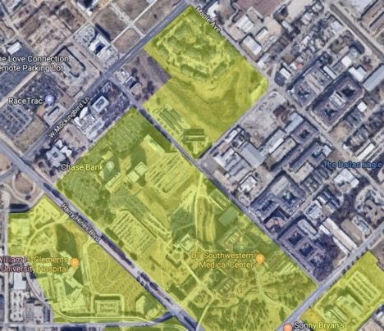
The image to the left depicts on-campus geography for UTSW. The area highlighted in yellow is considered UTSW property.

On-Campus Student Housing
The Clery Act requires the disclosure of incidents that occur in on-campus student housing areas, which would consist of student housing that is owned or controlled by UT Southwestern and is within a reasonably contiguous geographic area that makes up the campus. On-campus student housing is a subset of on-campus crimes. Any incident that occurs at on-campus student housing will also be included in the on-campus incident statistics.
Example:
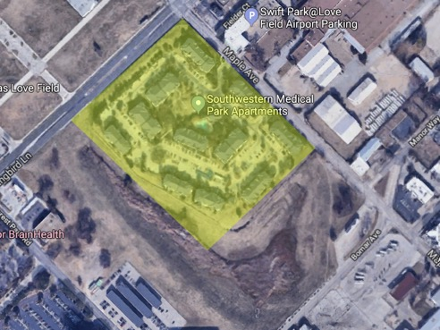
The image to the left depicts on-campus student housing geography for UTSW. The Southwestern Medical Park Apartments, highlighted in yellow, are considered on-campus student housing.

Public Property
The Clery Act requires the disclosure of incidents that occur on public property that immediately borders the UT Southwestern campus and is easily accessible from the campus. This includes sidewalks, streets, and the sidewalk on the other side of the street. Public property can also be within the campus if it is a public road or public bike path that runs through the campus.

Example:
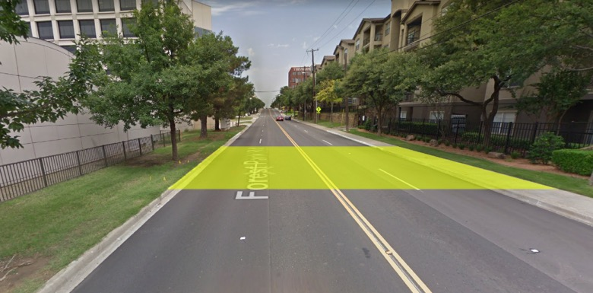
The image to the left depicts public property that is owned by a public entity (city or state government). The area highlighted in yellow is considered public property, and any incidents occurring on public property must be disclosed in accordance with the Clery Act.

Non-Campus
The Clery Act requires the disclosure of incidents that occur on non-campus geography if that space is frequented by students. The property may be rented or leased by UT Southwestern, or there may be some other type of written agreement for use of a building or property, or a portion of the building or property, where UT Southwestern has “control” of that space for a specified period of use. In order to be considered reportable geography for the Clery Act, the space must be used for an organized program of study or directly support educational purposes.

Guidance on University-Sponsored Trips
UT Southwestern Medical Center also obtains crime statistics for locations where University-sponsored groups that are deemed to be under University control either stay more than one night in the particular location or stay one night in the particular location in recurring years.
Every local law enforcement agency with jurisdiction over such locations has received a letter requesting crime statistics per the Clery Act. The letters are customized to meet the needs of each trip. Copies of the letters are on file at the UT Southwestern Police Department.

Definitions of Clery-Reportable Incidents

Primary Criminal Offenses
Murder and Non-Negligent Manslaughter – The willful (non-negligent) killing of one human being by another.
Manslaughter by Negligence – The killing of another person through gross negligence.
Aggravated Assault – An unlawful attack by one person upon another for the purpose of inflicting severe or aggravated bodily injury. This type of assault usually is accompanied by the use of a weapon or by means likely to produce death or great bodily harm. Simple assaults are excluded.
Arson – Any willful or malicious burning or attempt to burn, with or without intent to defraud, a dwelling house, public building, motor vehicle or aircraft, personal property of another, etc. Note that only fires determined through investigation to have been willfully or maliciously set are classified as arson. Arson therefore must be investigated before it can be disclosed. If other Clery Act offenses were committed during the arson incident, the most serious offense is counted in addition to the arson.
Burglary – The unlawful entry of a structure to commit a felony or a theft. Attempted forcible entry is included.
Robbery – The taking of or attempting to take anything of value from the care, custody, or control of a person or persons by force or threat of force or violence and/or by putting the victim in fear.
Motor Vehicle Theft – The theft or attempted theft of a motor vehicle. A motor vehicle is self-propelled and runs on a land surface and not on rails. Motorboats, construction equipment, airplanes, and farming equipment are specifically excluded from this category.
Sex Offenses – Any sexual act directed against another person, without the consent of the victim, including instances where the victim is incapable of giving consent.
Rape (Sexual Assault) – The penetration, no matter how slight, of the vagina or anus with any body part or object, or oral penetration by a sex organ of another person, without the consent of the victim.

Fondling (Sexual Assault) – The touching of the private body parts of another person for the purpose of sexual gratification, without the consent of the victim, including instances where the victim is incapable of giving consent because of his/her age and/or because of his/her temporary or permanent mental incapacity.
Incest (Sexual Assault) – Non-forcible sexual intercourse between persons who are related to each other within the degrees wherein marriage is prohibited by law.
Statutory Rape (Sexual Assault) – Non-forcible sexual intercourse with a person who is under the statutory age of consent.

Hate Crimes
The Clery Act requires institutions to collect crime statistics for hate crimes associated with either the commission of a primary crime or the lesser offenses of Larceny-Theft, Simple Assault, Intimidation, or Destruction, Damage, or Vandalism of a building or property. A hate crime is a criminal offense that manifests evidence that the victim was intentionally selected because of the perpetrator’s bias against the victim’s race, gender, gender identity, religion, disability, sexual orientation, ethnicity, or national origin. Under the Clery Act, hate crimes include any of the following offenses motivated by bias:
- Murder and Non-Negligent Manslaughter
- Sexual Assault
- Robbery
- Aggravated Assault
- Burglary
- Motor Vehicle Theft
- Arson
- Larceny-Theft
- Simple Assault
- Intimidation
- Destruction/Damage/Vandalism of Property
Larceny-Theft, Simple Assault, Intimidation, and Destruction/Damage/Vandalism of Property are included in the Clery Act statistics only if they are hate crimes.
Bias – A preformed negative opinion or attitude toward a group of persons.
Larceny-Theft – The unlawful taking, carrying, leading, or riding away of property from the possession or constructive possession of another.
Simple Assault – An unlawful physical attack by one person on another where neither the offender displays a weapon nor the victim suffers obvious severe or aggravated bodily injury involving apparent broken bones, loss of teeth, possible internal injury, severe laceration, or loss of consciousness.
Intimidation – To unlawfully place another person in reasonable fear of bodily harm through the use of threatening words and/or conduct, but without displaying a weapon or subjecting the victim to actual physical attack. This includes cyber-intimidation if the victim is threatened on Clery geography.
Destruction, Damage, or Vandalism of Property – To willfully or maliciously destroy, damage, deface, or otherwise injure real or personal property without the consent of the owner or the person having custody or control of the property.

Violence Against Women Act (VAWA) Offenses
Domestic Violence – A felony or misdemeanor crime committed by a current or former spouse or intimate partner of the victim under the domestic or family violence laws of the state of Texas, including the use or attempted use of physical abuse or sexual abuse, or a pattern of any other coercive behavior committed, enabled, or solicited to gain or maintain power and control over a victim, including verbal, psychological, economic, or technological abuse that may or may not constitute criminal behavior, by a person who: (a) is a current or former spouse or intimate partner of the victim, or a person similarly situated to a spouse of the victim; (b) shares a child in common with the victim; (c) is cohabitating with or has cohabitated with the victim as a spouse or intimate partner; or (d) commits acts against an adult or youth victim who is protected from that person’s acts under the domestic or family violence laws of the state of Texas.
- Economic abuse means behavior that is coercive, deceptive, or unreasonably controls or restrains a person’s ability to acquire, use, or maintain economic resources to which they are entitled, including coercion, fraud, or manipulation to: (a) restrict a person’s access to money, assets, credit, or financial information; (b) unfairly use a person’s personal economic resources, including money, assets, and credit, for one’s own advantage; or (c) exert undue influence over a person’s financial and economic behavior or decisions, including forcing default on joint or other financial obligations.
- Technological abuse means an act or pattern of behavior that occurs within sexual assault, domestic violence, dating violence, or stalking, and is intended to harm, threaten, intimidate, control, stalk, harass, impersonate, exploit, extort, or monitor, except as otherwise permitted by law, another person, that occurs using any form of technology, including but not limited to: internet-enabled devices, online spaces and platforms, computers, mobile devices, camera and imaging programs, apps, location-tracking devices, communication technologies, or any other emerging technologies.

Dating Violence – Violence committed by a person who is or has been in a social relationship of a romantic or intimate nature with the victim. The existence of such a relationship shall be determined based on the reporting party’s statement with consideration of the length of the relationship, the type of relationship, and the frequency of interaction between the persons involved in the relationship.
Stalking – Engaging in a course of conduct directed at a specific person that would cause a reasonable person to (1) fear for the person’s safety or the safety of others; or (2) suffer substantial emotional distress.
- Course of conduct means two or more acts, including, but not limited to, acts in which the stalker directly, indirectly, or through third parties, by any action, method, device, or means, follows, monitors, observes, surveils, threatens, or communicates to or about a person, or interferes with a person’s property.
- Substantial emotional distress means significant mental suffering or anguish that may, but does not necessarily, require medical or other professional treatment or counseling.
- Reasonable person means a reasonable person under similar circumstances and with similar identities to the victim.

Arrests and Disciplinary Actions
Arrests and Referrals for Disciplinary Action is a Clery Act requirement that compels institutions to collect statistics for violations of state law and/or ordinances for drug, alcohol, and weapons violations.
Arrest – Persons processed by arrest, citation, or summons.
Liquor Law Violations – The violation of laws or ordinances prohibiting the manufacture, sale, transporting, furnishing, possessing of intoxicating liquor; maintaining unlawful drinking places; bootlegging; operating a still; furnishing liquor to a minor or intemperate person; underage possession; using a vehicle for illegal transportation of liquor; drinking on a train or public conveyance; and all attempts to commit any of the aforementioned. (Drunkenness and driving under the influence are not included in this definition.)
Weapons Possession – The violation of laws or ordinances prohibiting the manufacture, sale, purchase, transportation, possession, concealment, or use of firearms, cutting instruments, explosives, incendiary devices, or other deadly weapons. This classification encompasses weapon offenses that are regulatory in nature.
Drug Abuse Violations – The violation of laws prohibiting the production, distribution and/or use of certain controlled substances and the equipment or devices utilized in their production and/or use; the unlawful cultivation, manufacture, distribution, sale, purchase, use, possession, transportation, or importation of any controlled drug or narcotic substance; and arrests for violations of state and local laws relating to the unlawful possession, sale, use, growing, manufacturing, and making of narcotic drugs. The relevant substances include opium or cocaine and their derivatives (morphine, heroin, codeine); marijuana; synthetic narcotics (Demerol, methadone); and dangerous non-narcotic drugs (barbiturates, Benzedrine).
Referred for Disciplinary Action – The referral of any person to any campus official who initiates a disciplinary action of which a record is kept, and which may result in the imposition of a sanction.

Hazing Incidents
On December 23, 2024, President Joe Biden signed the Stop Campus Hazing Act (SCHA) into law, amending the Clery Act to include hazing incidents as Clery-reportable offenses. Effective January 1, 2025, institutions must collect data on hazing incidents, with statistics to be published in the 2026 Annual Security and Fire Safety Report. Below are the definitions of “hazing” and “student organizations” for Clery statistical reporting purposes.
Hazing – For purposes of reporting statistics on hazing incidents, hazing is any intentional, knowing, or reckless act committed by a person (whether individually or in concert with other persons), against another person or persons regardless of the willingness of such other person or persons to participate, that is committed in the course of an initiation into, an affiliation with, or the maintenance of membership in, a student organization; and causes or creates a risk, above the reasonable risk encountered in the course of participation in the institution of higher education or the organization (such as the physical preparation necessary for participation in an athletic team), of physical or psychological injury, including:
- whipping, beating, striking, electronic shocking, placing of a harmful substance on someone’s body, or similar activity;
- causing, coercing, or otherwise inducing sleep deprivation, exposure to the elements, confinement in a small space, extreme calisthenics, or other similar activity;
- causing, coercing, or otherwise inducing another person to consume food, liquid, alcohol, drugs, or other substances;
- causing, coercing, or otherwise inducing another person to perform sexual acts;
- any activity that places another person in reasonable fear of bodily harm through the use of threatening words or conduct;
- any activity against another person that includes a criminal violation of local, state, tribal or federal law; and
- any activity that induces, causes, or requires another person to perform a duty or task that involves a criminal violation of local, state, tribal, or federal law.
Student Organization – An organization at an institution of higher education (such as a club, society, association, varsity or junior varsity athletic team, club sports team, fraternity, sorority, band, or student government) in which two or more of the members are students enrolled at the institution of higher education, whether or not the organization is established or recognized by the institution.

General Definitions
Unfounded – A report where sworn or commissioned law enforcement personnel have fully investigated the reported crime and, based on the results of this full investigation and evidence, have made a formal determination that the crime report is false and baseless, and therefore “unfounded.” Only sworn or commissioned law enforcement personnel may “unfound” a crime report for the purposes of reporting.

Annual Disclosure of Campus Crime Statistics

UT Southwestern Medical Center

2022-2024 Calendar Year Crime Statistics
This report complies with the Clery Act using information maintained by the UT Southwestern Police Department, the Office for Access & Title IX, Campus Security Authorities, and local law enforcement agencies surrounding UT Southwestern’s campus locations.
Note: The “On-Campus Property” numbers include the “On-Campus Student Housing” subset in the total. Therefore, the “Total Crime Reported” number will only include the categories for “On-Campus Property”, “Non-Campus Buildings & Property” and “Public Property”.
CRIMINAL OFFENSES | Year | On-Campus Property (Including Student Housing) | On-Campus Student Housing | Non-Campus Buildings & Property | Public Property | Total Crime Reported | Unfounded
Murder/Non- | 2024 | 0 | 0 | 0 | 0 | 0 | 0
Negligent | 2023 | 0 | 0 | 0 | 0 | 0 | 0
Manslaughter | 2022 | 0 | 0 | 0 | 0 | 0 | 0
Manslaughter by | 2024 | 0 | 0 | 0 | 0 | 0 | 0
Negligence | 2023 | 0 | 0 | 0 | 0 | 0 | 0
 | 2022 | 0 | 0 | 0 | 0 | 0 | 0
Rape | 2024 | 1 | 0 | 0 | 1 | 2ª | 0
 | 2023 | 2 | 0 | 0 | 0 | 2^{b} | 0
 | 2022 | 1 | 0 | 0 | 0 | 1^{c} | 0
Fondling | 2024 | 30 | 0 | 0 | 0 | 30^{d} | 0
 | 2023 | 6 | 0 | 0 | 0 | 6e | 0
 | 2022 | 4 | 0 | 0 | 0 | 4^{f} | 0
Incest | 2024 | 0 | 0 | 0 | 0 | 0 | 0
 | 2023 | 0 | 0 | 0 | 0 | 0 | 0
 | 2022 | 0 | 0 | 0 | 0 | 0 | 0
Statutory Rape | 2024 | 0 | 0 | 0 | 0 | 0 | 0
 | 2023 | 0 | 0 | 0 | 0 | 0 | 0
 | 2022 | 0 | 0 | 0 | 0 | 0 | 0
Robbery | 2024 | 0 | 0 | 0 | 1 | 1 | 0
 | 2023 | 0 | 0 | 0 | 3 | 3 | 0
 | 2022 | 0 | 0 | 0 | 0 | 0 | 0
Aggravated Assault | 2024 | 4 | 0 | 0 | 3 | 7 | 0
 | 2023 | 1 | 0 | 0 | 2 | 3 | 0
 | 2022 | 0 | 0 | 0 | 0 | 0 | 0
Burglary | 2024 | 2 | 0 | 0 | 0 | 2 | 0
 | 2023 | 1 | 0 | 0 | 0 | 1 | 0
 | 2022 | 12 | 1 | 0 | 0 | 12 | 0
Motor Vehicle Theft | 2024 | 21 | 0 | 0 | 0 | 21 | 0
 | 2023 | 19 | 0 | 0 | 0 | 19 | 0
 | 2022 | 17 | 0 | 0 | 0 | 17 | 0
Arson | 2024 | 1 | 0 | 0 | 1 | 2 | 0
 | 2023 | 0 | 0 | 0 | 0 | 0 | 0
 | 2022 | 0 | 0 | 0 | 0 | 0 | 0
ª The 2024 public property rape incident was reported by a local law enforcement agency. The 2024 on-campus rape incident occurred within the patient care environment and lacked sufficient information to support that an offense had been committed.
^{b} In 2023, 2 of the reported on-campus rape incidents occurred within the patient care environment and lacked sufficient information to support that an offense had been committed.
^{c} The 2022 on-campus rape incident occurred within the patient care environment and lacked sufficient information to support that an offense had been committed.
^{d} In 2024, of the 30 reported on-campus fondling incidents, 28 occurred within the patient care environment: 1 led to a non-custodial arrest, 3 resulted in issued warrants, 5 were exceptionally cleared (non-prosecutions), 6 lacked sufficient information to support that an offense had been committed, and 13 were reported to the Office for Access & Title IX without University police involvement. The remaining 2 on-campus fondling incidents occurred between staff in a non-patient care environment and were reported to the Office for Access & Title IX without University police involvement.
^{e} In 2023, 6 of the reported on-campus fondling incidents occurred within the patient care environment and lacked sufficient information to support that an offense had been committed.
^{f} In 2022, 2 of the reported on-campus fondling incidents occurred within the patient care environment, with 1 resulting in a non-custodial arrest. The remaining 2 on-campus fondling incidents occurred between staff in a non-patient care environment.
VAWA OFFENSES | Year | On-Campus Property (Including Student Housing) | On-Campus Student Housing | Non-Campus Buildings & Property | Public Property | Total Crime Reported | Unfounded
Domestic Violence | 2024 | 5 | 0 | 0 | 2 | 7 | 0
 | 2023 | 2 | 0 | 0 | 0 | 2 | 0
 | 2022 | 5 | 0 | 0 | 0 | 5 | 0
Dating Violence | 2024 | 3 | 0 | 0 | 1 | 4 | 0
 | 2023 | 3 | 0 | 0 | 2 | 5 | 0
 | 2022 | 2 | 0 | 0 | 0 | 2 | 0
Stalking | 2024 | 7 | 0 | 0 | 0 | 7 | 0
 | 2023 | 4 | 0 | 0 | 0 | 4 | 0
 | 2022 | 1 | 0 | 0 | 0 | 1 | 0
ARRESTS
Weapons Violation | 2024 | 1 | 0 | 0 | 0 | 1 | 0
 | 2023 | 7 | 0 | 0 | 0 | 7 | 0
 | 2022 | 0 | 0 | 0 | 0 | 0 | 0
Drug Law Violations | 2024 | 21 | 2 | 0 | 5 | 26 | 0
 | 2023 | 25 | 0 | 0 | 7 | 32 | 0
 | 2022 | 28 | 0 | 0 | 0 | 28 | 0
Liquor Law Violations | 2024 | 1 | 0 | 0 | 0 | 1 | 0
 | 2023 | 0 | 0 | 0 | 2 | 2 | 0
 | 2022 | 0 | 0 | 0 | 0 | 0 | 0
DISCIPLINARY ACTIONS
Weapons Violation | 2024 | 0 | 0 | 0 | 0 | 0 | 0
 | 2023 | 0 | 0 | 0 | 0 | 0 | 0
 | 2022 | 0 | 0 | 0 | 0 | 0 | 0
Drug Law Violations | 2024 | 0 | 0 | 0 | 0 | 0 | 0
 | 2023 | 0 | 0 | 0 | 0 | 0 | 0
 | 2022 | 0 | 0 | 0 | 0 | 0 | 0
Liquor Law Violations | 2024 | 0 | 0 | 0 | 0 | 0 | 0
 | 2023 | 0 | 0 | 0 | 0 | 0 | 0
 | 2022 | 0 | 0 | 0 | 0 | 0 | 0
Hate Crimes: No hate crimes were reported in 2024, 2023, or 2022.

Crime Prevention Education, Security Awareness, and Community Outreach
UT Southwestern offers services and programs designed to inform the UT Southwestern community about security awareness and crime prevention based on the concept of eliminating or minimizing criminal opportunities. We encourage faculty, staff, students, visitors, and patients to share the responsibility of crime prevention and to notify the University Police immediately about any suspicious persons or activity.

Crime Prevention Education & Security Awareness

Crime Prevention Presentations
The UT Southwestern Police Department will, upon request, provide safety and security presentations to campus and community groups on a variety of crime prevention topics, including:

- Active Shooter Response
- Campus and Personal Safety
- Theft Reduction in the Workplace
- Auto Theft Prevention and Anti-Carjacking
- Sexual Assault Prevention
- Home Security/Burglary Prevention
- Identity Theft
- Fraud Awareness
- University Police Q&A Session
- Coffee with the Chief
Presentations are appointment-based and scheduled by request.
The UT Southwestern Police Department will also, upon request, conduct tabling and outreach at resource fairs and campus events such as National Safety Month and United to Serve. For more information, or to request a presentation or participation in an event, please contact the Crime Prevention Coordinator at 214-648-8311 or UTCrimePrevention@UTSouthwestern.edu.

Crime Prevention Site Surveys
The UT Southwestern Police Department will, upon request, conduct site surveys to address a specific issue or to attempt to understand and mitigate general safety concerns. Site surveys are comprehensive reviews of a specific location to identify opportunities for improving the safety and security of persons who use that space. A number of strategies might be considered, including the use of physical security hardware and technologies; adjustments to the built environment; and changes to activities, procedures, or systems. For questions about site surveys, please contact the Crime Prevention Officer at 214-648-8311 or UTCrimePrevention@UTSouthwestern.edu.

Crime Prevention Tips & Guides
In addition to its in-person training opportunities, the UT Southwestern Police Department maintains practical safety and crime prevention information on its website, including active shooter and workplace violence educational videos and information on bomb threat preparedness and response.

Other Programs & Resources
Sexual Assault Awareness Month
[Cite your source here.]

Sexual Assault Awareness Month
Each April since 2020, the Title IX Division has provided a Sexual Assault Awareness Month event that provides information regarding resources and support for UT Southwestern community members should they ever experience sexual assault.
2023 | Conversations on Advocacy in the Community: How is sexual assault prevention a job for us all?

UTSW Safety Connection App
The Safety Connection app (access via campus network or VPN) provides you with a personal duress alarm, monitored virtual escorts, a shortcut to dial UTPD 911, and a tool for reporting suspicious circumstances and safety hazards. Download for free using the links below:

iOS Android

Contact the UT Southwestern Police Department at 214-648-8311 or UTCrimePrevention@UTSouthwestern.edu for any additional questions.

Personal Safety Escort Service
Officers are available 24 hours a day, including weekends and holidays, for personal safety escorts. Officers will escort all people to any location on or near campus. To request an escort, call 214-648-8311.

Bicycle & Property Registration
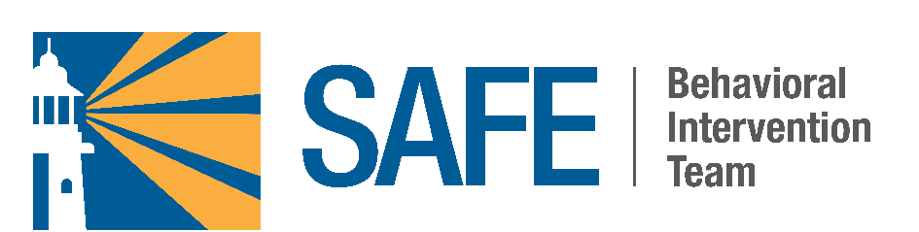
The UT Southwestern Police Department provides a bicycle registration service to students, faculty, and staff. Registration is free and can help aid the recovery of stolen bicycles. A free property registration service is also available through Report It, a property reporting tool that can be used to secure serial numbers, item descriptions, and pictures for your valuable property.

SAFE Community Safety Initiative
SAFE is a behavioral intervention initiative to provide reporting avenues for concerning behaviors exhibited by staff, faculty, learners, trainees, volunteers, contractors, and vendors that will allow us to proactively intervene with a specially trained, multidisciplinary intervention unit.

Commitment to a Safe Campus Environment
The unit comprises mental health professionals, University Police, administrative leaders, and others skilled in providing social support and community resources to individuals in need. This initiative marks a significant step forward in our commitment to providing a healthy work and learning environment, and our support for the safety and well-being of our staff, faculty, students, trainees, volunteers, contractors, and vendors.
Over the past couple of years, the organization has mobilized efforts around safety initiatives, including workplace violence prevention training and response processes you may have heard about in our clinical areas. The creation of the SAFE initiative is an additional layer to promote a healthy work environment across the campus, including academic and administrative settings.

SAFE Is | SAFE Is NOT
A resource to prevent campus violence by providing a confidential option for employees and students to report concerning behaviors. | A replacement for law enforcement and should not be used for emergencies. If a violent act is imminent, call University Police at 214-648-8911.
A multidisciplinary team of experienced members from relevant offices.
Available 24/7 via the Compliance Hotline at 877-507-7319.

How to Report Concerning Behavior
As part of our SAFE community safety Initiative, we have established a confidential online form, email address, and hotline at 877-507-7319 (option 2) to report concerning behaviors, such as those mentioned below. All reports will be reviewed by UT Southwestern’s multidisciplinary intervention unit.
The success of behavioral intervention programs depends on the willingness of colleagues, co-workers, and others to come forward with potential concerns so they can be properly assessed, and appropriate interventions or other action can be taken proactively. Our responses are designed to address both the needs of the individual and the safety of the campus community, and to be implemented in a way that reduces or removes threats or disturbing behavior.

Signs to Watch For
Physical | Emotional or Psychological | Safety Risk
Aggressive or violent behavior: This may include physical threats or any form of physical intimidation | Excessive agitation: Restlessness, pacing, or heightened anxiety that may disrupt the health care environment | Threats: Expressions of harm or aggression towards others or UTSW, even if they appear non-specific, including verbal, physical, writings, online forums and social posts
Confusion or disorientation: Sudden changes in mental status or altered consciousness | Inability to cope: Difficulty coping with stress or issues at work or home | Self-harm or suicidal ideation: Any direct or indirect expression that an individual is contemplating self-injury or suicide

Reporting any of the above signs or any other concerning behavior is crucial. Your prompt and accurate reporting allows the intervention unit to intercede early with compassionate care to ensure the safety of everyone involved.
For more information about SAFE, contact the Office of Institutional Compliance & Audit Services or visit the following website: SAFE Community Safety Initiative.

Community Outreach Initiatives


National Night Out
Hosted by the UT Southwestern Police Department, National Night Out is an annual community-building event that provides the UT Southwestern community with the opportunity to connect with colleagues and the University Police Department, as well as learn more about safety on our campus.

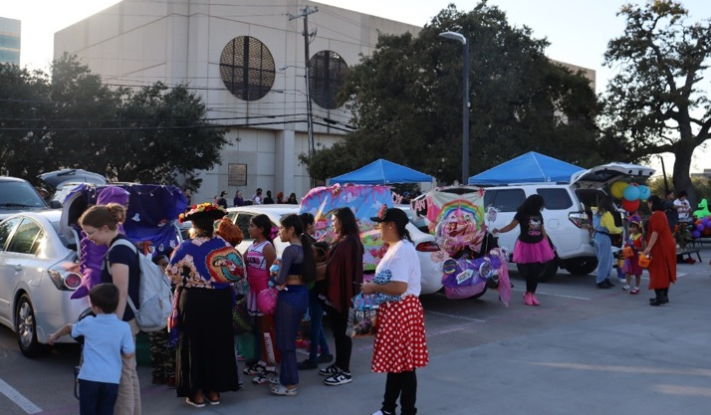
Trunk or Treat
Each October since 2023, the UT Southwestern Police Department has hosted Trunk or Treat, a family-friendly Halloween event that provides a safe trick-or-treating experience for its community members right outside the Police Department. The UT Southwestern community and their families are all welcome for an evening of fun and the opportunity to connect with the University Police.

Procedures

Timely Warnings
A Timely Warning is an emergency notification distributed to the campus community in a timely manner to warn the community that it has been determined that an incident represents a serious and ongoing threat affecting students, faculty, and staff. In the event of such an emergency, the entire campus will be notified via text message, email, and/or phone call from UT Southwestern’s emergency alert system. The intent of a Timely Warning is to aid in the prevention of similar crimes by helping members of the campus community protect themselves.
The circumstances in which a Timely Warning will be generated include, but are not limited to, the receipt of a good-faith report to the UT Southwestern Police Department or other Campus Security Authority of a crime reportable under the Clery Act that poses a serious or continuing threat to the campus community. The community will be alerted as soon as first responders confirm that a crime occurred and a dangerous situation exists.
In the event that a situation arises, the Chief of Police or designee will determine if a Crime Alert (Timely Warning) will be issued. The determination will be made on a case-by-case basis after due consideration of all available facts of the crime, such as the nature of the crime and whether a continuing danger to the campus community exists.
If the review determines that the offense presents a continuing threat to students and employees, then the following steps will be taken:
- In exigent circumstances, the Police Communications Center will send a mass communication through the UTSW Alert mass notification system, notifying the campus of the threat.
- In non-exigent circumstances, the Chief of Police, in consultation with the Executive Vice President for Business Affairs, will coordinate an institutional notification.
The Timely Warning will include information that the Chief of Police or designee determines is necessary and appropriate to promote safety and aid in the prevention of similar crimes. The content of a Timely Warning will, at minimum, include the time, location, and type of crime. The warning may also provide brief information about the situation if warranted, and information that promotes safety and helps individuals protect themselves from similar crimes. The Timely Warning will withhold as confidential the names and other identifying information of victims. Additionally, some facts about the incident may be kept confidential to avoid compromising an investigation.
Please note that Clery Act crimes disclosed to Pastoral and Professional Counselors are exempt from Timely Warning consideration.

Emergency Notification
The institution shall have emergency response and evacuation procedures for notifying the community in the event of a significant emergency or dangerous situation involving an immediate threat to the health or safety of students or employees occurring on the campus. Emergency notifications and public notices will be issued by the Chief of Police as part of our emergency response system and protocols.
UT Southwestern will, without delay, and taking into account the safety of the community, determine the content of the notification and initiate the notification system, unless issuing the notification will, in the professional judgment of responsible authorities, compromise efforts to assist a victim or to contain, respond, or otherwise mitigate the emergency.
UT Southwestern utilizes the UTSW Alert mass notification system for all emergency notifications. UTSW Alert utilizes information provided in PeopleSoft for mass notification alerts. Updating changes to personal contact information in PeopleSoft is vital as the success of this service relies on personnel providing accurate contact information. Affiliated personnel can also sign up for Building Interruption Alerts to receive text and email notifications for incidents that occur in your building location(s). The following link provides directions on how affiliated personnel can sign up for these notifications: https://member.everbridge.net/3091830992273431/login/sso. Depending on the nature of the incident, campus affiliates may be instructed to shelter in place, evacuate a floor or building, avoid a particular area, or simply remain alert and report any related issues to the appropriate campus entity.
Notifications will include the type of incident occurring, the location of the incident, and the response actions the campus community is advised to follow. Additional updated information will be provided as it becomes available and as circumstances allow for its release.
Emergency notifications are sent out via email, phone call, and text message upon confirmation of a significant or dangerous situation – including Clery Act crimes – occurring on the campus and involving an immediate threat to the health or safety of students or employees.
Emergency notifications are initiated by the Office of Safety and Business Continuity or the UT Southwestern Police Department, depending on the nature of the incident. The Office of Safety and Business Continuity and/or the UT Southwestern Police Department will gather the information necessary to confirm that there is a significant emergency or dangerous situation, including consulting with outside resources as appropriate. Based on this information, the Office of Safety and Business Continuity and/or the UT Southwestern Police Department will determine the appropriate segment(s) of the campus community to receive the emergency notification, depending on who has the potential to be affected by the situation. UT Southwestern will disseminate emergency information to individuals and/or organizations outside of the campus community as appropriate depending on the situation.
The UT Southwestern Police Department and/or members of the Office of Safety and Business Continuity will respond to all emergencies, triage the incidents, and provide information to administrators regarding the appropriate campus responses. The required campus responses will be delivered via an emergency notification.

Types of Emergencies

The types of incidents that may cause an immediate threat to the community (and therefore require an emergency notification) could include, but are not limited to:
- Extreme weather conditions
- Earthquake
- Gas leak
- Acts of terrorism
- Armed intruder
- Bomb threat
- Civil unrest
- Explosion
- Airplane crash
- Structure fire or wildfire
- Hazardous material incident

Emergency Management and Evacuation Procedures
The Emergency Management Program is a part of UT Southwestern’s Office of Safety and Business Continuity. All policies and procedures are promulgated by the Office of Safety and Business Continuity in partnership with other relevant departments, including University Police. The UT Southwestern Emergency Management Plan is a guide that provides UT Southwestern executive management with an emergency and crisis management system when responding to major disasters or disturbances to the campus. All personnel designated to carry out specific responsibilities are trained to know and understand the UT Southwestern policies and procedures. UT Southwestern will utilize the Incident Command System (ICS) in the event of an emergency.
The Emergency Management Plan is designed to effectively coordinate the use of University and community resources to protect life and property both during and immediately following a major crisis or disturbance at or near UT Southwestern. It shall be placed into operation whenever an emergency affecting the University cannot be controlled using daily operating procedures.
Fire Alarm / Drill Procedures (utsouthwestern.net)

Emergency Response Guide
Available in a mobile application, the purpose of the Emergency Response Guide is to provide an understandable and accessible reference for use in emergency situations to promote the safety of the UT Southwestern community. This guide addresses the most common and most likely emergencies that employees and students may face on the UT Southwestern campus on any given day, shows emergency equipment locations, and provides action steps for the campus to follow.

Emergency Tests and Evacuation Drills
UT Southwestern shall participate in emergency tests or evacuation drills at least once per year to assess and evaluate emergency procedures and capabilities. The emergency drills, tabletop exercises, and emergency preparedness trainings are done in partnership with various internal departments at UT Southwestern as well as affiliated institutions in the Southwestern Medical District.
External agencies may include the Dallas Police Department, Dallas Fire-Rescue, Dallas Emergency Operations Center, Dallas Area Rapid Transit, and state agencies. The Office of Safety and Business Continuity will document each test, including a description of the test, the date and time, and whether it was announced or unannounced. UT Southwestern will publicize its emergency response and evacuation procedures in conjunction with at least one test per year.

Security and Access to UT Southwestern Facilities
Physical access pertains to the management of access control points into UT Southwestern operated facilities and work areas across the UT Southwestern campus and in UT Southwestern leased spaces. Physical entry is variable through centrally monitored electronically scanned badges, physical keys and decentralized battery-powered entry devices (BPED) or keypads requiring separate codes. All UT Southwestern students, employees, faculty members and approved persons must wear institution-issued identification (ID) badges whenever they are on campus to promote overall safety by identifying parties who belong on campus. Additionally, UT Southwestern Police officers and public safety personnel are deployed throughout the main campus and off-campus to enhance the overall safety and security.
The Access Control team reporting to the University Police Department (UPD) is responsible for issuing and managing all ID badges, access control points, and the campus-wide video management system for certain perimeter entrances or high-security locations. The UPD Access Control team uses a Lenel system to manage ID badges, including badge issuance, access rights activation and deactivation, and monitoring of facility access points.
The Facilities Management Department Building Maintenance & Operations Division (Facilities) is responsible for issuing and managing keys and installing keypads in individual offices at all UT Southwestern facilities. Facilities uses an Archibus facilities management and space planning system to issue keys upon department request and replace and recover keys. Employee records are maintained in PeopleSoft HCM and student records are maintained in PeopleSoft Campus Solutions. These system modules provide daily updates of new hires, transfers, and terminations as part of the interface with Lenel and Archibus.
See SEC-153 Badge and Identification Requirements, FSS-312 Campus Facilities, Security Devices, and Key Control, and UHEC 06 Key Control for more information.

Registered Sex Offender Information

UT Southwestern Procedures
UT Southwestern is dedicated to providing a safe environment and takes steps to ensure that this is a safe place for educating, treating patients, and working. To do so, UT Southwestern requires background checks in positions stated in policy EMP-152 Security-Sensitive Positions and Background Checks.

Public Access to Sex Offender Data
The Campus Sex Crimes Prevention Act sets minimum national standards for state sex offender registration and community notification programs. Pursuant to Texas Code of Criminal Procedure Article 62.005, the Texas Department of Public Safety (DPS) has established this website as the official internet public access to the DPS sex offender registration computerized database. The information can be found at:
https://publicsite.dps.texas.gov/SexOffenderRegistry

New Student and Employee Training
All new students and employees are provided training on the prevention of dating violence, domestic violence, sexual assault, and stalking. This training defines the concept of consent and provides specific definitions for dating violence, domestic violence, sexual assault, and stalking. The training reinforces the University’s prohibition of these actions and includes information about the procedures UT Southwestern will follow when these actions are reported, risk reduction, and safe and positive options for bystander intervention.

Incumbent Student and Employee Training
UT Southwestern notifies all employees and students regarding the availability of after-hours security transportation, crime prevention tips, and the availability of refresher training regarding dating violence, domestic violence, sexual assault, and stalking. The training reinforces the concepts explored during the new student/employee training.

Missing Students
Students, employees, or other individuals should report to the UT Southwestern Police Department when a student has been missing for 24 hours. Any missing student report must be referred immediately to the University Police. A decision to initiate emergency contact procedures will be made by the UT Southwestern Police Department based on the information known at the time. Call 214-648-8911 (88911 from a campus extension) to report missing students.
Students may designate one or more contacts whom UT Southwestern will notify within 24 hours of a determination that the student is missing. This contact information will be registered confidentially, will be accessible only to authorized campus officials, and may not be disclosed except to law enforcement personnel in furtherance of a missing person investigation. Those contacted by the UT Southwestern Police Department as part of the emergency notification process will include the individuals listed on the confidential card filled out by the resident during the move-in process, but others may also be contacted as permitted by state and federal law.
In cases where the resident is not yet 18 years of age and not emancipated, the UT Southwestern Police Department will contact the minor’s parent or guardian no later than 24 hours after the time the student is determined to be missing, in addition to notifying the student’s designated contact person. UT Southwestern Police will notify the Dallas Police Department within 24 hours of a determination that a student is missing.

Sexual Assault, Domestic Violence, Dating Violence, and Stalking

Reporting Domestic Violence, Dating Violence, Sexual Assault, and Stalking to Law Enforcement
Incidents of domestic violence, dating violence, sexual assault, and stalking that occurred on campus should be immediately reported to the UT Southwestern Police Department at 214-648-8911 (emergency), 214-648-8311 (non-emergency), or via the online Report a Crime form found on the UT Southwestern Police Department’s webpage. Incidents occurring in other jurisdictions should be reported to the appropriate local law enforcement authority. Individuals who witness or experience domestic violence, dating violence, sexual assault, or stalking are strongly encouraged to promptly report the incident to the appropriate law enforcement authority, regardless of whether the victim intends to pursue criminal charges. Police in the jurisdiction where the incident occurred can assist victims with applying for protective orders. A sexual assault victim will also have an opportunity to have a crime victim liaison, counselor, advocate, or police officer with specialized training be present with the victim during police investigative interviews.
Reporting domestic violence, dating violence, sexual assault, or stalking to law enforcement does not mean the case will automatically go to criminal trial or through a formal grievance process under policy ETH-153. If domestic violence, dating violence, sexual assault, or stalking that occurred on campus is reported to the UT Southwestern Police Department, the Department will advise the individual of his or her right to also submit a formal complaint under ETH-153 Title IX Sexual Harassment: Formal Grievance Policy. To the extent permitted by the law and UT Southwestern policy, the UT Southwestern Police Department will also notify the Title IX Coordinator when a criminal complaint of domestic violence, dating violence, sexual assault, or stalking is received involving an employee, student, resident, or applicant for admission or employment, with the exception of when the individual uses a pseudonym form under the Code of Criminal Procedure for incidents of sexual assault, stalking, family violence, and human trafficking. In those instances where a pseudonym form is used, the UT Southwestern Police Department will only report the type of incident to the Title IX Coordinator but not any information identifying victims. The UT Southwestern Police Department may also provide the Title IX Coordinator access to related law enforcement records, so long as such access will not compromise any criminal investigation.
The University will assist victims, upon request, in contacting law enforcement. Victims may decline to notify law enforcement.

Reporting Domestic Violence, Dating Violence, Sexual Assault, and Stalking to UT Southwestern (ETH-153 Title IX Sexual Harassment: Formal Grievance Policy)
UT Southwestern’s 2024 ASR included a statement regarding 2024 amendments to federal Title IX regulations, noting UT Southwestern was continuing to rely on the 2020 Title IX amendments pursuant to a directive from the Governor of Texas and an injunction enjoining Texas from implementing the amendments. On January 9, 2025, in Tennessee v. Cardona, the U.S. District Court for the Eastern District of Kentucky struck down the 2024 Title IX amendments nationwide. Accordingly, UT Southwestern will continue to apply the 2020 Title IX amendments, which are the current federal Title IX regulations nationwide.
UT Southwestern is committed to maintaining a working, educational, and training environment that is free from sexual harassment in compliance with Title IX of the Education Amendments of 1972 (“Title IX”) and the Campus Sexual Violence Elimination Act (SaVE Act), Violence Against Women Act (VAWA), and Clery Act.
In furtherance of this commitment, it is UT Southwestern policy that the Office for Access & Title IX will investigate and resolve Formal Complaints of Title IX Sexual Harassment in the manner outlined in policy ETH-153 Title IX Sexual Harassment: Formal Grievance Policy. This grievance process is a prompt, fair, and impartial process conducted by officials who receive annual training on dating violence, domestic violence, sexual assault, and stalking, and conducting investigations and hearings that balance protecting the safety of victims and promoting accountability. Individuals who are found responsible for Title IX Sexual Harassment in violation of that policy will be subject to disciplinary action, up to and including dismissal or termination of employment.
Under federal law and policy ETH-153, Title IX Sexual Harassment means conduct on the basis of sex that satisfies one or more of the following:
- Quid pro quo: an employee conditioning the provision of an aid, benefit, or service of UT Southwestern on an individual’s participation in unwelcome sexual conduct
- Unwelcome conduct determined by a reasonable person to be so severe, pervasive, and objectively offensive that it effectively denies a person equal access to UT Southwestern’s education programs or activities
- “Sexual assault”, “dating violence”, “domestic violence”, or “stalking” as defined in policy ETH-153.
Conduct under subsections (a) and (c) are not evaluated for severity, pervasiveness, offensiveness, or denial of equal educational access, because such conduct is sufficiently serious to deprive a person of equal access. Therefore, any instance of quid pro quo harassment and any instance of sexual assault, dating violence, domestic violence, or stalking are considered Title IX Sexual Harassment under policy ETH-153. Individuals can consult policy ETH-153 for definitions of all terms used in this section.

Scope of Policy ETH-153 and Exclusions
Policy ETH-153 applies to all UT Southwestern faculty, employees, students, residents, and third parties participating or attempting to participate in any UT Southwestern education program or activity, including patients, visitors, volunteers, contractors, and vendors, as well as applicants for admission or employment. The policy applies regardless of the gender, gender identity, or sexual orientation of the reporter, Complainant, or Respondent.
The policy only applies to Title IX Sexual Harassment as defined by federal law and the policy. Conduct that does not constitute Title IX Sexual Harassment may be prohibited by other UT Southwestern policies. For example, other sexual misconduct that does not rise to the level of Title IX Sexual Harassment, but is unacceptable for the working or educational environment, will be handled in accordance with ETH-154 Sexual Harassment and Sexual Misconduct.
The Office for Access & Title IX, in consultation with the Office of Legal Affairs, will determine whether a Formal Complaint constitutes Title IX Sexual Harassment that will be adjudicated under policy ETH-153 or whether a different UT Southwestern policy or process may apply. This determination may be made at any point in the Formal Grievance Process. For example, if in the course of the investigation, the Office for Access & Title IX determines alleged conduct by a student does not meet the definition of Title IX Sexual Harassment, the Formal Complaint must be dismissed but the matter may be referred to the Dean of the applicable School for action in accordance with EDU-151 Student Conduct and Discipline.
Complaints related to patient care provided in the treatment setting will be handled by the Office of Medical Risk Management and/or the Patient Assistance Office, as appropriate.

Reporting Title IX Sexual Harassment to UT Southwestern
All members of the UT Southwestern community are strongly encouraged to promptly report incidents that could constitute Title IX Sexual Harassment in violation of policy ETH-153 to the Title IX Coordinator, regardless of where or when they occurred. Reports may also be made to a Responsible Employee, via the online reporting form on the Title IX Website, to the Office of Institutional Compliance & Audit Services, or to the Compliance Hotline. All reports made via these avenues will be promptly forwarded to the Title IX Coordinator. Anonymous reports may be made via the Title IX website or the Compliance Hotline. However, anonymous reports may greatly limit UT Southwestern’s ability to stop the alleged conduct, complete an investigation, or take appropriate remedial action against individuals accused of violating policy ETH-153.
Reporting an incident informs UT Southwestern and allows the Office for Access & Title IX to provide appropriate Supportive Measures. Reporting an incident does not constitute filing a Formal Complaint and will not automatically result in an investigation or hearing process under policy ETH-153. Individuals wishing to file a Formal Complaint must follow the procedures outlined below to invoke an investigation, hearing, or informal resolution process.
Responsible Employees are required by Texas law to promptly report to the Title IX Coordinator all information concerning any incident the Responsible Employee reasonably believes constitutes Title IX Sexual Harassment committed by or against a student or employee. If a Responsible Employee knowingly fails to promptly report, state law requires their employment be terminated. The definition of what must be reported by Responsible Employees under state law includes Title IX Sexual Harassment as defined in policy ETH-153. Please refer to ETH-154 Sexual Harassment and Sexual Misconduct for a complete description of reporting obligations, which include a broader range of conduct than Title IX Sexual Harassment.

The UT Southwestern Title IX Coordinator is:
Travis Gill, J.D.
Assistant Vice President of Access & Title IX
Phone: 214-648-9843
Email: Travis.Gill@utsouthwestern.edu

Supportive Measures
UT Southwestern will offer reasonably available individualized services, without any fee or charge, to the parties involved in a reported incident of Title IX Sexual Harassment. Supportive Measures, coordinated by the Title IX Coordinator and the Office for Access & Title IX, will always be offered via written correspondence upon actual notice of a Formal Complaint. Supportive Measures are available without the filing of a Formal Complaint, as the situation warrants. Supportive Measures are equally available to all parties and may include, but are not limited to: assistance with alternative student housing, counseling, or course-related adjustments; modifications of class or rotation schedules; withdrawal from a course without penalty; campus escort services; mutual, non-punitive restrictions on contact between the parties; change in work locations; leaves of absence; increased security and monitoring of certain areas of campus; or other similar measures tailored to the individualized needs of the parties and appropriate to the situation.
Supportive Measures are non-disciplinary and non-punitive measures that do not unreasonably burden any of the parties involved in a reported incident of Title IX Sexual Harassment. Any disciplinary or punitive measures may only be implemented following the conclusion of the Formal Grievance Process, excluding an emergency removal issued in accordance with policy ETH-153.
Supportive Measures provided to the parties will be maintained as confidential, to the extent that maintaining such confidentiality does not impair the ability of UT Southwestern to provide the Supportive Measures.

Confidentiality, Requests Not to Investigate, and Requests to Dismiss Formal Complaints
UT Southwestern has great respect for the sensitive nature of the subject matter covered by policy ETH-153 and for the privacy of the parties identified in a report or Formal Complaint. In the course of the Formal Grievance Process, UT Southwestern will share information only as necessary with people who need to know, and in compliance with law, which may include, but is not limited to, the investigators, witnesses, the Complainant, the Respondent, the parties’ advisers, the hearing officer, and the appeal official.
Students and residents may discuss an incident with Confidential Employees or an off-campus resource (e.g., rape crisis center, doctor, psychologist, or clergyperson) without concern that their identity will be reported to UT Southwestern. Employees may seek assistance from the external Employee Assistance Program, their personal health care provider, the clergyperson of their choice, or an off-campus rape crisis resource without concern that their identity will be reported to UT Southwestern.
UT Southwestern may need to act to maintain campus safety and must determine whether further investigation is required, even in instances where a Complainant requests confidentiality or prefers that an investigation not be conducted. In making determinations regarding a Complainant’s request that UT Southwestern not investigate, that a Formal Complaint be dismissed, and/or that UT Southwestern not disclose identifying information to Respondent(s), the Office for Access & Title IX must deliberately weigh the rights, interests, and safety of the Complainant, the Respondent, and the campus community. Factors the Division of Title IX will consider when determining whether to investigate an alleged incident of Title IX Sexual Harassment under policy ETH-153 include, but are not limited to:
- The seriousness of the alleged incident.
- Whether UT Southwestern has received other complaints about the same Respondent.
- The Respondent’s right to receive information about the allegations, in accordance with federal and state law.
- Whether the alleged incident of Title IX Sexual Harassment poses a risk of harm to others.
- Any other factors UT Southwestern deems relevant.
Under state law, if the Complainant requests in writing that UT Southwestern not investigate a report, the Office for Access & Title IX must inform the Complainant of the decision whether or not to investigate.

Mandatory and Discretionary Dismissal of Formal Complaints by the Office for Access & Title IX
Title IX regulations require UT Southwestern to assess whether conduct constitutes Title IX Sexual Harassment or whether it constitutes prohibited conduct in violation of another University policy. UT Southwestern is required to dismiss a Formal Complaint (in whole or in part) when the alleged conduct, even if substantiated:
- Does not meet the definition of Title IX Sexual Harassment in ETH-153;
- Did not occur in a UT Southwestern education program or activity; or
- Did not occur against a person in the United States.
UT Southwestern has the discretion to dismiss a Formal Complaint under the following circumstances:
- The Complainant requests in writing to withdraw or dismiss a Formal Complaint (or any allegations therein) in accordance with the procedures below;
- The Respondent was an employee but is no longer employed by UT Southwestern at the time the Formal Complaint is filed;
- The Respondent was a student but is no longer enrolled at UT Southwestern at the time the Formal Complaint is filed; or
- Specific circumstances prevent UT Southwestern from gathering evidence sufficient to reach a determination as to the Formal Complaint or any allegations therein.
A mandatory or discretionary dismissal only means that the Formal Complaint will not be investigated or resolved in accordance with policy ETH-153. UT Southwestern may still handle allegations of misconduct under other applicable University policies or processes, for example: ETH-151 Equal Opportunity (gender discrimination), ETH-154 Sexual Harassment and Sexual Misconduct (sexual misconduct or Title VII sexual harassment), EDU-151 Student Conduct and Discipline (student misconduct), or EMP-351 Discipline and Dismissal of Classified Employees (employee misconduct). The Office for Access & Title IX may offer Supportive Measures to the parties if a Formal Complaint is dismissed.

Appealing the Dismissal of a Formal Complaint
If a Formal Complaint is dismissed, the Office for Access & Title IX will provide the parties with prompt written notice of the dismissal and the reason(s). A Formal Complaint may be dismissed at any point in the Formal Grievance Process if it is determined dismissal is appropriate. Both parties may appeal the decision to dismiss a Formal Complaint in writing to the Assistant Vice President of Access & Title IX within five (5) days. The appeal should set forth the reasons why the party believes the dismissal was in error. Appeals may only be based on the following grounds:
- Procedural irregularity that affected the dismissal decision;
- New evidence that was not reasonably available at the time of the dismissal that could affect the outcome; or
- The individual who made the decision to dismiss the Formal Complaint had a conflict of interest or bias for or against the parties (generally, or specifically in this matter) that affected the outcome.
Upon receipt of an appeal, the Assistant Vice President of Access & Title IX will provide a copy to the non-appealing party (which may be the Office for Access & Title IX) and an opportunity to respond in writing. The Assistant Vice President may, at their discretion, schedule a meeting with the appealing party to discuss the dismissal. In that event, the non-appealing party will also have the opportunity to meet with the Assistant Vice President. The Assistant Vice President will issue a written decision to the parties no later than 30 days after receipt of the appeal. The decision of the Assistant Vice President of Access & Title IX is final as to dismissal or reinstatement of a Formal Complaint.

The Formal Grievance Process May Be Invoked by the Following:
- Students and Residents: The Complainant is a student or resident at UT Southwestern at the time of the alleged Title IX Sexual Harassment, and the alleged conduct occurred when the Complainant was participating or attempting to participate in an education program or activity at UT Southwestern.
- Employees: The Complainant is an employee of UT Southwestern at the time of the alleged Title IX Sexual Harassment, and the alleged conduct occurred when the Complainant was participating or attempting to participate in an education program or activity at UT Southwestern.
- Third parties (e.g., vendors, contractors, volunteers, patients, visitors, applicants for admission or employment): The Complainant is participating or attempting to participate in an education program or activity at UT Southwestern at the time the Title IX Sexual Harassment occurred, and the Respondent is a UT Southwestern student, resident, or employee.
If the Formal Complaint does not fit within any of the above situations, the Office for Access & Title IX will not proceed with an investigation under ETH-153 and will refer the matter to another UT Southwestern official or office, as appropriate, and provide written notice to the Complainant. A determination that the Complainant is not eligible to invoke the Formal Grievance Process and the matter is properly handled by another UT Southwestern official or office is not a dismissal and is not appealable by any party.

Submitting a Formal Complaint
To begin the Formal Grievance Process, the Complainant must sign (physically or electronically) a written Formal Complaint and submit it to the Title IX Coordinator. The Complainant must include a statement setting out the known details of the alleged conduct that is the subject of the Formal Complaint, including:
- Complainant’s name and contact information;
- Respondent’s name;
- Detailed description of the alleged conduct or event that is the basis of the alleged Title IX Sexual Harassment in violation of policy ETH-153;
- Date(s) and location(s) of the alleged occurrence(s);
- Names of any witnesses to the alleged occurrence(s);
- The resolution sought; and
- Any documents, evidence, or other information that is relevant to the Formal Complaint.
The Title IX Coordinator may also sign (physically or electronically) and submit a written Formal Complaint against a Respondent to initiate the Formal Grievance Process. When the Title IX Coordinator submits a Formal Complaint, it will include the rationale for initiating the complaint instead of the Complainant. UT Southwestern will not be deemed to have actual knowledge of a Formal Complaint unless and until it is received by the Title IX Coordinator or Office for Access & Title IX.

Notice of a Formal Complaint
After receiving a Formal Complaint and determining that it is actionable under policy ETH-153, the Office for Access & Title IX will provide a written notice to the parties of the Formal Complaint that will include:
- A copy of ETH-153 Title IX Sexual Harassment: Formal Grievance Process;
- A detailed description of the factual allegations that potentially constitute prohibited Title IX Sexual Harassment under policy ETH-153, including the identity of the parties, and the date(s), time(s), and location(s) of alleged conduct, to the extent this information is known by the Office for Access & Title IX at the time;
- A statement of the potential policy violations being investigated;
- A statement that the Respondent is presumed not responsible for the alleged conduct and that the determination regarding responsibility will be made at the conclusion of the Formal Grievance Process;
- A statement informing both parties that they may have an adviser of their choice, who may be, but is not required to be, an attorney;
- A statement that the parties may review all evidence gathered as part of any investigation; and
- Notification that knowingly making false statements or submitting false information during the Formal Grievance Process is prohibited and could result in disciplinary action.
If at any point during the investigation, new allegations emerge or the original allegations in the Formal Complaint change, the Office for Access & Title IX will issue concurrently to both parties a revised Notice of Formal Complaint summarizing the additional and/or updated allegations.

Emergency Removal
A Respondent may be removed from UT Southwestern education, training, or employment activities and temporarily barred from the campus on an emergency basis pending the outcome of a Formal Grievance Process under policy ETH-153. The decision to issue an emergency removal will be based on an individualized safety and risk analysis and determination that the Respondent poses an immediate threat to the physical health or safety of an individual arising from the allegations of Title IX Sexual Harassment. The Office for Access & Title IX will notify the Respondent in writing of an emergency removal decision. The Respondent will have an opportunity to immediately challenge the emergency removal in writing to the Assistant Vice President of Access & Title IX.
Students and residents who are subject to emergency removal will be placed on leave of absence and will not be permitted to participate in any UT Southwestern education programs or training activities. Residents may use paid leave in accordance with Graduate Medical Education (GME) policies and the applicable employer’s policies. At the discretion of UT Southwestern, employees who are subject to emergency removal may be placed on paid administrative leave pending investigation, may be required to use available paid leave accruals or placed on unpaid leave in accordance with UT Southwestern policies, or may be assigned to work remotely from an alternate location off campus.

Informal Resolution Option
After the parties have been provided a copy of the written notice of a Formal Complaint, both parties may, in writing, voluntarily agree to use this Informal Resolution option at any point prior to a final determination regarding responsibility. No party is required to use the Informal Resolution option. The Informal Resolution option is in lieu of the investigation, live hearing, and appeal process described below. The Informal Resolution process is not permitted in cases where Title IX Sexual Harassment by an employee against a student is alleged in the Formal Complaint. At any point prior to agreeing to an Informal Resolution, each party has the right to withdraw from the Informal Resolution process and resume the Formal Grievance Process.
Upon receipt of the written agreement of both parties to pursue the Informal Resolution option, the Office for Access & Title IX will issue a Notice of Informal Resolution Option concurrently to both parties, which will include:
- A summary of the allegations in the Formal Complaint;
- An outline of the Informal Resolution process;
- A statement that if the informal process results in a mutual agreement, then the parties forgo resuming a Formal Grievance Process arising from the same allegations;
- A statement that at any point prior to agreeing to an Informal Resolution, each party has the right to withdraw from the informal process and resume the Formal Grievance Process;
- A statement acknowledging that an agreed-upon Informal Resolution by both parties will fully and finally resolve the allegations and create a binding obligation on both parties to abide by the resolution; and
- Any potential consequences that may result from participating in the informal process, such as:
  - failure to comply with an Informal Resolution by either party may result in disciplinary action
  - documentation and recordkeeping of the informal process, and
  - confidentiality of records.
Informal Resolutions will be concluded within 45 days of the Office for Access & Title IX’s receipt of written notice that both parties wish to exercise this option. This time limit can be extended by the Office for Access & Title IX for good cause and with written notice to both parties. The Office for Access & Title IX will provide a written copy of any Informal Resolution reached. All documentation related to the Informal Resolution process will be treated as confidential to the extent possible under law and will be kept for seven years as required by law and UT Southwestern policy. The Informal Resolution process is confidential, it will not be recorded or transcribed, and any statements made by the parties may not be used for or against either party should the parties resume the Formal Grievance Process. Information related to an Informal Resolution may be relevant in any future complaint against the same Respondent. Failure to comply with an Informal Resolution may result in disciplinary action.

Investigation of the Formal Complaint
All Formal Complaints will be investigated by an investigator in the Office for Access & Title IX. Investigations will proceed as follows:
- The Respondent will have the opportunity to respond to the Notice of Formal Complaint and the allegations in writing and during an interview with the investigator.
- The Office for Access & Title IX will provide written notice to a party whose participation is invited or expected of the date, time, location, participants, and purpose of all meetings, investigative interviews, or other proceedings in the Formal Grievance Process.
- Parties must provide the Office for Access & Title IX with the name and contact information of their adviser. If a party wants the Office for Access & Title IX to release information to their adviser (e.g., evidence, the completed final report, hearing notices), the party must submit a written, signed consent for such release. Advisers are not permitted to actively participate in meetings or proceedings in the Formal Grievance Process, except when questioning witnesses at a live hearing, as expressly permitted by policy ETH-153.
- During the investigation, the parties may present any information and evidence that may be relevant to the Formal Complaint and may have an adviser of their choice attend any related interview, meeting, or proceeding in the Formal Grievance Process. The parties may present the names of any fact or expert witnesses who may provide relevant information, and how the witnesses may be relevant to the Formal Complaint. The parties may submit to the investigator any questions they would like asked of any potential witnesses or the other party.
- The investigator will interview relevant and available witnesses and all parties. Neither the Complainant nor the Respondent or their respective advisers will be permitted to attend interviews of other witnesses, including interviews of the other party.
- The investigation of a Formal Complaint will be concluded within 90 days, unless the process is tolled while the parties are pursuing an Informal Resolution or an extension is granted for good cause by the Office for Access & Title IX.
- Prior to completion of the investigation report, the Office for Access & Title IX will provide access to all evidence obtained (whether relevant or not) as part of the investigation to both parties.
- Both parties will have an equal opportunity to inspect, review, and respond to the evidence. All responses to the evidence must be submitted by the party in writing to the Office for Access & Title IX within 10 days. Advisers are not permitted to submit written responses to the evidence on their own or on behalf of the party they are advising. The Office for Access & Title IX will consider all timely responses submitted by the parties before finalizing the investigation report.
- The completed investigation report will outline each of the allegations that potentially constitutes prohibited Title IX Sexual Harassment under policy ETH-153, describe the investigation, and fairly summarize relevant evidence, witness statements, and responses to questions.
- The investigator will provide a completed investigation report concurrently to both parties no later than 10 days prior to the date of any scheduled hearing. A copy of the completed investigation report will be issued to the Title IX Coordinator and to the hearing officer.

Live Hearing and Determination of Responsibility
UT Southwestern will provide a live hearing for all Formal Complaints that are not dismissed, resolved informally, or referred for handling under another UT Southwestern policy or process. The Formal Grievance Process will use the preponderance of the evidence standard, as defined in policy ETH-153. By law, it is presumed that the Respondent is not responsible for the alleged conduct unless a determination regarding responsibility is made at the conclusion of the Formal Grievance Process, including any appeals.
- Hearing Notice. The Office for Access & Title IX will provide at least 10 days’ written notice of the hearing to the parties that includes the date, time, location, the name of the hearing officer, and the names of all participants of the hearing (all parties, each party’s advisers, and witnesses in the investigation report who will testify), purpose of the hearing, a statement of the Title IX Sexual Harassment charges, and a summary of the evidence gathered. The hearing notice may also provide a deadline by which the UT Southwestern representative and the parties have an opportunity to disclose (1) the names of any witnesses they intend to call to testify at the hearing, if any, and (2) a copy of any documents they intend to use as exhibits at the hearing not already included in the investigation report, if any.
- Challenges to the Hearing Officer. Either party may challenge the fairness, impartiality, or objectivity of a hearing officer. The challenge must be submitted in writing to the Office for Access & Title IX within three days after receipt of the Hearing Notice and must state the basis for the challenge. The hearing officer will be the sole judge of whether they can serve with fairness, impartiality, and objectivity. In the event that the hearing officer recuses themselves, a new hearing officer will be assigned by the Office for Access & Title IX, and a new Hearing Notice will be issued.
- Hearing Officer Duties. The hearing officer is responsible for conducting the hearing in accordance with these procedures. The hearing officer will rule on all procedural matters and on objections regarding exhibits and testimony of witnesses at the hearing; may question witnesses who testify at the hearing; and is entitled to have the advice and assistance of an attorney from the Office of Legal Affairs and/or an attorney from the Office of General Counsel of the UT System.
- Access to Evidence. Each party will have access to all of the evidence from the investigation, including a copy of the completed investigation report, in advance of the hearing.
- Separate Rooms and Virtual Participation. At the request of either party, UT Southwestern will arrange for the hearing to occur with the parties located in separate rooms using technology enabling the hearing officer and the parties to simultaneously see and hear the participants answering questions. Participants may appear at the hearing virtually and are not required to be physically present at the same physical location of the hearing.
- UT Southwestern Representative Role. The UT Southwestern representative will present information regarding the case at the hearing and will have the ability to present information and witnesses, question witnesses, and provide opening and closing statements at the hearing.
- Privileged Information Excluded. No person will be required to disclose information protected under a legally recognized privilege. The hearing officer must not allow into evidence or rely upon any questions or evidence that may require or seek disclosure of such information, unless the person holding the privilege has waived the privilege. This prohibition includes information protected by attorney-client privilege.
- Advisers. Each party may have an adviser of their choice at the hearing. If a party does not have an adviser, the Office for Access & Title IX will provide one. Advisers are not permitted to actively participate in the hearing, except that advisers may ask questions of the other party and any other witnesses. In addition, witnesses may have an adviser of their choice at the hearing; however, the Office for Access & Title IX will not provide advisers to non-party witnesses.
- Questioning of the Witnesses in the Hearing. The hearing officer may, at their discretion, ask questions during the hearing of any party or witness at any time during the proceeding. Each party’s adviser will have an opportunity to ask relevant questions and follow-up questions of the other party and of any witnesses who participate in the hearing, including questions that challenge credibility. Each adviser has the ability to ask questions directly, orally, and in real time at the hearing. The parties will not be permitted to personally ask questions of the other party or any witnesses who participate in the hearing. The UT Southwestern representative and the advisers may ask questions using the following procedure:
- The adviser questioner will ask a question of the witness.
- Before the witness answers a question, the hearing officer will rule as to whether the adviser’s question is relevant to the alleged Title IX Sexual Harassment charges.
- If the hearing officer rules that the adviser’s question is not relevant, then the hearing officer must explain any decision to exclude a question as not relevant.
- If the hearing officer allows the question as relevant, the witness will answer it.
- Prior Sexual History. A Complainant’s sexual predisposition or prior sexual behavior is not relevant except where questions and evidence about such behavior are offered to prove that someone other than the Respondent committed the alleged Title IX Sexual Harassment or if the questions or evidence concern specific incidents of the Complainant’s prior sexual behavior with the Respondent and are offered to prove the Complainant’s consent.
- Hearing Officer Determination. Within 10 days after the hearing concludes, the hearing officer will issue a written determination, which will include the following:
- The allegations that potentially constitute Title IX Sexual Harassment prohibited by policy ETH-153;
- A description of all of the procedural steps of the Formal Grievance Process under policy ETH-153;
- The findings of fact supporting the hearing officer’s determination, based on a preponderance of the evidence standard;
- The conclusion(s) and a rationale as to whether the Respondent is responsible for each allegation;
- The disciplinary sanctions, if applicable;
- Whether additional remedies designed to restore or preserve equal access to the education program or activity will be provided; and
- Procedures and permissible grounds for the parties to appeal, if applicable.
The hearing officer will send a copy of the written determination concurrently to the parties; to the Dean of the applicable School (for student Respondents); to the Program Director and GME Office (for resident Respondents); to Employee Relations and the immediate supervisor (for employee Respondents); and to the Title IX Coordinator and the Office for Access & Title IX.
- The hearing will be recorded in audio or audiovisual format or may be transcribed by a court reporter at the discretion of the Office for Access & Title IX. The recording or transcript, if applicable, will be available for the parties to inspect and review, upon written request.

Sanctions and Remedies
If the hearing officer determines the Respondent was responsible for violation of policy ETH-153, the hearing officer will determine appropriate sanctions and remedies. Possible sanctions and remedies for student or resident Respondents could include:
- Educational training;
- No shared classes, rotations, or extracurricular activities between Complainant and Respondent;
- Disciplinary warning or probation;
- Withholding of degree;
- Delayed graduation or extension of training;
- Bar against readmission, bar against enrollment, drop from one or more classes, and/or withdrawal from UT Southwestern;
- Suspension of other rights and privileges such as participation in extracurricular activities;
- Denial of degree;
- Disciplinary Suspension from UT Southwestern for a specific period of time;
- Expulsion and permanent separation from UT Southwestern and a permanent notation on the student’s official transcript;
- Suspension, probation, or dismissal from residency/fellowship program;
- Revocation of degree and withdrawal of diploma; and/or
- Other sanction(s) or remedies as deemed appropriate under the circumstances by the hearing officer, including additional Supportive Measures.
Possible sanctions and remedies for employee Respondents could include:
- Documented Counseling, Written Warning, or Letter of Expectations;
- Involuntary demotion or job reassignment;
- Suspension with or without pay for a specific period of time;
- Termination of employment;
- Notice of non-reappointment;
- Not eligible for rehire (NEFR) designation for a specified period of time or permanently; and/or
- Other sanction(s) or remedies as deemed appropriate under the circumstances by the hearing officer, including additional Supportive Measures.

Appeals
Either party may appeal in writing a hearing officer’s determination regarding a Respondent’s responsibility under the Formal Grievance Process within 10 days of notification of such a determination. Appeals following a live hearing may only be submitted on the following grounds:
- A procedural irregularity that affected the outcome of the matter;
- There is new evidence that was not reasonably available at the time of the determination regarding responsibility that could affect the outcome of the matter; or
- The investigator or hearing officer had a conflict of interest or bias for or against the parties (generally, or specifically in this matter) that affected the outcome.
The Office for Access & Title IX will appoint an appellate officer to review any appeals. The appellate officer will not be the Title IX Coordinator, investigator(s), or hearing officer in the Formal Grievance Process. Both parties will be notified concurrently in writing when an appeal is filed, and the appeal procedures will apply equally for both parties.
Any non-appealing party will have seven days from the notification of an appeal to submit a written statement in support of the outcome. The appeal officer may take any one of the following actions regarding an appeal:
- Affirm the hearing officer’s determination regarding the Respondent’s responsibility and affirm the disciplinary sanctions and remedies, if applicable;
- Affirm the hearing officer’s determination regarding the Respondent’s responsibility and amend the disciplinary sanctions and remedies, if applicable;
- Affirm the University’s dismissal of a Formal Complaint (or any allegations in the Formal Complaint);
- Remand the Formal Complaint back to the investigation or hearing stage for the investigator or hearing officer to remedy any procedural irregularity or consider any new evidence;
- Reverse the hearing officer’s determination of the Respondent’s responsibility and amend the disciplinary sanctions and remedies, if applicable;
- Uphold or overturn the Office for Access & Title IX’s decision not to investigate or to dismiss a Formal Complaint.
The appeal officer will release a written decision within 30 days of the date of the appeal. The appeal official’s decision is final in all respects and ends the Formal Grievance Process.
Complainants and Respondents may appeal the hearing officer’s determination of responsibility and any sanctions and remedies only in accordance with policy ETH-153. Due process or appeals available under other policies or processes, such as EDU-151 Student Conduct and Discipline, GME’s Grievance and Due Process Policy, EMP-351 Discipline and Dismissal of Classified Employees, EMP-401 Employee Grievances, or FAC-501 Faculty Grievances do not apply.

Time Frames for the Formal Grievance Process
All deadlines and time frames contained in policy ETH-153 are counted in calendar days. The entire Formal Grievance Process (including any appeal) will generally be completed in no more than 150 days from the filing of the Formal Complaint, unless circumstances may require a temporary delay (e.g., at the request of law enforcement). The Office for Access & Title IX may extend this time frame for good cause. In cases of extension, the Office for Access & Title IX will provide written notice to the parties and the reason(s) for the action. Examples of good cause may include considerations such as the absence of a party, a party’s adviser, or a witness; concurrent law enforcement activity; or the need for language assistance or accommodation of disabilities. The 150-day time frame for completion of the entire Formal Grievance Process does not include any period of time the parties attempted but failed to reach an agreement in the Informal Resolution Process, if applicable. In cases where an Informal Resolution was attempted but failed, the Formal Grievance Process time frame will be extended by an amount of time equivalent to the time the parties were engaged in the Informal Resolution process.

Documentation of the Formal Grievance Process
The Office for Access & Title IX will retain all of the documentation included in the Formal Grievance Process for seven years, in accordance with state and federal laws and UT Southwestern policy. All records are considered confidential to the extent permitted by law. Student records are subject to the Family Educational Rights and Privacy Act (FERPA). Disciplinary sanctions impacting a student’s status (e.g., suspension, dismissal) will also be maintained by the Dean’s Office of the applicable School and/or the Office of the Registrar. See EDU-201 Student Rights Under the Family Educational Rights and Privacy Act (FERPA). Employee records are subject to the Freedom of Information Act (FOIA) and the Texas Public Information Act (TPIA). Disciplinary sanctions against employees will also be included in the employee’s official employment file maintained by the Office of Human Resources.

Training for Title IX-Related Personnel
All Title IX Coordinators, investigators, hearing officers, and appeal officials will receive training each academic year about Title IX Sexual Harassment, policy ETH-153, and other UT Southwestern policies related to sexual misconduct. All training materials used to train Title IX-related personnel will be made available on the Title IX & Sexual Misconduct webpage: www.utsouthwestern.edu/about-us/title-ix/.

Medical, Mental Health, and Counseling Services for Victims of Domestic Violence, Dating Violence, Sexual Assault, or Stalking
Any victim who experiences domestic violence, dating violence, sexual assault, or stalking is encouraged to seek immediate medical care. It is important to preserve all physical evidence and to get a medical exam, regardless of whether the victim intends to report a crime, notify the police, or press criminal charges. Having a forensic exam will help preserve evidence in case the victim decides at a later date to file a police report.
Individuals who have experienced a sexual assault are encouraged to have a Sexual Assault Forensic Exam (SAFE) performed by a Sexual Assault Nurse Examiner (SANE) as soon as possible but no later than four days after the incident. With the victim’s consent, evidence collected during a SAFE can be used in a criminal investigation; however, a victim can undergo a SAFE even without contacting or intending to contact law enforcement. To undergo a SAFE, the individual should go directly to the emergency department of the nearest hospital that provides SAFE services. There are three hospitals in the city of Dallas equipped to offer SAFE services:
- Parkland Memorial Hospital
- Texas Health Presbyterian Hospital Dallas
- Methodist Dallas Medical Center
The cost of the forensic portion of the SAFE is covered by the law enforcement agency investigating the assault or, in cases where a report is not made to police, the Texas Department of Public Safety. This does not include the cost of medical treatment that is not part of the SAFE.
An individual who has experienced a sexual assault but who does not plan to undergo a SAFE or report to police is strongly encouraged to seek medical attention and counseling. Counseling is available for students through the Student Wellness and Counseling Center (214-645-8680) and for residents and fellows through the Resident Wellness and Counseling Center (214-648-9969). Counseling is available to employees through the Employee Assistance Program (214-648-5330 or 1-800-386-9156). Victims are strongly encouraged to contact the Title IX Coordinator, so that UT Southwestern can provide other Supportive Measures appropriate to the situation.
Additional notification to students and employees about existing counseling, health, advocacy, and other services available for victims, both within the University and in the community, is available in policy ETH-153 and in the Hotlines section of this report.

Disciplinary Proceedings: Notification of Final Results
The institution will, upon written request, disclose to the alleged victim of a crime of violence (as that term is defined in Section 16 of Title 18, United States Code), or a non-forcible sex offense, the report on the results of any disciplinary proceeding conducted by the institution against a student who is the alleged perpetrator of such crime or offense. If the alleged victim is deceased as a result of such a crime or offense, the next of kin of such victim shall be treated as the alleged victim for purposes of this paragraph.

Policies

UTSW PD-418.00 Campus Crime Reporting
UT Southwestern Medical Center is deeply concerned with the safety and security of its students, faculty, staff, and visitors. To this end, the UT Southwestern Police Department will comply with the Clery Act, or the Jeanne Clery Campus Safety Act. The Act requires that colleges and universities publicize campus crime statistics and interim reports of serious crime incidents. These publicized statistics are meant to warn students, employees, and applicants of the occurrence of campus crime. Students and employees must be given statistics on murder, manslaughter, forcible sex offenses, non-forcible sex offenses, robbery, aggravated assault, burglary, vehicle theft, arson, certain hate crimes, dating violence, domestic violence, stalking, and certain arrests and referrals for disciplinary action. The Annual Security Report must describe how to report crimes and emergencies occurring on campus, as well as the method used to collect data. The purpose of this Act is to educate the campus community about security.

UTSW PD-113.00 Unusual Occurrences, “All Hazards Plan”
It is the responsibility of the UT Southwestern Police Department to provide effective police and security responses to unusual occurrences and critical incidents. Our plan is to limit the growth of the incident, ensure citizen and responder safety, and stabilize the scene. Our plan supplements the UTSW Institutional Emergency Management Plan.

EMP-152 Security-Sensitive Positions and Background Checks
UT Southwestern is committed to providing a safe and secure environment for its students, visitors, patients, faculty, and staff and for its physical resources. In an effort to maintain a safe environment and meet all federal and state regulatory requirements, UT Southwestern requires background checks on applicants under final consideration for positions designated as security-sensitive, certain volunteers, certain contractors and vendors, and current employees, consistent with applicable law and policy EMP-152.

ETH-151 Equal Opportunity
UT Southwestern is committed to providing equal opportunities to all members of the campus community and to maintaining an environment that is free from unlawful discrimination, harassment, and retaliation. In accordance with the Board of Regents’ Rules and Regulations, UT System policy, and applicable federal and state law, no individual will be excluded from participation in, denied the benefits of, or be subjected to discrimination in UT Southwestern services, programs, and activities on the basis of race, color, national origin, religion, sex, age, disability, genetic information, protected veteran status, citizenship status, sexual orientation, gender identity, or gender expression.

EDU-151 Student Conduct and Discipline
All students are expected and required to obey federal, state, and local laws; to comply with the Regents' Rules and Regulations and all policies, procedures, rules, and regulations of The University of Texas System and UT Southwestern; to follow directives issued by an administrative official of the UT System or UT Southwestern in the course of his or her official duties; and to observe standards of conduct appropriate for an academic medical institution. Possible disciplinary sanctions for students who fail to adhere to this policy include:
1. Disciplinary probation. Disciplinary probation identifies a specified period of time during which the student is not in good standing and required to comply with terms and conditions that include not engaging in further conduct in violation of this policy. Any conduct in violation of these terms and conditions while in a probationary status may result in the imposition of a sanction of suspension or expulsion;
2. Withholding of a degree;
3. Bar against readmission;
4. Restitution or reimbursement for damage to or misappropriation of UT Southwestern or UT System property;
5. Suspension of rights and privileges at UT Southwestern, including participation in extracurricular activities;
6. Failing grade or reduction of a grade for an examination, an assignment, or a course;
7. Denial of a degree;
8. Suspension from UT Southwestern for a specified period of time or until the student meets specified conditions. Students who are currently enrolled will be administratively withdrawn from all courses, and tuition and fees previously paid will not be refunded;
9. Expulsion (permanent separation from UT Southwestern);
10. Revocation of degree and withdrawal of diploma;
11. Written warning. The student will be notified that continuation or repetition of the specified conduct may be cause for further disciplinary action; and
12. Other sanctions as deemed appropriate under the circumstance.
The disciplinary process for violations of this policy will be conducted as set forth in EDU-151P-01 Procedures for Student Discipline. Per that disciplinary process, the hearing officer will issue a decision in writing and will deliver it to all parties within 10 business days of the hearing.

SEC-201 Drug-Free Campus
In compliance with the Drug-Free Schools and Communities Act, the Drug-Free Workplace Act, and UT System policies, UT Southwestern is committed to providing a drug-free campus, University community, and workplace. Policy SEC-201 Drug-Free Campus and its appendix are attached to this report.

SEC-204 Serving Alcohol on Campus
Rule 80102 of the Rules and Regulations of the Board of Regents of The University of Texas System generally prohibits the use of alcoholic beverages on property and in buildings owned or controlled by UT Southwestern. State law relating to alcoholic beverages will be enforced at all times.
As permitted under Rule 80102, alcoholic beverages may be served and consumed at the A.W. Harris Faculty and Alumni Center (Faculty Club), and the President has the authority to approve the service and consumption of alcoholic beverages at specific events sponsored by UT Southwestern. It is UT Southwestern policy that requests to serve alcohol at events in the Faculty Club or preapproved locations, which include the 14th Floor of the T. Boone Pickens Biomedical Building (ND14), the T. Boone Pickens Medical Education & Conference Center Commons Food Court and Plaza (NG3), the Donald Seldin Plaza, and McDermott Plaza, will be approved so long as all criteria for approving service of alcohol and all requirements regarding service of alcohol are otherwise met.

SEC-205 Tobacco-Free Environment
UT Southwestern has a responsibility for and is committed to maintaining a safe and healthy environment for our employees and customers. In keeping with this philosophy, UT Southwestern shall maintain a tobacco-free workplace free of all forms of tobacco products and smoking devices as defined in policy SEC-205.
It is UT Southwestern policy that smoking and/or using tobacco products is prohibited on all property that is owned, operated, leased, occupied, or controlled by the institution. “Property” for purposes of this policy includes buildings and structures, grounds, parking structures, enclosed bridges and walkways, sidewalks, parking lots, and UT Southwestern vehicles. There will be no designated smoking areas, since no level of tobacco use is considered to be safe. No tobacco products will be sold on the campus either by UT Southwestern or outside vendors. Employees are responsible for informing their guests of this policy.
It is the responsibility of each employee to ensure that a healthy environment is provided by example and deed.
Employee cooperation and support of this policy are essential to its success. Employees are to report events of tobacco use in violation of policy SEC-205 to supervisory staff or security.
To enforce our tobacco-free environment, employees found using tobacco products or smoking devices anywhere on UT Southwestern property may be reported to their dean, chair, or department head, and will be subject to disciplinary action, up to and including termination of employment.
Employees are encouraged not to use tobacco in any form. UT Southwestern encourages students, faculty, and staff to use available tobacco cessation resources listed on the UT Southwestern Benefits and Wellness website.

SEC-156 Violence on Campus

Campus Violence Prohibited
UT Southwestern does not tolerate campus violence, threats of violence, or intimidation. Conduct that may threaten the safety or well-being of individuals affiliated with UT Southwestern or the safety and security of UT Southwestern premises is prohibited. It is the policy of UT Southwestern to maintain a safe and secure campus; to educate employees, students, and trainees about violence awareness and prevention; and to provide support and resources to employees, students, and trainees who have been affected by violence, threats of violence, or intimidation.
Any individual who suspects, witnesses, or experiences campus violence, threats of violence, or intimidation is strongly encouraged to report the incident in accordance with the procedures outlined below. Every supervisor, administrator, and UT Southwestern official is responsible for promptly reporting incidents or threats of campus violence or intimidation that come to their attention. Any individual who engages in campus violence, threats of violence, or intimidation prohibited by this policy will be subject to disciplinary action, up to and including dismissal or non-renewal of appointment.
Examples of prohibited campus violence include, but are not limited to:
• Intentionally striking, attempting to strike, or threatening to strike another individual, e.g., hitting, punching, slapping, kicking, elbowing, pushing, or shoving.
• Intentionally causing, attempting to cause, or threatening to cause physical harm or injury to another individual or the individual’s family, friends, or co-workers.
• Intentionally causing, attempting to cause, or threatening to cause damage to UT Southwestern premises or property, or the property of another individual.
• Harassment as defined by Texas Penal Code 42.07.
• Committing, attempting to commit, or threatening to commit any sexual assault, domestic violence, dating violence, or stalking. See also ETH-154 Sexual Harassment and Sexual Misconduct and ETH-153 Title IX Sexual Harassment: Formal Grievance Policy.
• Unlawfully using or attempting to use a weapon or other dangerous device to cause harm to or threaten any individual or to cause or threaten property damage. See also SEC-155 Weapons on Campus.
• Intimidating, coercing, or attempting to intimidate or coerce another individual to engage in any act of campus violence prohibited by this policy.

Retaliation Prohibited
Retaliation is strictly prohibited. Any person who retaliates in any way against an individual who made a good-faith report of campus violence under this policy or who utilized any of the UT Southwestern resources outlined herein for those affected by violence may be subject to disciplinary action, up to and including dismissal or non-renewal of appointment. An individual who believes that he or she has been subjected to retaliation in violation of this policy should submit a written complaint, setting out the details of the conduct that is the subject of the complaint, to the Office of Institutional Compliance & Audit Services.

Making a False Report or Providing False Information Prohibited
Any person who knowingly and intentionally makes a false report or provides false information regarding an incident of campus violence may be subject to disciplinary action, up to and including dismissal or non-renewal of appointment.

SEC-155 Weapons on Campus
It is UT Southwestern policy to follow all federal and state laws that pertain to weapons – including, but not limited to, handguns – on its campus, while striving to provide a campus environment in which students, post-graduate trainees, staff, faculty, vendors, patients, and visitors can focus on their studies, research, work, and receipt of medical care without fear or concern for their safety.

Weapons Prohibited on UT Southwestern Property
The possession of a weapon by an individual anywhere on property owned or controlled by UT Southwestern is strictly prohibited – unless it is a concealed handgun carried by an individual holding a valid license to carry a handgun (LTC) in ways that are consistent with state and federal law, as well as with policy SEC-155. UT Southwestern property includes streets, sidewalks or walkways, parking lots, parking garages, off-campus leased facilities, and any facility over which UT Southwestern has control. It also includes UT Southwestern-owned or leased vehicles.

Open Carry Prohibited on UT Southwestern Property
The carrying of a firearm openly on UT Southwestern property is strictly prohibited.

SEC-101 University Police
It is UT Southwestern policy that the University Police Department is charged with the responsibility of proactively protecting the people, resources, and infrastructure comprising UT Southwestern. Policy SEC-101 describes the purview and responsibilities of the University Police Department, so that all members of the UT Southwestern community are informed about the role and operations of the University Police.
The University Police Department is composed of duly commissioned peace officers (as authorized by Article 51.203 of the Texas Education Code), non-commissioned officers, and civilian personnel. Operating 24 hours a day, seven days a week, the University Police Department provides protection and security services to the UT Southwestern community. This is achieved by developing proactive measures to ensure the safety and security of the campus, providing education and training related to personal safety and crime prevention, and establishing trust with the community through intentional community outreach efforts.
The primary jurisdiction of commissioned peace officers employed by the University Police Department, as defined by Texas Education Code Section 51.203, and subject to the principal focus as identified by the Chief of Police of the University Police Department, includes all counties in which property is owned, leased, rented, or otherwise under the control of The University of Texas System. All criminal offenses and traffic violations that occur on the UT Southwestern campus are to be reported to the University Police Department.
UT Southwestern incorporates the UT System Police Code of Conduct, the University Police Department policies and procedures, and the Office of the Director of Police (ODOP) Policies and Procedures in the Handbook of Institutional Policies and Operating Procedures as part of its policies.

SEC-154 Reporting of Campus Security Policies and Crime Statistics
It is UT Southwestern policy to ensure a safe work and study environment. To keep the campus community informed of current and emerging issues that impact campus security, the UT Southwestern Police Department (University Police) maintains daily incident logs, provides timely notifications of conditions or events that may impact the safety and well-being of the campus community, and publishes annual reports on the security of the campus.
In compliance with the Clery Act, 20 U.S.C. § 1092(f), as amended, the University Police compiles and publishes the Annual Security Report (ASR), which contains statistics on crimes that occurred on campus, in certain non-campus locations, and on certain public property. The ASR contains, but is not limited to, the following information:
- Statistics of campus crimes, as defined by the Act, that occurred in the three previous calendar years
- Applicable policies and procedures regarding:
  - Campus security
  - Accurate and prompt reporting of crimes
  - Timely Warnings
  - Emergency notifications
  - Emergency response
  - Emergency system testing
  - Missing students
  - Sex-related offenses
- Programs to prevent dating violence, domestic violence, sexual assault, and stalking; and the procedures UT Southwestern will follow when such crimes are reported (see ETH-153)
- Fire Safety Report
- Drug-free workplace and campus notification and resources (see SEC-201)

Campus Security Authorities (CSAs)
UT Southwestern will appoint designated individuals as Campus Security Authorities, who are required to report all crimes reportable under the Clery Act to University Police as soon as possible. Individuals who are identified as a Campus Security Authority will be notified annually and assigned mandatory training.

Daily Crime Log
The University Police maintains a Daily Crime Log that records crimes or related events reported to the University Police that occur on campus, in non-campus locations, and on public property. The Daily Crime Log is available for review 24 hours a day at the Police Communications Center, located at the University Police offices in the BE Building, 6010 Forest Park, Suite 100, on the North Campus.

SEC-153 Badge and Identification Requirements
In order to protect the safety and welfare of students, employees, patients, and participants in the programs and services at UT Southwestern and to maintain campus security, it is UT Southwestern policy that all individuals on UT Southwestern premises must identify themselves in response to a request by an authorized representative by stating truthfully:
1. Their name and complete address, substantiated by a current driver’s license, a UT Southwestern identification badge, or other official documentation.
2. Their institutional affiliation or other legitimate business on the premises of UT Southwestern (e.g., employee, student, patient, visitor).
Individuals who refuse to identify themselves or who have no legitimate business may be denied entry to or removed from UT Southwestern premises. Individuals who refuse to identify themselves may be subject to disciplinary action, up to and including dismissal or non-renewal of appointment, as well as possible criminal or civil penalties.

UT Southwestern Identification Badges
All employees, individuals holding a faculty appointment, students, and trainees are issued an identification badge by UT Southwestern. Identification badges may also be provided to visitors, volunteers, observers, contractors, vendors, and temporary employees, as appropriate. It is UT Southwestern policy that all individuals holding a UT Southwestern identification badge must wear the badge in a readily visible location at all times while on UT Southwestern premises.
UT Southwestern identification badges are the property of UT Southwestern, not the badge holder, and UT Southwestern reserves the right to determine what information is displayed on the badge. Identification badges include a color photograph of the individual and his or her name as indicated in the applicable information system or on a government-issued photo identification. Identification badges may also display an individual’s credentials (e.g., licensure, certification, or degree held) if appropriate for the individual’s role and status at UT Southwestern. Credentials that may misrepresent the nature of the individual’s role at UT Southwestern will not be displayed on the identification badge.
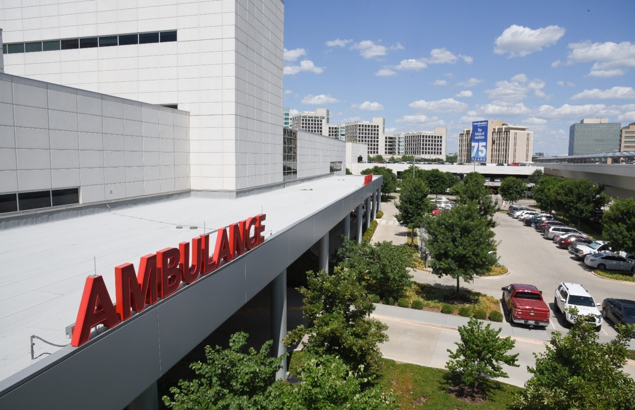
UT Southwestern identification badges are part of the institution’s total security management system and are also used for timekeeping and for access to facilities and medications. See FSS-312 Campus Facilities Access and Key Control for information on badge function, issuance, and replacement.

Annual Fire Safety Report

Overview
The Higher Education Opportunity Act (Public Law 110-315) became law in August 2008. The Act requires United States academic institutions to produce an annual fire safety report outlining fire safety practices, standards, and fire-related statistics for on-campus housing. The following report details all information required by this law as it relates to UT Southwestern Medical Center.
Fire safety at the University is the responsibility of UT Southwestern’s Office of Safety and Business Continuity. All policies and procedures are promulgated by the Office of Safety and Business Continuity in accordance with the Texas State Fire Marshal’s Office and the National Fire Protection Association codes and standards.

Description of Each On-Campus Student Housing Facility Fire Safety System
Southwestern Medical Park Apartments includes 11 three-story apartment buildings with a total of 282 apartment units and a leasing office. Each building is protected by an automatic fire alarm system that includes smoke detection and manual pull stations and has off-premises monitoring 24 hours a day, seven days a week. The apartment buildings are also protected by automatic fire sprinkler systems that are interconnected to the fire alarm system to send an alarm when activated. Fire extinguishers are provided in the breezeways of each building and in common areas of the leasing office.

Residence Hall Fire Drills
In accordance with the definitions of the National Fire Protection Association Life Safety Code (NFPA 101), the Southwestern Medical Park Apartments are occupied as apartment buildings, not dormitories. In accordance with the code, fire drills are not required for these residences.

Policy or Rules on Portable Electrical Appliances, Smoking, and Open Flame in Student Housing Facilities
All of the tenants are given a copy of the Handbook for Residents of Southwestern Medical Park Apartments. This document contains the rules and regulations related to leasing an apartment, and each tenant is required to sign an acknowledgment sheet confirming that they have received a copy. This handbook also contains fire prevention regulations, tips, and procedures, including what to do in the event of a fire. Below is policy information specifically related to portable electrical appliances, smoking, and open flames on the property.
Portable Electrical Appliances, i.e. Space Heaters – Space heaters shall be a maximum of 1,500 watt, listed by Underwriters Laboratories (UL), have a tip-over switch, and be plugged directly into a wall outlet. Combustible materials shall not be stored on top of space heaters or located within 3 feet of the space heater, even when they are not in use.
Smoking – Per UT Southwestern Policy SEC-205, smoking and/or the use of tobacco products is prohibited on all property that is owned, operated, leased, occupied, or controlled by the institution. “Property” for purposes of this policy includes buildings and structures, grounds, parking structures, enclosed bridges and walkways, sidewalks, parking lots, and UT Southwestern vehicles. This includes breezeways, stairwells, and green spaces.
Open Flame – The use of candles, oil lamps, incense, or halogen “torchiere” lamps is prohibited in the buildings. In the event of a power outage, flashlights or other battery-operated lights should be used. BBQ grills, food smokers, or any open-flame device of any type are strictly prohibited within the apartment unit, balcony, patios, or within 25 feet of any building.

Southwestern Medical Park Apartments Instructions on Evacuation in Case of a Fire Alarm or Fire
If there is a fire alarm or fire in your apartment:
Evacuate the apartment immediately and close the door behind you! Use the back of your hand on any closed door prior to opening it. If the door is HOT, find another way out.
Upon exiting the apartment, activate the RED FIRE ALARM PULL STATION at the end of each breezeway on your way out of the building. The pull station will activate the fire alarm, alerting all of the occupants in the building. Dial 214-648-8911 (campus emergency phone number) and report the location of the fire immediately. Once outside of the building, report to the clubhouse and check in with the office personnel.
In the event that the office is closed, if safe, stay in front of the office until management arrives. For accountability purposes, you will need to report to management.
If you are unable to exit your apartment, REMAIN CALM. Dial 214-648-8911 and provide your location to the dispatcher. If there is smoke in your apartment, remember to STAY LOW AND CRAWL to the exit door. Place wet clothing or a towel underneath the door to slow smoke movement into the room. If your clothes catch fire, STOP, DROP, AND ROLL while covering your face.

Fire Safety Education and Training
The fire safety information included in this report is also provided in the Handbook for Residents of Southwestern Medical Park Apartments. Fire safety training is received as part of UT Southwestern Medical Center orientation and includes fire prevention information and the proper use of a fire extinguisher.

Reporting a Fire
Students reporting any fire should contact the UT Southwestern Police Communication Center at 214-648-8911. The University Police will inform the Office of Safety and Business Continuity of any fires.

The responsible party for all fire reports is:
Michael Garcia
Director, Fire and Occupational Safety
Office of Safety and Business Continuity (OSBC)
214-648-2250

Improvements in Fire Safety
The project to add additional fire alarm notification devices in the leasing office is completed, and the devices have been tested and approved for use.

Fire Safety Statistics 2022-2024
Building Address/Unit | Total # of Fires at This Location | Cause of Fire | # of Related Injuries that Required Treatment | # of Related Deaths | Value of Property Damage
 |  | 2022
None | 0 | N/A | 0 | 0 | 0
 |  | 2023
None | 0 | N/A | 0 | 0 | 0
 |  | 2024
None | 0 | N/A | 0 | 0 | 0

Higher Education Opportunity Act Annual Fire Safety Report
The U.S. Department of Education requires compliance with the Higher Education Act of 1965 as a means of keeping the public aware of safety and security concerns related to on-campus student housing. The UT Southwestern Police Department issues a combined Security and Fire Safety Report.
The Office of Safety and Business Continuity Fire Safety Program is responsible for providing information and statistics that satisfy the requirements of the fire safety information portion of the report. Fire safety information in the report is limited to the UT Southwestern Medical Park Apartments, as specified by the Higher Education Opportunity Act.
Fires occurring at on-campus student housing facilities must be documented in a Fire Log that includes the nature, date, time, and general location of each fire. This document is maintained by the UT Southwestern Police Department.
When a fire occurs, the Fire Log is maintained as follows:
- All fires at Southwestern Medical Park Apartments are immediately reported to UT Southwestern Police Dispatch.
- The UT Southwestern Police Department will promptly notify the Office of Safety and Business Continuity to respond and investigate the incident.
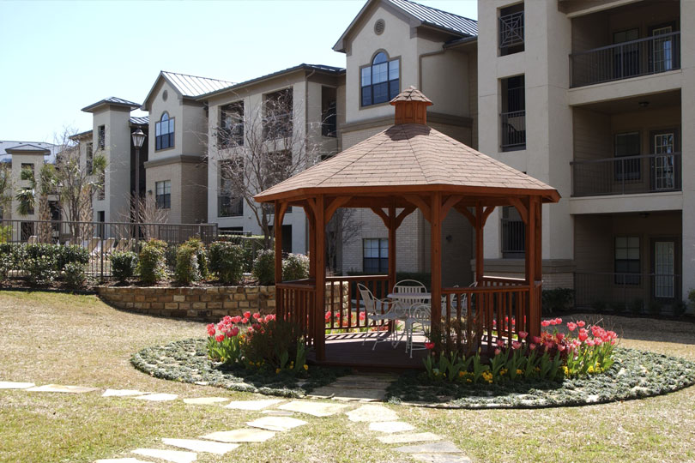
- The date, time, and location of each incident are reported and a case number is automatically assigned by the UT Southwestern Police Department.
- The Office of Safety and Business Continuity will determine the cause of the fire and report it to the UT Southwestern Police Department before the scene is cleared.
- The UT Southwestern Police Department will update the Fire Log within 24 hours of the incident.
Subsequent incident information, such as fire incident response and fire cause and origin reports, may be obtained through the UT Southwestern Medical Center Office of Safety and Business Continuity Fire Safety Program.

Additional Safety and Business Continuity Resources
- Code of Federal Regulations
- Environmental Protection Agency (EPA)
- Occupational Safety and Health Administration (OSHA)
- Centers for Disease Control and Prevention (CDC)
- Federal Emergency Management Agency (FEMA)
- Nuclear Regulatory Commission (NRC)
- National Institute for Occupational Safety and Health (NIOSH)
- Food and Drug Administration (FDA)
- National Institutes of Health (NIH)
- Texas Department of State Health Services

Title IX
UT Southwestern Medical Center is committed to maintaining safe, professional work and learning environments for all employees, students, and residents. The Office for Access & Title IX supports the University’s vision by holding each student and employee to our standards of conduct while proactively providing training and resources designed to create and foster a campus environment free from all forms of sex discrimination.
Title IX of the Education Amendments of 1972 protects people from sex discrimination, including sexual misconduct, harassment, and violence, in educational programs and activities at institutions that receive federal funding.
University policy protects against all forms of sex-based discrimination and sexual misconduct, including Sexual Harassment, Sexual Violence, Sexual Assault, Stalking, Domestic Violence, and/or Dating Violence. These non-discrimination protections include protection against discrimination on the basis of sexual orientation, gender expression, and gender identity. Retaliation against any individual who submits a report, files a complaint, or otherwise participates in the investigation or disciplinary process under the policy is prohibited.
Please see FAQ, Policies, and Training to learn more.

Reporting to UT Southwestern
UT Southwestern strongly encourages the prompt reporting of incidents of sex discrimination (including discrimination on the basis of gender identity, gender expression, and sexual orientation), Sexual Harassment, Sexual Assault, Dating/Domestic Violence, Stalking, or other sexual misconduct. All UT Southwestern employees MUST report all information known about incidents of Sexual Assault, Sexual Harassment, Dating Violence, Stalking, or other sexual misconduct committed by or against a UTSW student, resident, or employee to a Title IX Coordinator. Confidential Employees must report only the type of incident to a Title IX Coordinator. Knowingly failing to promptly report an incident as required could lead to termination of employment and possible criminal charges under state law. If you have questions about your reporting obligations, please contact a Title IX Coordinator.
How to report an incident or Title IX concern:
- Contact the UT Southwestern Title IX Coordinator.
- Contact the Office for Access & Title IX.
- Report the concern to the Compliance Hotline at 877-507-7319. The Compliance Hotline is a confidential third-party reporting service that is available 24 hours a day, seven days a week, 365 days a year. Calls can be made anonymously, or individuals may leave their name. Reports to the hotline are forwarded to UT Southwestern to be promptly evaluated. Employees who choose to report anonymously via this method must retain a record of the report number demonstrating the employee made the report as required by state law.
- Report the concern online.
The University recognizes that deciding whether to make a report and choosing how to proceed can be difficult decisions. The University encourages any individual who has questions or concerns to seek the support of campus and community resources. These professionals can provide information and assistance regardless of when or where the incident occurred.

Reporting to Law Enforcement
The University also encourages complainants to pursue criminal action for incidents that may also be crimes under state criminal law, including sexual violence, relationship violence, assault, or stalking. The University will assist a complainant, at the complainant’s request, in contacting local law enforcement and will cooperate with local or campus law enforcement agencies if a complainant decides to pursue the criminal process.
Emergency On-Campus
911

Emergency – Off-Campus or Mobile Callers
214-648-8911

Non-Emergency
214-648-8311

Commitment to Privacy and Confidentiality
All Title IX concerns are treated as confidential, and Title IX Coordinators will only share information with authorized individuals as necessary. All UT Southwestern employees must report any incidents of Sexual Harassment, Sexual Violence, Domestic/Dating Violence, Stalking, or other sexual misconduct committed by or against a student, resident, or employee. This reporting requirement does NOT apply to Confidential Employees, including counselors in Student Wellness and Counseling, the Resident Wellness and Counseling Center, the Employee Assistance Program, members of the Student Assistance Committee, providers in Student Health Services, or members of the clergy. This reporting requirement also does not apply to police officers when a victim uses a pseudonym form under the Code of Criminal Procedure for incidents of Sexual Assault, Stalking, family violence, and human trafficking. Employees who learn about incidents under other confidential circumstances (such as attorneys or treating health care providers) are also exempt from the reporting requirement. Confidential Employees are only required to report the type of incident and may not include any information that would violate an individual’s privacy.

Title IX Coordinator
Travis Gill, J.D.
Assistant Vice President of Access & Title IX
Phone: 214-648-9843
Email: Travis.Gill@utsouthwestern.edu

Victim Services
Victims of crime are guaranteed certain rights and participation in the criminal justice system under Texas law. These rights are discussed within the Texas Constitution Article 1, § 30, and the Texas Code of Criminal Procedure Articles 56A.01 – 56A.054.
In order to exercise your rights as a crime victim, it is necessary to contact crime victim service providers to discuss and request, if applicable, your rights and available services. Your local district or county attorney’s office, law enforcement agency, or supervising agency (probation or prison) will have crime victim service providers and staff available to assist you.
If you have any questions regarding these rights and how to exercise them, please contact the Texas Department of Criminal Justice Victim Services Division at 800-848-4284 or victim.svc@tdcj.texas.gov

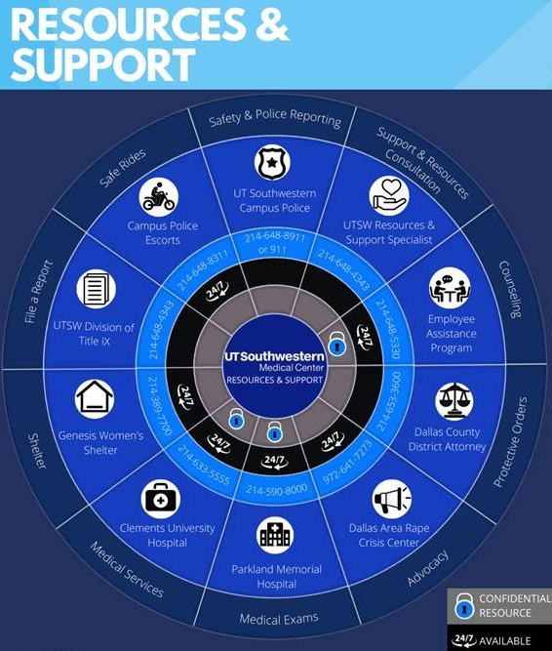


SEC-201 DRUG-FREE CAMPUS
CHAPTER 4: CAMPUS SECURITY AND PREPAREDNESS
CONTENTS  Policy Link  Policy Rationale and Text  Scope  Definitions  Related Statutes, Policies, or Standards  Appendix  Contacts/For Further Information  Policy History | ADMINISTRATIVE INFORMATION  Responsible Office: University Police Department  Executive Sponsor: Executive Vice President for Business Affairs  Effective Date: January 1998  Last Updated: May 1, 2025  Contact: policyoffice@utsouthwestern.edu
POLICY RATIONALE AND TEXT
In compliance with the Drug-Free Schools and Communities Act, the Drug-Free Workplace Act, and UT System policies, it is UT Southwestern policy to provide a drug-free campus, University community, and workplace.

Standards of Conduct

Possession and Use of Controlled Substances
UT Southwestern prohibits the unlawful purchase, manufacture, distribution, possession, sale, storage, dispensation, or use of a Controlled Substance while in or on premises or property owned or controlled by UT Southwestern, in vehicles used for UT Southwestern business, or while participating in UT Southwestern-related activities. This prohibition includes the distribution of a drug or Controlled Substance obtained pursuant to a prescription, except by a duly licensed and certified person. Controlled Substances may be used as prescribed for an individual by a duly certified medical practitioner or used for research in accordance with RES-205 Controlled Substances for Non-Human Research.

Possession and Use of Alcohol
UT Southwestern prohibits the unauthorized and illegal use or possession of alcohol while in or on premises or property owned or controlled by UT Southwestern, in vehicles used for UT Southwestern business, or while participating in UT Southwestern-related activities. Alcoholic beverages are allowed on UT Southwestern premises or property only with prior written approval of the President for specific events or as permitted in the A.W. Harris Faculty-Alumni Center, in accordance with SEC-204 Serving Alcohol on Campus. However, the use of alcohol in or on premises or property owned or controlled by UT Southwestern or at UT Southwestern-related activities in any manner that adversely affects job performance or the safety of any other person is prohibited.

Reporting Requirement
An employee, resident, or fellow who is found guilty (including a plea of “no contest”) or has a sentence, fine, or other penalty imposed by a court of competent jurisdiction under a criminal statute for an offense involving a Controlled Substance that occurred in or on premises or property owned or controlled by UT Southwestern, in vehicles used for UT Southwestern business, or while participating in UT Southwestern-related activities shall report such action to UT Southwestern in writing within five (5) business days. Failure to timely report in the manner required by this policy could result in disciplinary action.
- Employees must report in accordance with EMP-152 Security-Sensitive Positions and Background Checks.
- Students must report in accordance with EDU-151 Student Conduct and Discipline.
- Residents and fellows must report to the Office of Graduate Medical Education.

Violations
UT Southwestern will impose sanctions on individuals who violate the Standards of Conduct in this policy in accordance with the UT Southwestern disciplinary policy and procedure applicable to the individual (e.g., student, resident, employee), up to and including expulsion, dismissal, or non-renewal of appointment.
In addition to the above-mentioned sanctions, any person who violates the Standards of Conduct in this policy can be referred for arrest and prosecution under appropriate State or Federal criminal laws.

Resources, Assistance, and Education
UT Southwestern recognizes drug, alcohol, and chemical abuse as treatable conditions that affect the lives and productivity of many individuals and offers the following education and resources for individuals in need of information and assistance:
- Each year, the University Police Department will distribute to all employees and students a copy of this policy and Appendix A, which includes a description of sanctions under State and Federal law for drug- and alcohol-related offenses, a description of the UT Southwestern penalties for violating the Standards of Conduct in this policy, and a description of the health risks of drug and alcohol abuse.
- Employees in need of assistance with drug or alcohol abuse, dependence, or other related problems may receive confidential counseling and other services through our external Employee Assistance Program provider. Support is available 24/7 by calling 855-420-0734.
- Students in need of assistance with drug or alcohol abuse, dependence, or other related problems may contact the Student Assistance Committee (214-648-5594), Student Health Services (214-645-8690), or Student Wellness and Counseling (214-645-8680) for confidential counseling. (See EDU-117 Fitness for Participation in UT Southwestern Activities.)

- Residents or fellows in need of assistance with drug or alcohol abuse, dependence, or other related problems are encouraged to voluntarily self-report to their program director, to seek guidance from the UT Southwestern Resident Wellness and Counseling Center, or to seek support from our external Employee Assistance Program provider or from another appropriate medical professional. (See Graduate Medical Education Policies and Procedures, Impaired Resident Policy.)

Biennial Review
The Office of Business Affairs will review UT Southwestern’s drug and alcohol abuse program every two years in accordance with applicable laws and regulations.
SCOPE
This policy applies to all UT Southwestern students, including postdoctoral scholars appointed to academic training positions; to all employees, including faculty and staff members, residents and fellows; and to volunteers, vendors, contractors, and other individuals involved in UT Southwestern-related activities.
DEFINITIONS
Controlled Substance – a Controlled Substance included in schedules I through V of the Drug Abuse Prevention and Control Act, 21 U.S.C. § 812.
Prescribed drug – any substance prescribed specifically for an individual by a licensed medical practitioner or used in an Institutional Review Board-approved protocol for human subject research.
UT Southwestern-related activities – work, educational, research, training, or clinical activities or events sponsored or supported by UT Southwestern, regardless of whether the activities or events take place in or on premises or property owned or controlled by UT Southwestern.
RELATED STATUTES, POLICIES, OR STANDARDS
- The Drug-Free Workplace Act of 1988 (41 U.S.C. §§ 8101-8106)
- The Drug-Free Work Force Regulations for Department of Defense (DOD) Contractors (48 C.F.R. §§ 252.223-7004)
- The Drug-Free Schools and Communities Act of 1989 and Regulations (20 U.S.C. § 1011i; 34 C.F.R. Part 86)
- UT System Policy UTS 102 Drugs and Alcohol Policy
- UT System Policy UTS 164 Drug-Free University Community and Workplace Policy
- EDU-117 Fitness for Participation in UT Southwestern Activities
- EDU-118 Drug Testing Requirement
- EDU-151 Student Conduct and Discipline
- EDU-151P-01 Procedures for Student Discipline
- EMP-152 Security-Sensitive Positions and Background Checks
- EMP-160 Drug Testing Requirement
- EMP-255 Fitness for Duty
- EMP-255P-01 Determining Fitness for Duty
- EMP-351 Discipline and Dismissal of Classified Employees
- FAC-157 Faculty Fitness for Duty
- RES-205 Controlled Substances for Non-Human Research
- SEC-204 Serving Alcohol on Campus
- AMB 6.15 Controlled Substances
- UHMM 06 Controlled Substance – Hospital Policy
- Graduate Medical Education Policies and Procedures, Academic Improvement and Corrective Action Policy
APPENDIX
- SEC-201A Appendix A – Information for Students and Employees Regarding Illicit Drugs and Alcohol Abuse
CONTACT/FOR FURTHER INFORMATION
Employee Support Program:
- Website: https://www.utsouthwestern.edu/employees/hr-resources/eap/
Office of Human Resources
- Phone: 214-648-9810
- Email: hr@utsouthwestern.edu
Resident Wellness and Counseling Center
- Phone: 214-648-9969
Student Assistance Committee
- Phone: 214-648-5594
Student Health Services
- Phone: 214-645-8690
Student Wellness and Counseling
- Phone: 214-645-8680
University Police Department
- Phone: 214-648-8311
POLICY HISTORY
May 1, 2025: Completed scheduled review; added students to the Reporting Requirement section; referred to the appropriate policies for employees and students for reporting; updated information about the Employee Assistance Program.
July 6, 2020: Completed scheduled review; updated policy as necessary.
July 7, 2015: Completed scheduled review; renamed to SEC-201 Drug-Free Campus.
May 14, 2015: Transferred HR Policy Memorandum 9.0404 Possession or Use of Illegal Drugs to online Handbook as SEC-201 Alcohol, Drug, and Chemical Abuse; superseded 2.8.
Sept. 1, 1998: Posted HR Policy Memorandum 9.0404 Possession or Use of Illegal Drugs.
January 1998: Published as 2.8 Alcohol, Drug, and Chemical Abuse.

HANDBOOK OF INSTITUTIONAL POLICIES AND OPERATING PROCEDURES
SEC-201 DRUG-FREE CAMPUS

Appendix A: Information for Students and Employees Regarding Illicit Drugs and Alcohol Abuse

Health Risks of Alcohol and Drugs
Alcohol. Health hazards associated with the excessive use of alcohol or with alcohol dependency include dramatic behavioral changes, retardation of motor skills, and impairment of reasoning and rational thinking. These factors result in a higher incidence of accidents and accidental death for such persons than for non-users of alcohol. Nutrition also suffers and vitamin and mineral deficiencies are frequent. Prolonged alcohol abuse causes bleeding from the intestinal tract, damage to nerves and the brain, psychotic behavior, loss of memory and coordination, damage to the liver often resulting in cirrhosis, impotence, severe inflammation of the pancreas, and damage to the bone marrow, heart, testes, ovaries, and muscles. Damage to the nerves and organs is usually irreversible. Cancer is the second leading cause of death in alcoholics and is 10 times more frequent than in non-alcoholics. Sudden withdrawal of alcohol from persons dependent on it will cause serious physical withdrawal symptoms. Drinking during pregnancy can cause fetal alcohol syndrome. Overdoses of alcohol can result in respiratory arrest and death.
Drugs. The use of illicit drugs usually causes the same general type of physiological and mental changes as alcohol, though frequently those changes are more severe and more sudden. Death or coma resulting from an overdose of drugs is more frequent than from alcohol.
Cocaine. Cocaine is a stimulant that is most commonly inhaled as a powder. It can be dissolved in water and used intravenously. The cocaine extract (crack) is smoked. Users can progress from infrequent use to dependence within a few weeks or months. Psychological and behavioral changes resulting from use include overstimulation, hallucinations, irritability, sexual dysfunction, psychotic behavior, social isolation, and memory problems. An overdose produces convulsions and delirium and may result in death from cardiac arrest. Discontinuing the use of cocaine requires considerable assistance, close supervision, and treatment.
Amphetamines. Patterns of use and effects are similar to cocaine. Severe intoxication may produce confusion, rambling or incoherent speech, anxiety, psychotic behavior, ringing in the ears, hallucinations, and irreversible brain damage. Intense fatigue and depression resulting from use can lead to severe depression. Large doses may result in convulsions and death from cardiac or respiratory arrest.
MDA and MDMA (XTC, ecstasy). These amphetamine-based hallucinogens are sold in powder, tablet, or capsule form and can be inhaled, injected, or swallowed. They cause similar, but usually milder, hallucinogenic effects than those of LSD. Because they are amphetamines, tolerance can develop quickly and overdoses can happen. Exhaustion and possible liver damage can occur with heavy use. In high doses, these drugs can cause anxiety, paranoia, and delusions. While rare, these drugs have been associated with deaths in users with known or previously undiagnosed heart conditions.
Rohypnol (rophies, roofies, rope). This drug is in the same category of drugs as Valium, a benzodiazepine, but it is more potent than Valium. Initially, it causes a sense of relaxation and reduction of anxiety; at higher doses, lightheadedness, dizziness, lack of coordination, and slurred speech occur. The drug affects memory and, in higher doses or if mixed with other drugs or alcohol, can result in amnesia for the time period the user is under the influence. Because of this amnesia effect, Rohypnol has been given intentionally to others to facilitate sexual assault and other crimes. Combining this drug with other sedating drugs, including alcohol, will increase the intensity of all effects of the drug and, in sufficient doses, can cause respiratory arrest and death. Dependency can occur.
Heroin and other opiates. These drugs are usually taken intravenously. “Designer” drugs similar to opiates include fentanyl, Demerol, and “China white.” Addiction and dependence develop rapidly. Use is characterized by impaired judgment, slurred speech, and drowsiness. Overdose is manifested by coma, shock, and depressed respiration, with the possibility of death from respiratory arrest. Withdrawal problems include sweating, diarrhea, fever, insomnia, irritability, nausea and vomiting, and muscle and joint pain.
Hallucinogens or psychedelics. These include LSD, mescaline, peyote, and phencyclidine (PCP or “angel dust”). Use impairs and distorts one’s perceptions of surroundings, causes bizarre mood changes, and results in visual hallucinations involving geometric forms, colors, and persons or objects. Users who discontinue use experience “flashbacks” consisting of distortions of virtually any sensation. Withdrawal may require psychiatric treatment for the accompanying persistent psychotic states.
Solvent inhalants, e.g., glue, lacquers, plastic cement. Fumes from these substances cause problems similar to alcohol. Incidents of hallucinations and permanent brain damage are more frequent with chronic use.
Marijuana (cannabis). Marijuana is usually ingested by smoking. Smoking marijuana causes disconnected ideas, alteration of depth perception and sense of time, impaired judgment, and impaired coordination. Prolonged use can lead to psychological dependence.
Damage from intravenous drug use. In addition to the adverse effects associated with the use of a specific drug, intravenous drug users who use unsterilized needles or who share needles with other drug users can contract or develop HIV, hepatitis, tetanus (lockjaw), and infections in the heart. Permanent damage may also result.

UT Southwestern Penalties
Students. UT Southwestern will impose a minimum sanction of suspension for a specified period of time or suspension of rights and privileges, or both, on any student found responsible for the illegal use, possession, or distribution of a Controlled Substance (as defined in SEC-201 Drug-Free Campus) while in or on premises or property owned or controlled by UT Southwestern, in vehicles used for UT Southwestern business, or while participating in UT Southwestern-related activities. Other sanctions that UT Southwestern may impose on students found responsible for the illegal use, possession, or distribution of a Controlled Substance or alcohol while in or on premises or property owned or controlled by UT Southwestern, in vehicles used for UT Southwestern business, or while participating in UT Southwestern-related activities include disciplinary probation, restitution or reimbursement for damage to or misappropriation of property, expulsion, or such other sanction as deemed appropriate under the circumstances.
Employees, Residents, and Fellows. The illegal use, possession, or distribution of a Controlled Substance or alcohol will result in a penalty of disciplinary probation, demotion, suspension without pay, or dismissal or non-renewal of appointment, depending on the circumstances.

Penalties Under State and Federal Law
PENALTIES UNDER TEXAS LAW
OFFENSE | MINIMUM PUNISHMENT | MAXIMUM PUNISHMENT
Manufacture or delivery of Controlled Substances (drugs) | Confinement in jail for a term of not more than two years or less than 180 days, and a fine not to exceed $10,000 | Imprisonment for life or for a term of not more than 99 years nor less than 15 years, and a fine not to exceed $250,000
Possession of Controlled Substances (drugs) | Confinement in jail for a term of not more than 180 days, a fine not to exceed $10,000 | Imprisonment for life or for a term of not more than 99 years nor less than 10 years, and a fine not to exceed $250,000
Delivery of marijuana | Confinement in jail for a term not more than 180 days, a fine not to exceed $2,000, or both | Imprisonment for life or for a term of not more than 99 years nor less than 10 years, and a fine not to exceed $100,000
Possession of marijuana | Confinement in jail for a term not more than 180 days, a fine not to exceed $2,000, or both | Imprisonment for life or for a term of not more than 99 years nor less than 5 years, and a fine not to exceed $50,000
Driving while intoxicated (includes intoxication from alcohol, drugs, or both) | Confinement in jail for a term of not more than 180 days nor less than 72 hours, and a fine of not more than $2,000 | Imprisonment for a term of not more than 10 years nor less than two years, and a fine not to exceed $10,000
Public intoxication | A fine not to exceed $500 | Varies with age and number of offenses
Purchase of alcohol by a minor | A fine not to exceed $500 | Varies with number of offenses
Consumption or possession of alcohol by a minor | A fine not to exceed $500 | Varies with number of offenses
Sale of alcohol to a minor | A fine not to exceed $4,000 or confinement in jail for not more than one year, or both | A fine not to exceed $4,000 or confinement in jail for not more than one year, or both
PENALTIES UNDER FEDERAL LAW
OFFENSE | MINIMUM PUNISHMENT | MAXIMUM PUNISHMENT
Manufacture, distribution, or dispensing drugs (includes marijuana) | A term of imprisonment for not less than 5 years and a fine of not more than $5,000,000 (for an individual) or $25,000,000 (if other than an individual) | A term of life imprisonment without release (no eligibility for parole) and a fine not to exceed $20,000,000 (for an individual) or $75,000,000 (if other than an individual)
Possession of drugs (including marijuana) | Imprisonment for no less than 5 years and a fine not more than $250,000 (for an individual) or $1,000,000 (if other than an individual) | Imprisonment for not less than 20 years and a fine not more than $20,000,000 (for an individual) or $75,000,000 (if other than an individual)
Operation of a Common Carrier under the influence of alcohol or drugs |  | Imprisonment for up to 15 years and a fine not to exceed $250,000

Additional Resources

Office of Student Affairs
The Office of Student Affairs serves to advance the academic, intellectual, and personal development and success of future physicians as they prepare at UT Southwestern Medical School for a career in medicine.
Office of Student Affairs
5323 Harry Hines Blvd.
Dallas, Texas 75390-9006
Phone: 214-648-2168
Fax: 214-648-7517

Office of Student Empowerment and Engagement (OSEE)
The Office of Student Empowerment and Engagement serves all the students of UT Southwestern Medical Center. Students’ education is not limited to classrooms, labs, and clinics. The Office of Student Empowerment and Engagement supports campus engagement through events that celebrate different backgrounds and student organizations that encourage fellowship and community service. In fact, the Office of Student Empowerment and Engagement houses a large space for student organization meetings, social and cultural events, or even just to relax.
Office of Student Empowerment and Engagement (OSEE)
Phone: 214-648-0308

Student Health Services
Student Health Services, located on the second floor of Professional Office Building 1, 5959 Harry Hines Blvd., is staffed by a nurse practitioner, a registered nurse, a certified medical office assistant, and a clinic staff assistant. All office visits are confidential.
Prior to your first visit to Student Health or another on-campus clinic, please call to verify that your insurance plan is accepted.
Services available to students include:
- Acute care
- Primary care services
- Sexual and reproductive health
- LGBTQI healthcare
- Specialty referral
- Travel medication
- Routine immunizations
Student Health Services does not manage medical emergencies such as:
- Severe pain
- Deep cuts or lacerations
- Suspected broken bones
- Injuries related to a motor vehicle accident
If you are experiencing a medical emergency, go to William P. Clements Jr. University Hospital or the nearest emergency facility. If you are not sure whether you need to go to an emergency medical facility, call Student Health Services at 214-645-8690 for help assessing the situation.
If you have an after-hours need, call 214-645-8690 and the answering service will have the on-call physician contact you.
For mental health emergencies, call the Student Wellness and Counseling Center at 214-645-8680 and follow the voice prompts. The on-call psychiatrist will return your call.
Student Health Services
POB 1, Suite HP2.204 (2nd Floor)
5959 Harry Hines Blvd.
Dallas, Texas 75390-9006
Phone: 214-645-8690
Fax: 214-645-8676

Student Wellness and Counseling
The UT Southwestern Student Wellness and Counseling Center provides personal counseling, psychotherapy, group therapy, and psychiatric services for UT Southwestern students in the Medical School, Graduate School of Biomedical Sciences, School of Health Professions, and the Peter O’Donnell Jr. School of Public Health. Our goal is to help students maintain wellness and discover ways of thriving instead of merely surviving during their time here as students.
Student Wellness and Counseling Center
S Building, Suite S2.100 (2nd Floor)
5323 Harry Hines Blvd.
Dallas, Texas 75390-9006
Phone: 214-645-8680

UTSW Student Wellness and Counseling Crisis Line
Phone: 214-645-8680
Monday-Friday, 5 p.m.-8 a.m.
Saturday and Sunday, 24 hours
(UT Southwestern students only – available every day of the year, including holidays)
UTSW Crisis Line is a confidential service that offers an opportunity for UTSW students to talk with trained counselors about urgent concerns after hours. A counselor is available every day of the year, including holidays. You can call us at your convenience. Our telephone counselors will spend time addressing your immediate concerns. Our telephone counselors also have specific training in responding to crisis situations.
Common reasons students call include:
- You want help with an immediate personal crisis.
- You are thinking about suicide.
- You are feeling distressed.
Students who exercise self-care by engaging with our clinical staff have expressed that they experience an enhanced quality of life, personal fulfillment, and academic success. We have a wonderful, diverse staff including medical office assistants, a registered nurse clinical supervisor, clinical psychologists, and psychiatrists. Once students receive the support they need to achieve a state of health and balance, they are better able to engage in learning and go on to become leaders and contribute to their profession in meaningful ways.
Services available to students include:
- Psychotherapy
- Psychiatric assessment and medication management
- Assessment for learning, attention, and academic issues
- Mindfulness training
- Grief counseling
- Stress and anxiety management
- Wellness and prevention
- Consultation
- After-hours crisis management, 214-645-8680

Court-Issued Protective Orders
The UT Southwestern Police Department officers are authorized under Article 14.03 of the Texas Code of Criminal Procedure to enforce orders of protection. UT Southwestern students, staff, and faculty are encouraged to notify the UT Southwestern Police Department when an order of protection has been issued on their behalf. The UT Southwestern Police Department will record and maintain a copy of the order for the duration of its validity. However, the UT Southwestern Police Department is not required to have a copy of the order for enforcement purposes.

Dallas County District Attorney’s Office Resources
Visit the Dallas County District Attorney’s Office website for its full list of resources, available in both English and Spanish.
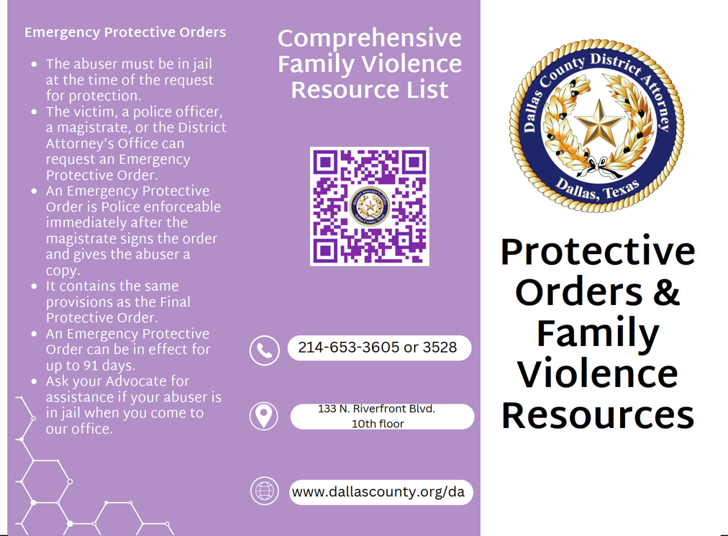
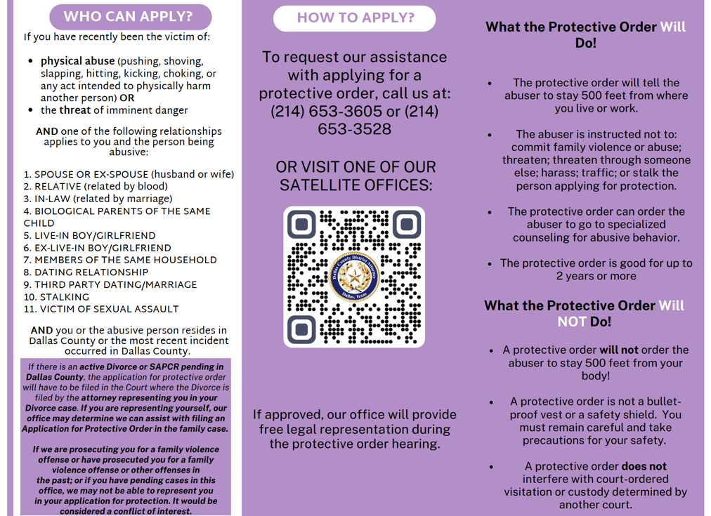

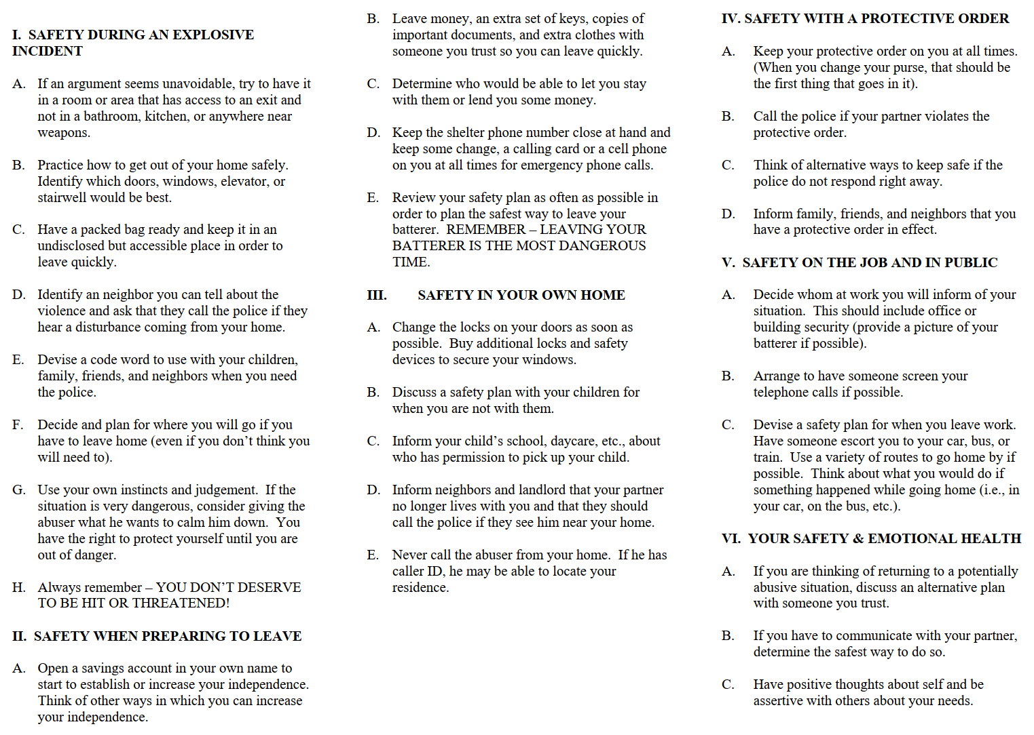
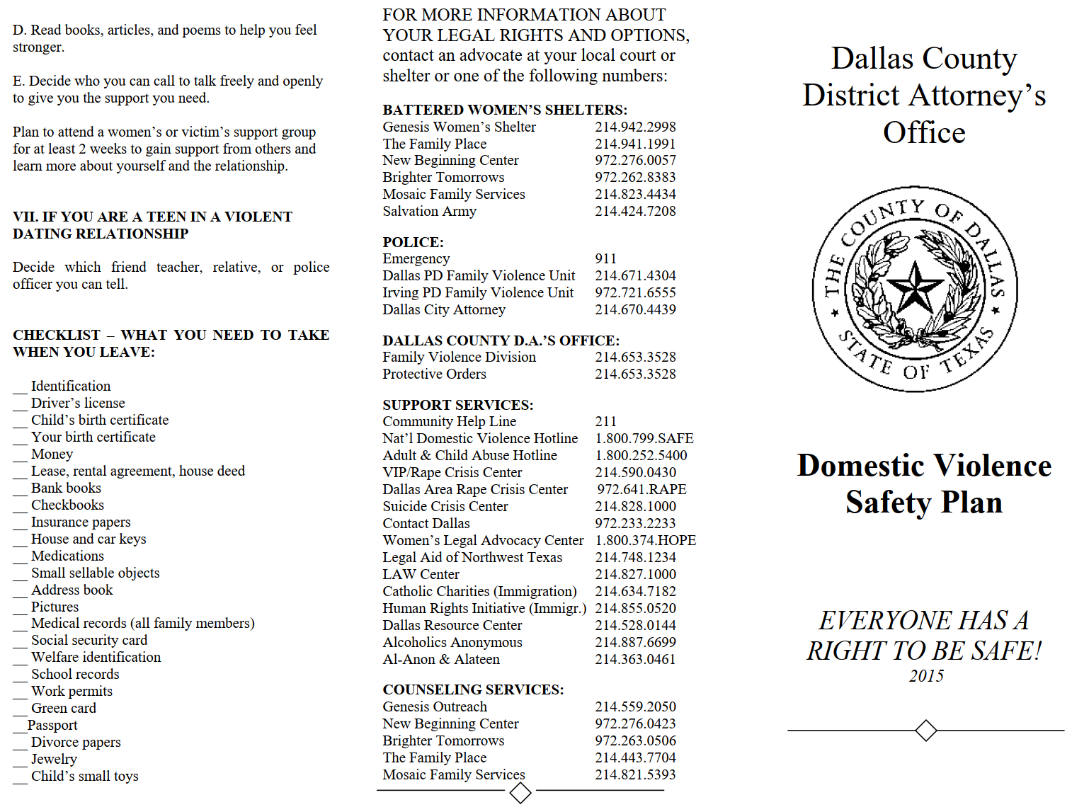

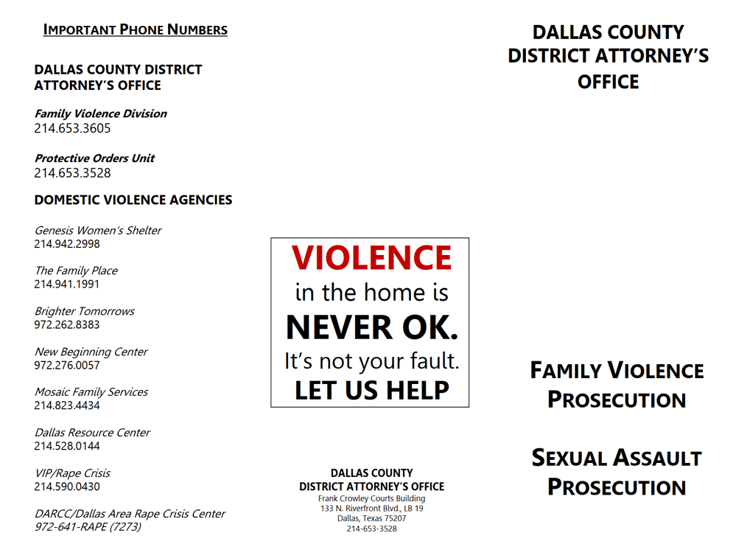

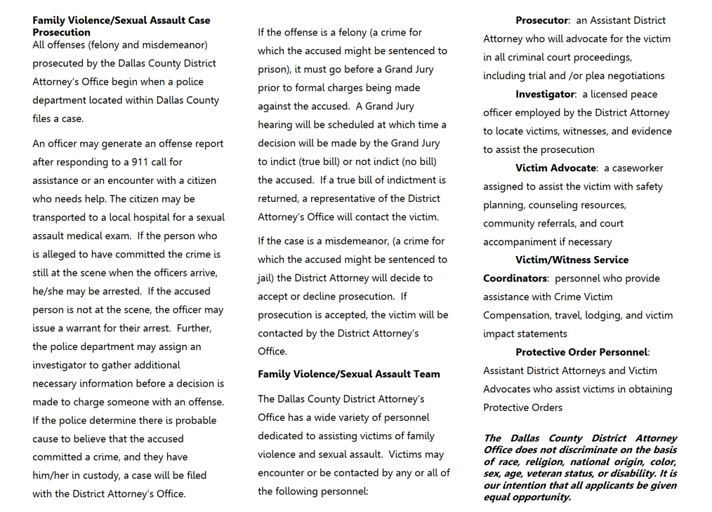
Campus Map The blue phones represent the approximate location of blue light emergency phones
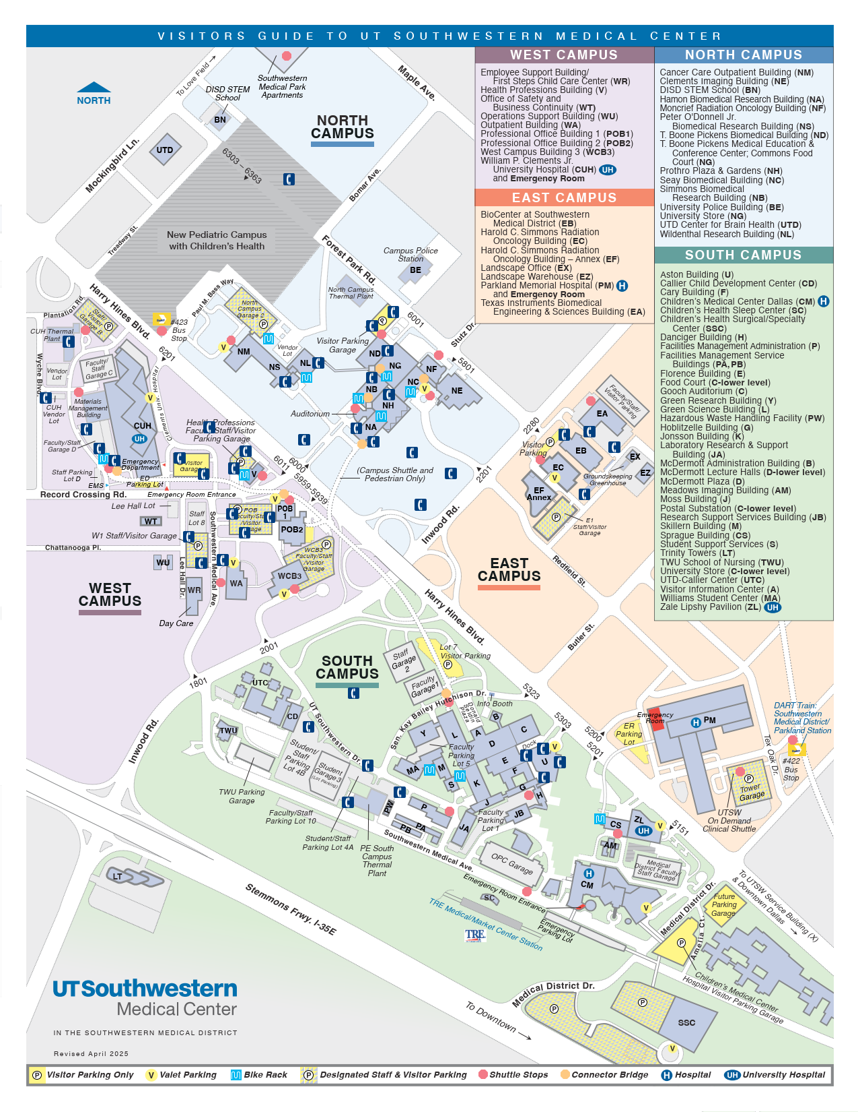
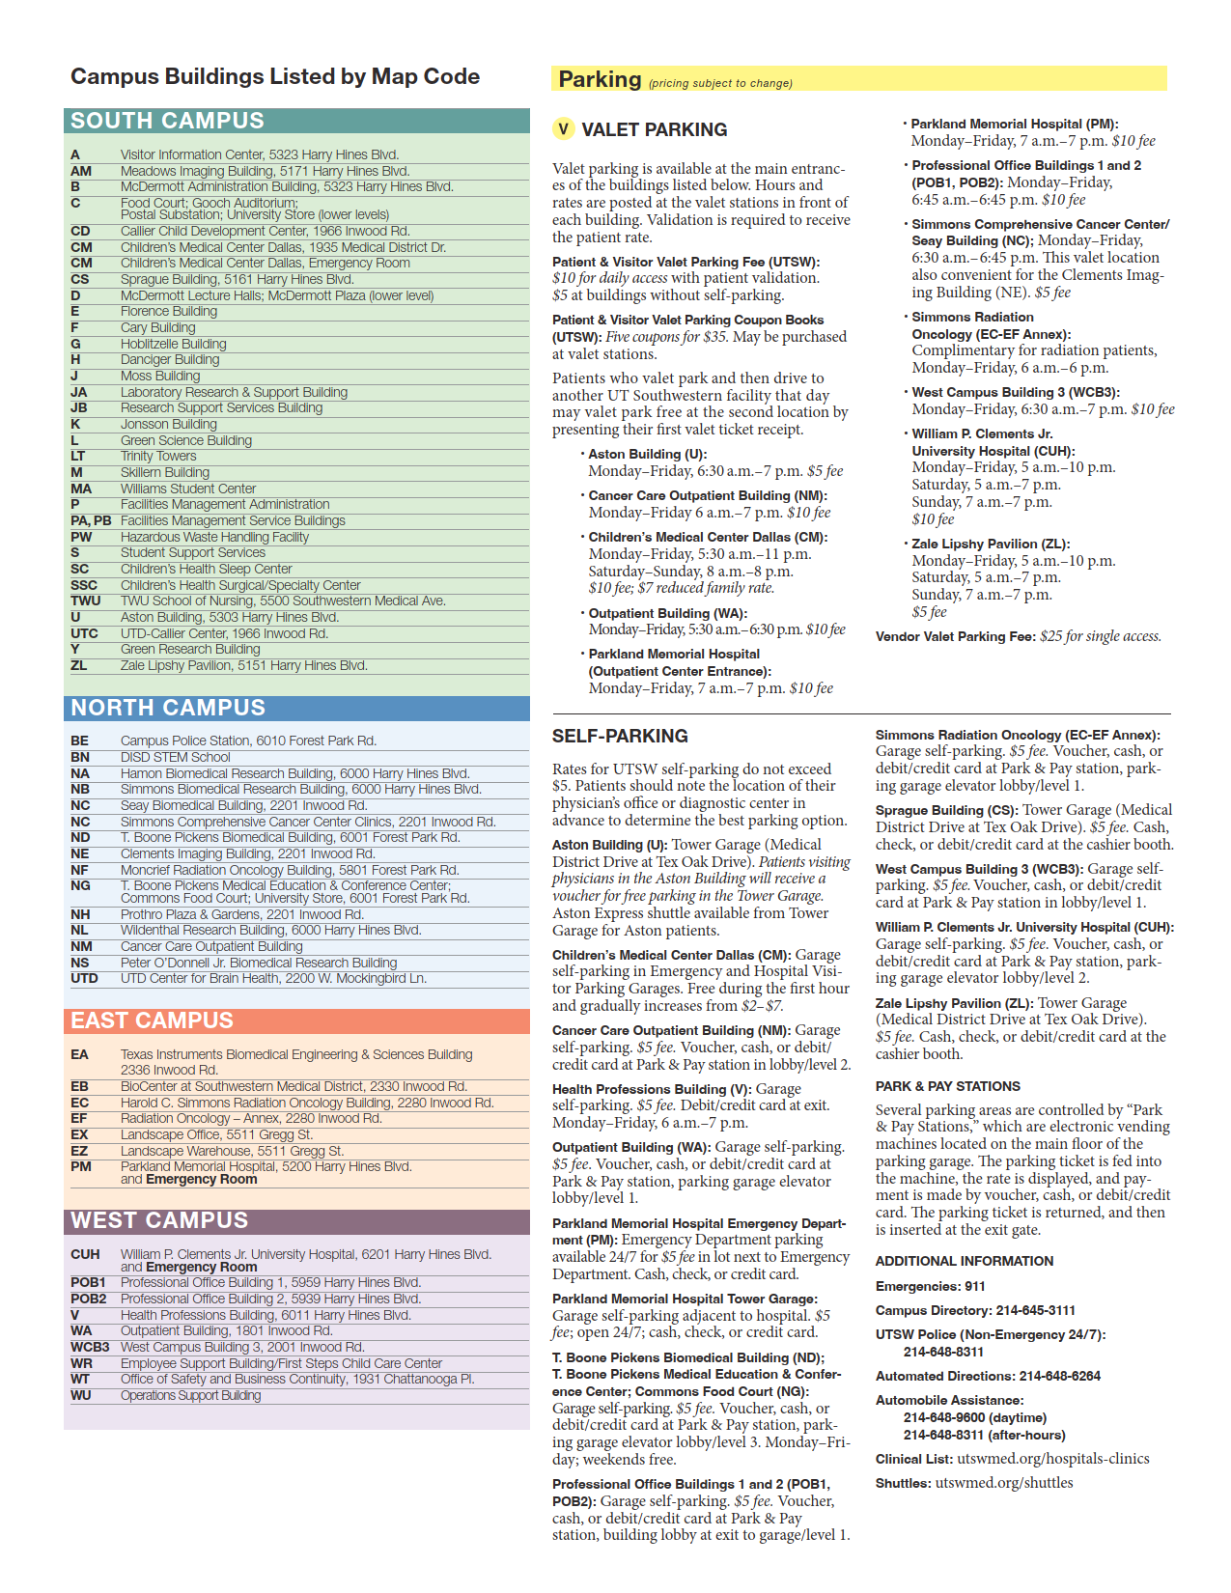

Hotlines
Child & Adult Protective Services | 1-800-252-5400
Alcoholic Recovery (Dallas 24 Hour Club) | 214-823-3200
Child and Family Guidance Center (various services) | 214-351-3490
Dallas City Attorney | 214-670-4439
Other Dallas City Services | 3-1-1
Dallas Area Rape Crisis Center | 972-641-7273
Dallas Police Crisis Intervention/Social Services | 214-671-3498
Dallas Police Domestic Violence Counselors | 214-671-4307 (Spanish)  214-671-4325
Dallas Police Family Violence Unit | 214-671-4304
Dallas Police Victim Services | 214-671-3587 (Spanish)  214-671-3588 (Vietnamese)
Dallas Police Non-Emergency Dispatch | 214-744-4444
Department of Protective and Regulatory Services | 1-800-252-5400
Dispute Mediation Service (court-ordered) | 214-754-0022
Dallas District Attorney Family Violence | 214-653-3528
The Family Place Domestic Violence Center (Dallas County) | 214-941-1991
Genesis Women’s Shelter (Dallas County) | 214-942-2998
Lawyers Against Domestic Violence | 214-748-1234, ext.3012
Mothers Against Drunk Driving (MADD) | 1-800-382-6233
National Domestic Violence Hotline | 1-800-799-SAFE (7233)
National Sex Assault Hotline | 1-800-656-HOPE (4673)
National Suicide Prevention Line | 1-800-273-8255
National Hotline for Crime Victims | 1-855-4-VICTIM (84-2846)
Hope’s Door/New Beginning Center (Dallas/Collin Co) | 972-276-0057
North Texas Poison Center | 1-800-222-1222
Parkland Violence Intervention Prevention Center | 214-590-2926 / 214-590-0430
Dallas Police Protective Order Information | 214-653-3528
Rape Crisis Center | 214-590-0430
National Runaway Hotline | 1-800-786-2929 / 1-800-RUN-AWAY
Salvation Army Family Violence Shelter | 214-424-7208
Suicide & Crisis Center of North Texas | 214-828-1000
Suicide Crisis Center | 214-828-1000
The Turning Point (Rape Crisis Center, Dallas & Collin County) | 1-800-886-7273

