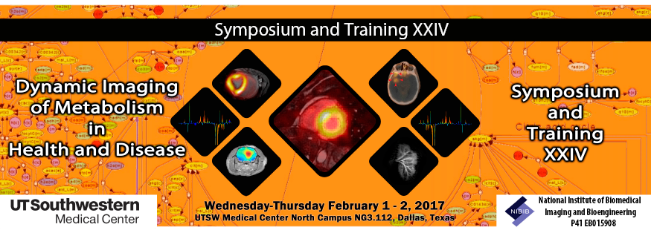

Event Registration Questionnaire:

Please complete this form, then save as a PDF and email the completed form to:
AnnualSymposium@UTSouthwestern.edu
(Registration confirmation will be via email address unless requested otherwise)

Name (Last, First, MI): _____________________________________________________
Institution: __UTA __UTD __UTSWMC __Other: _________________________________
City: __________________________________ State:___________________________
UTSWMC Mail Code: _________
Department: ***____________________________________________________________
Degree (s):** __________________________
Institution Title (faculty, postdoc, staff, etc.)______________________________________
Email Address: ___________________________________________________________

Do you plan to attend the Hyperpolarized MR Facility Tour/Demos between 1:15PM – 2:45PM?
SPINlab/Clinical MRI YES or NO
Preclinical Hyperpolarization (HyperSense/SwissSense) YES or NO
Pharmacy Facility for Hyperpolarized Agents YES or NO

Do you plan to eat lunch on day 1 (Wednesday, February 01, 2017)? YES or NO
Do you plan to eat lunch on day 2 (Thursday, February 02, 2017)? YES or NO
Would you prefer a vegetarian lunch option? YES or NO
(Coupons for lunch will be distributed at meeting registration)

We encourage you to submit an abstract reviewing your current area of research. Please go to Abstract Registration for Instructions.
The Registration deadline is January 24, 2017 at 5:00 PM.

Contacting AIRC
For additional information, please contact Paula Walker at (214) 645-2780 or AnnualSymposium@UTSouthwestern.edu

