Hyperpolarized ¹³C NMR Detects Rapid Drug-induced Changes in Cardiac Metabolism
Authors: Chalermchai Khemtong, Nicholas R. Carpenter, Lloyd L. Lumata, Matthew E. Merritt, Karlos X. Moreno, Zoltan Kovacs, Craig R. Malloy, and A. Dean Sherry*
Institution: Advanced Imaging Research Center, University of Texas Southwestern Medical Center, 5323 Harry Hines Blvd., Dallas, Texas 75390-8568
Email: dean.sherry@utsouthwestern.edu
Myocardial metabolism is highly flexible with alterations in substrate utilization occurring daily. It is believed that diagnostic tools that can quickly and accurately detect rapid changes in cardiac metabolism would be highly useful for detecting diseased myocardium with compromised metabolic flexibility. Herein, we report the use of HP ¹³C NMR to detect sudden changes in cardiac metabolism in perfused hearts as a result of cardiac drug stimulation. After injection of HP-[1-¹³C]pyruvate, resonances characteristic of HP-lactate, bicarbonate, and alanine began to appear in each spectrum as a result of pyruvate metabolism. At the time when the signal of HP-lactate had reached an apex (the maximum intensity occurred at ~18 s), isoproterenol was injected into the perfusion chamber to stimulate cardiac function (Figs. 1A-B). Within a few sec, the HR increased from 345 to 490 bpm and the coronary flow increased from 11 to 22 mL/min. Surprisingly, signal intensity of HP-lactate, which had begun to decay after reaching a first apex, sharply increased in intensity and reached a second apex ~40 s later. Neither the HP-[1-¹³C]alanine or the HP-HCO₃⁻ curves were altered upon addition of isoproterenol (Fig. 1B). The second apex in the HP-lactate curve was not observed in hearts undergoing the same perfusion conditions without the injection of isoproterenol (Fig. 1C). The second apex in the HP-lactate curve was subsequently traced to a sudden increase in lactate pool size arising from glycogenolysis, glycolysis and subsequent production of lactate (confirmed in separate experiments not described here). This indicates that lactate derived from glycogen rapidly mixes with the existing lactate and exchanges with any remaining HP-[1-¹³C]pyruvate. This results in the appearance of second apex in the lactate polarization curve near 70 s. These results demonstrate the feasibility of using HP ¹³C MRS as a tool to detect rapid changes in cardiac metabolism in response to exposure to cardiac drugs.
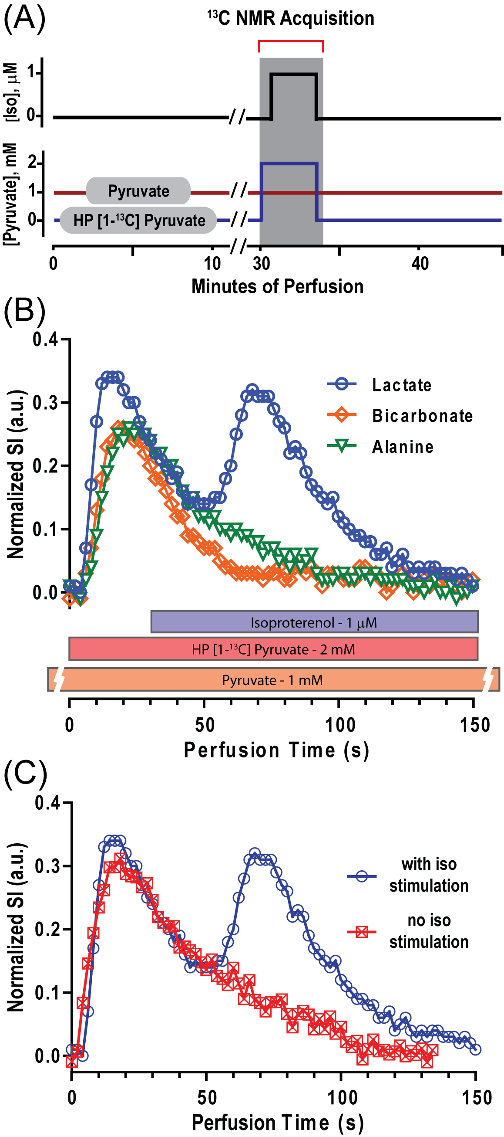
Figure 1. (A) A perfusion diagram, (B) ¹³C NMR signals of HP-lactate, alanine and bicarbonate in a heart injected with HP-[1-¹³C]pyruvate, (C) ¹³C NMR signals of HP-lactate in two separate hearts with or without the injection of isoproterenol at 30 s.

